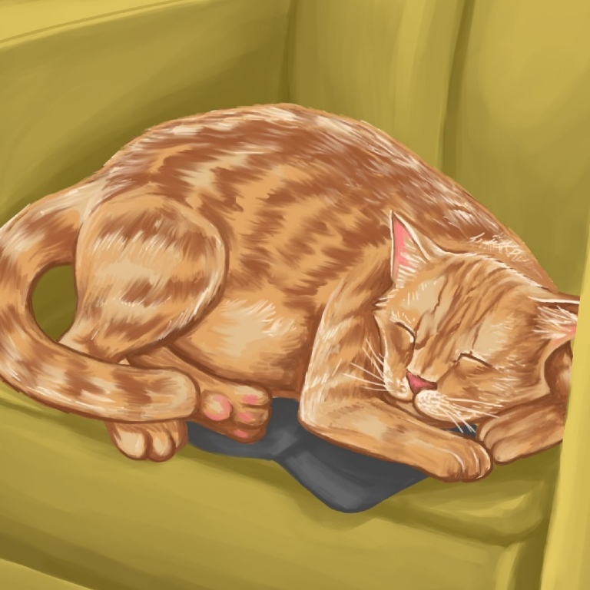

Mot and Don
By Maggie Boston
Illustrations by Susan Trisna

Mot and Don
Book 1

This reader for young children is part of a reading series for the Better Start Literacy Approach. Each book provides reading practice for children to decode short words with a focus on target consonants and vowels. The reader has been designed to support class teaching activities that are part of the Better Start Literacy Approach.

The Better Start Literacy Approach has been developed through the University of Canterbury Child Well-being Research Institute. The lead research team includes:
Professor Gail Gillon, Associate Professors Brigid McNeill and Alison Arrow, Drs Amy Scott and Amanda Denston and Professor Angus Macfarlane.

To access these readers online in narrated and book form, please visit https://sites.google.com/view/betterstart-whānau/home and click on the ‘Children’s Readers’ tab.
Published February, 2020, UC Child Well-being Research Institute.

The Better Start Literacy Approach is supported by the
A Better Start National Science Challenge, a 10-year programme of research investigating practical, evidence-based solutions that make a measurable difference for our tamariki. https://www.abetterstart.nz/



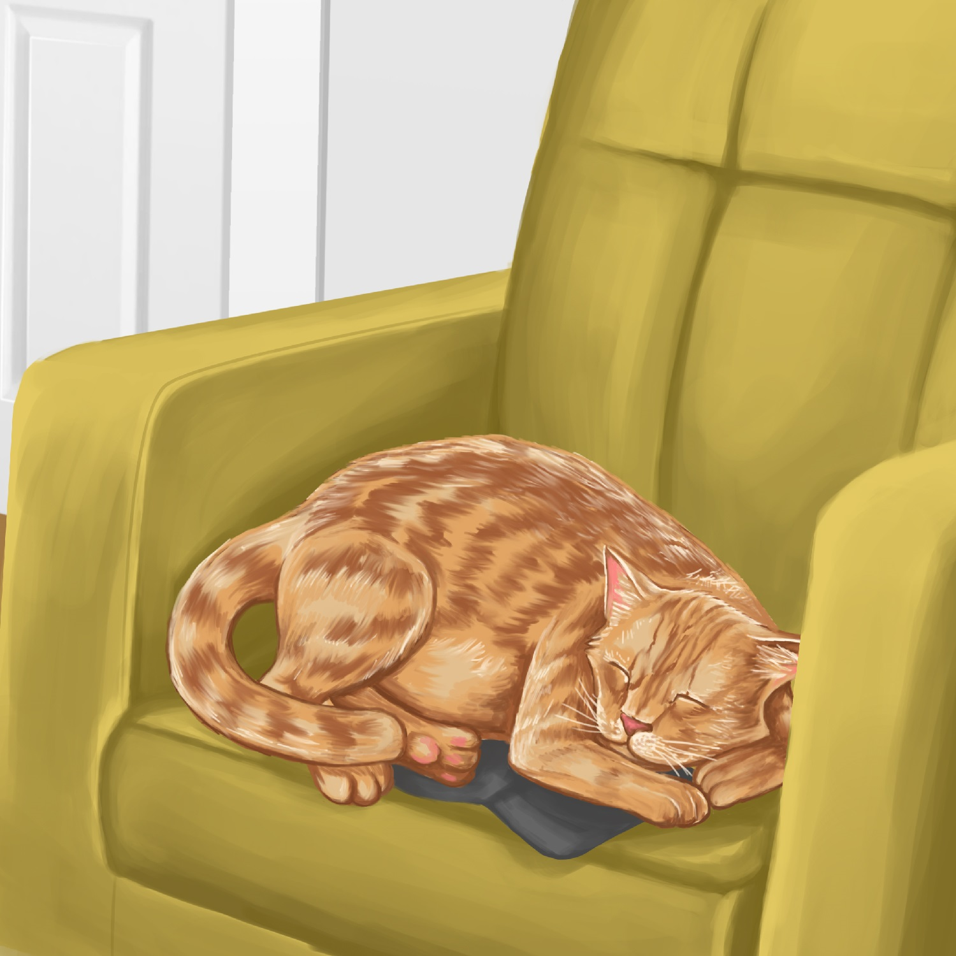

Mot is a cat.
Mot likes to nap.

Mot naps on the chair.
“Good Mot,” said Dad.

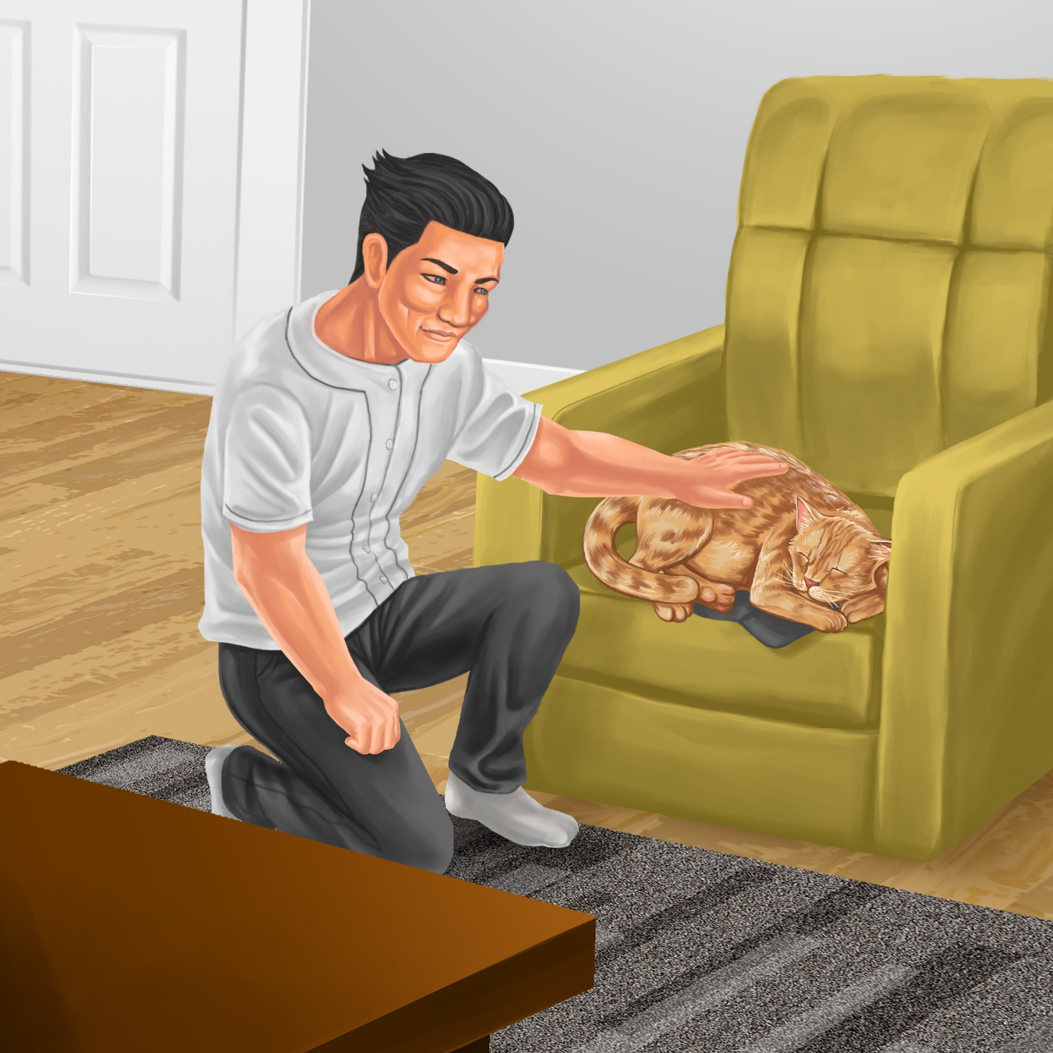
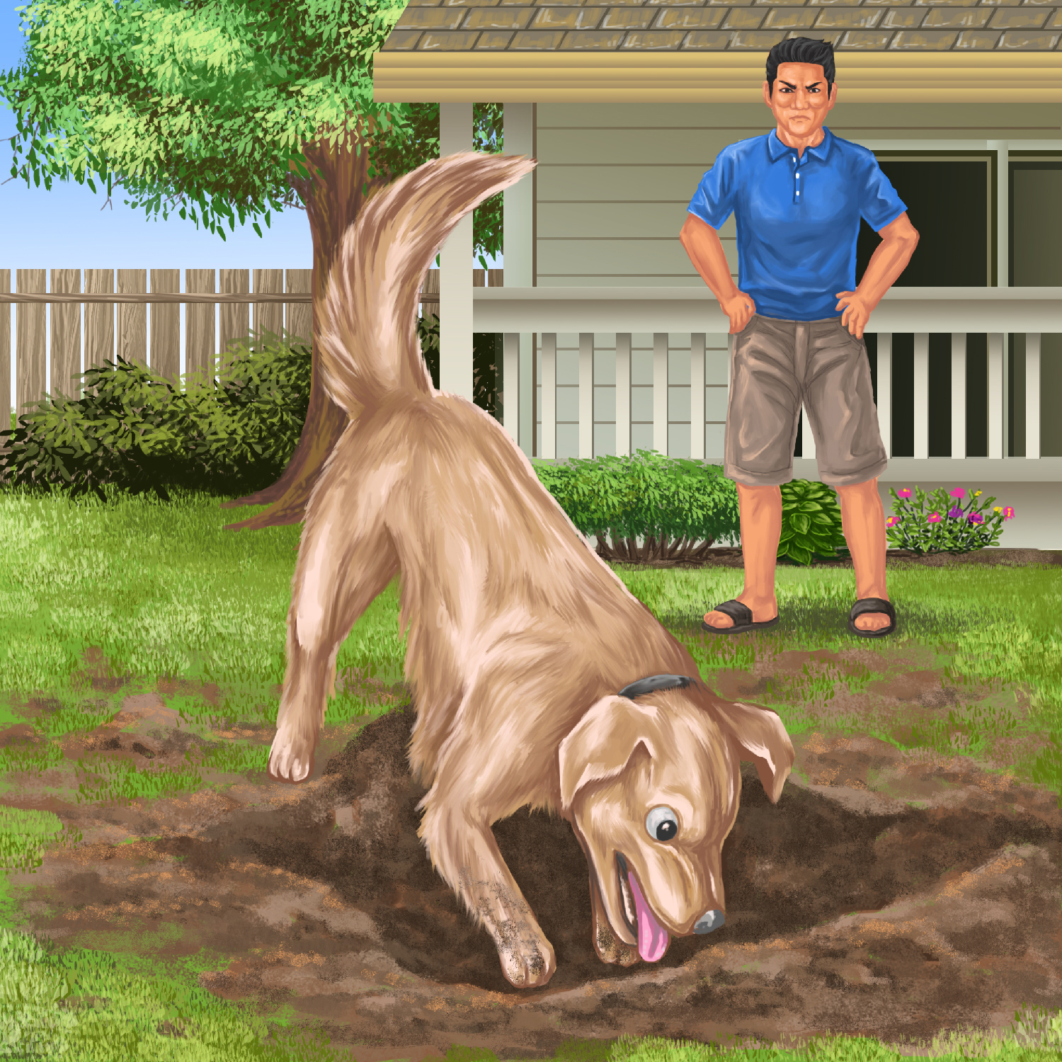

Don is a dog.
Don likes to dig.

Don digs the mud.
“Bad dog,” said Dad.
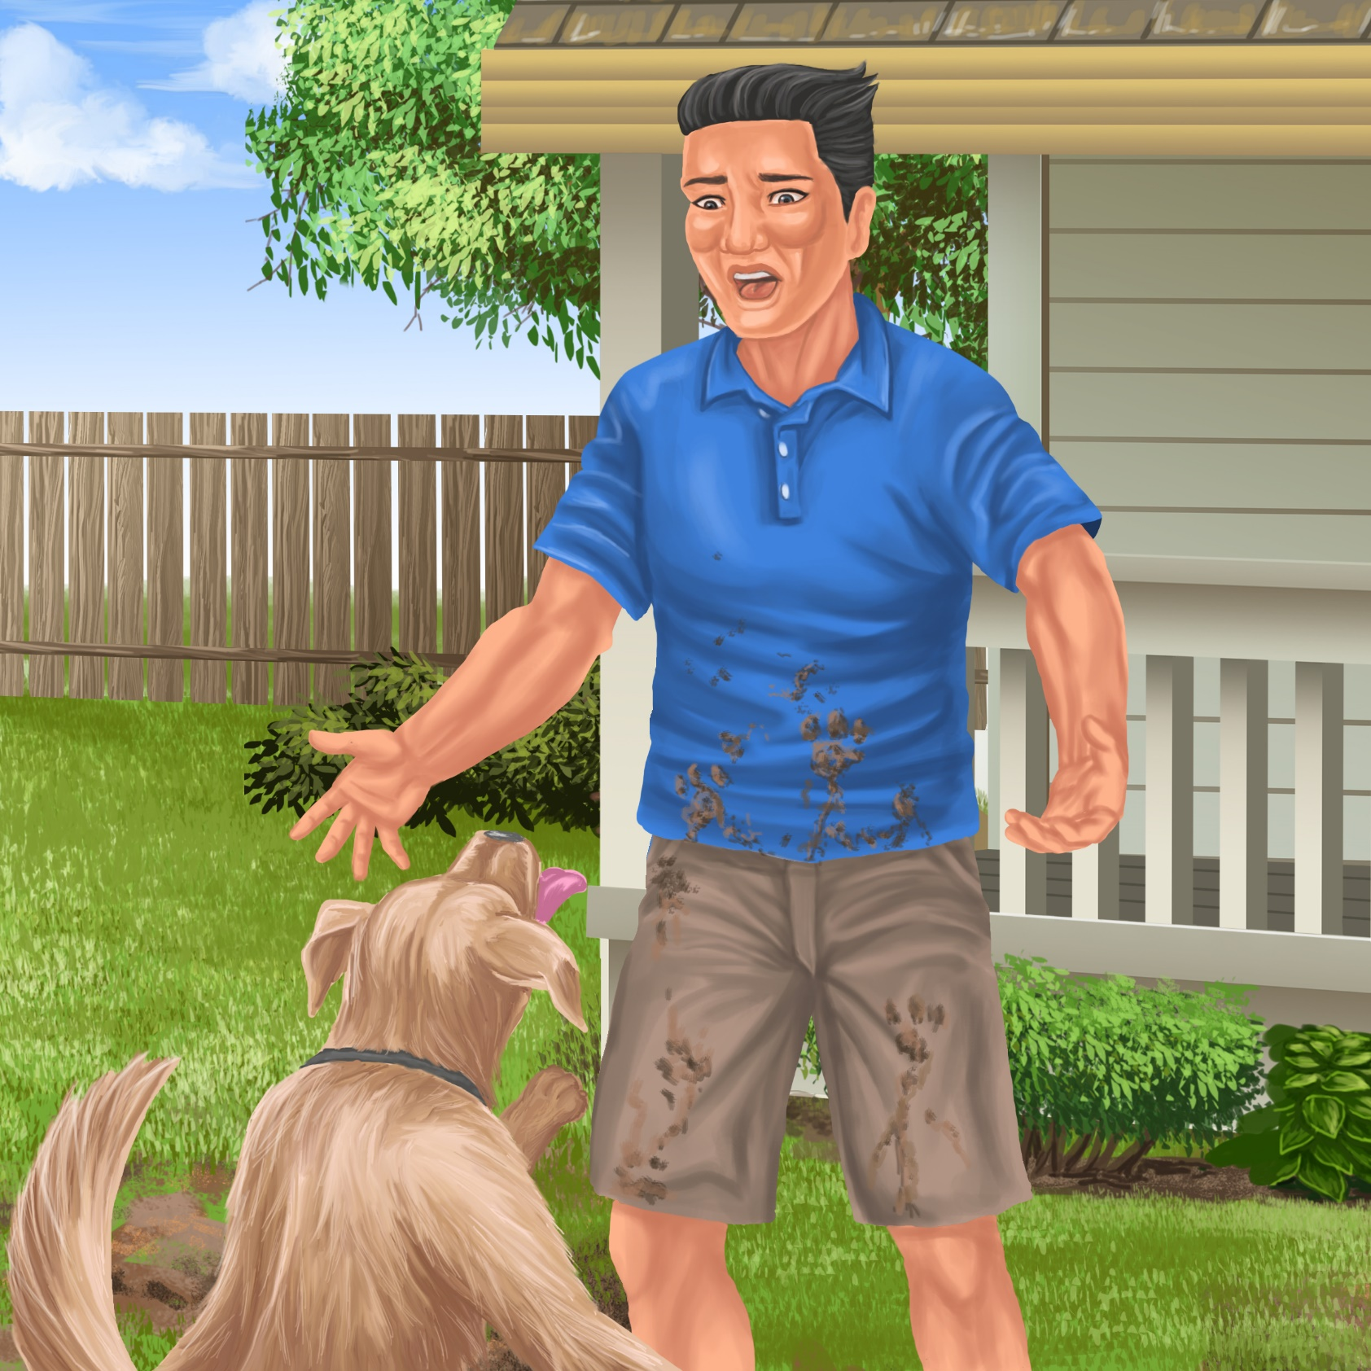
Mud is everywhere!
Teaching Notes: Mot and Don
Reading Practice: This story provides children with practice in decoding and understanding short words using carefully selected focus sounds.
Focus sounds
m d p t n a e o

Introduce the text and read the story aloud together, pointing to each word as you read. Help children sound out some of the regular words and then blend the sounds together. When reading other new words simply tell children the words as you read together. Give plenty of praise for children’s reading attempts and encourage re-reading to build accuracy and fluency.

Regular words for sounding out | tap, pat, mat, Ted, Dad, pot, pet, mad
Other words to tell your child | Mia, a, no, her, Mum, is

Phonological Awareness
Practice segmenting and blending sounds together to make words. You could say “Let’s clap out the sounds (phonemes) together in each word I say”.
Help children find each word you segment and blend on the page.
Use the table below for suggestions on how to segment and blend target words from this story.
tap | t-a-p | 3 claps
Dad | d-a-d | 3 claps
mat | m-a-t | 3 claps
no | n-o | 2 claps
pats | p-a-t-s | 4 claps

Morphological Awareness
Bring attention to how the word ‘tap’ can change (taps, tapping, tapped. Draw attention to the part of the word that is the same and the part that is different. Create sentences using different forms of the word tap.

Spelling
Support children to listen and identify where the sound change occurs in words. Use the suggested letters or letter blocks to spell and read the words. Prompt as necessary to ensure success.
m
p
t
a
e
o
Use the phrasing: “If this word spells tap, can you spell map. If this word spells map, can you spell mat?”

Easier changes: | tap > map > mat > pat
Harder changes: | pat > pet > pot > pop

Vocabulary
Talk about the meaning of the word ‘tap’ in the story. Think of other words with a similar meaning that would make sense in the sentence Mia taps on a mat (e.g. raps, beats, bangs, pats). Talk about another meaning for the word tap (e.g. the tap you turn to wash your hands).

Story Discussion
Talk about why Mia’s mum is mad and tells her “no!” (e.g. Mia was annoying her mum by tapping on everything).
Discuss how Mia might be tapping her drum sticks because she is learning to play the drums and she is practicing her drumming. Invite children to talk about things they might practice at home (e.g. dancing, violin, passing a ball).

Story Retell
Ask the children to re-tell the story to a friend or family member. Prompt as necessary using picture cues. Give plenty of praise and encouragement for verbal responses.

Print Concepts
Bring children’s attention to the lower and upper case version for the letters Mm, Dd, Tt and Pp. Think of people’s names or place names that start with M, D, P or T. Write them down, highlighting the capital letters.

