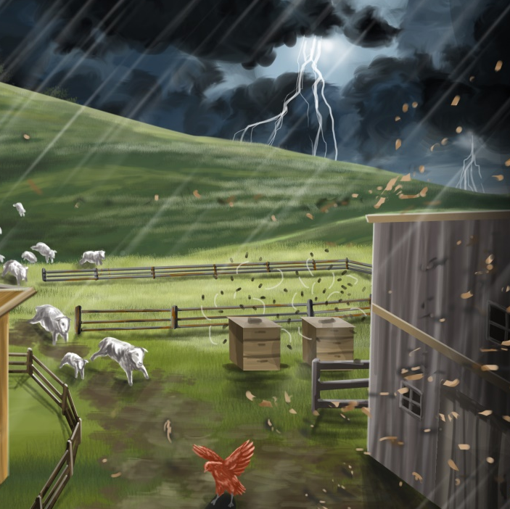

The Big Wind
By Maggie Boston
Illustrations by Susan Trisna

The Big Wind
Book 18

This reader for young children is part of a reading series for the Better Start Literacy Approach. Each book provides reading practice for children to decode short words with a focus on target consonants and vowels. The reader has been designed to support class teaching activities that are part of the Better Start Literacy Approach.

The Better Start Literacy Approach has been developed through the University of Canterbury Child Well-being Research Institute. The lead research team includes:
Professor Gail Gillon, Associate Professors Brigid McNeill and Alison Arrow, Drs Amy Scott and Amanda Denston and Professor Angus Macfarlane.

To access these readers online in narrated and book form, please visit https://sites.google.com/view/betterstart-whānau/home and click on the ‘Children’s Readers’ tab.
Published February, 2020, UC Child Well-being Research Institute.

The Better Start Literacy Approach is supported by the
A Better Start National Science Challenge, a 10-year programme of research investigating practical, evidence-based solutions that make a measurable difference for our tamariki. https://www.abetterstart.nz/




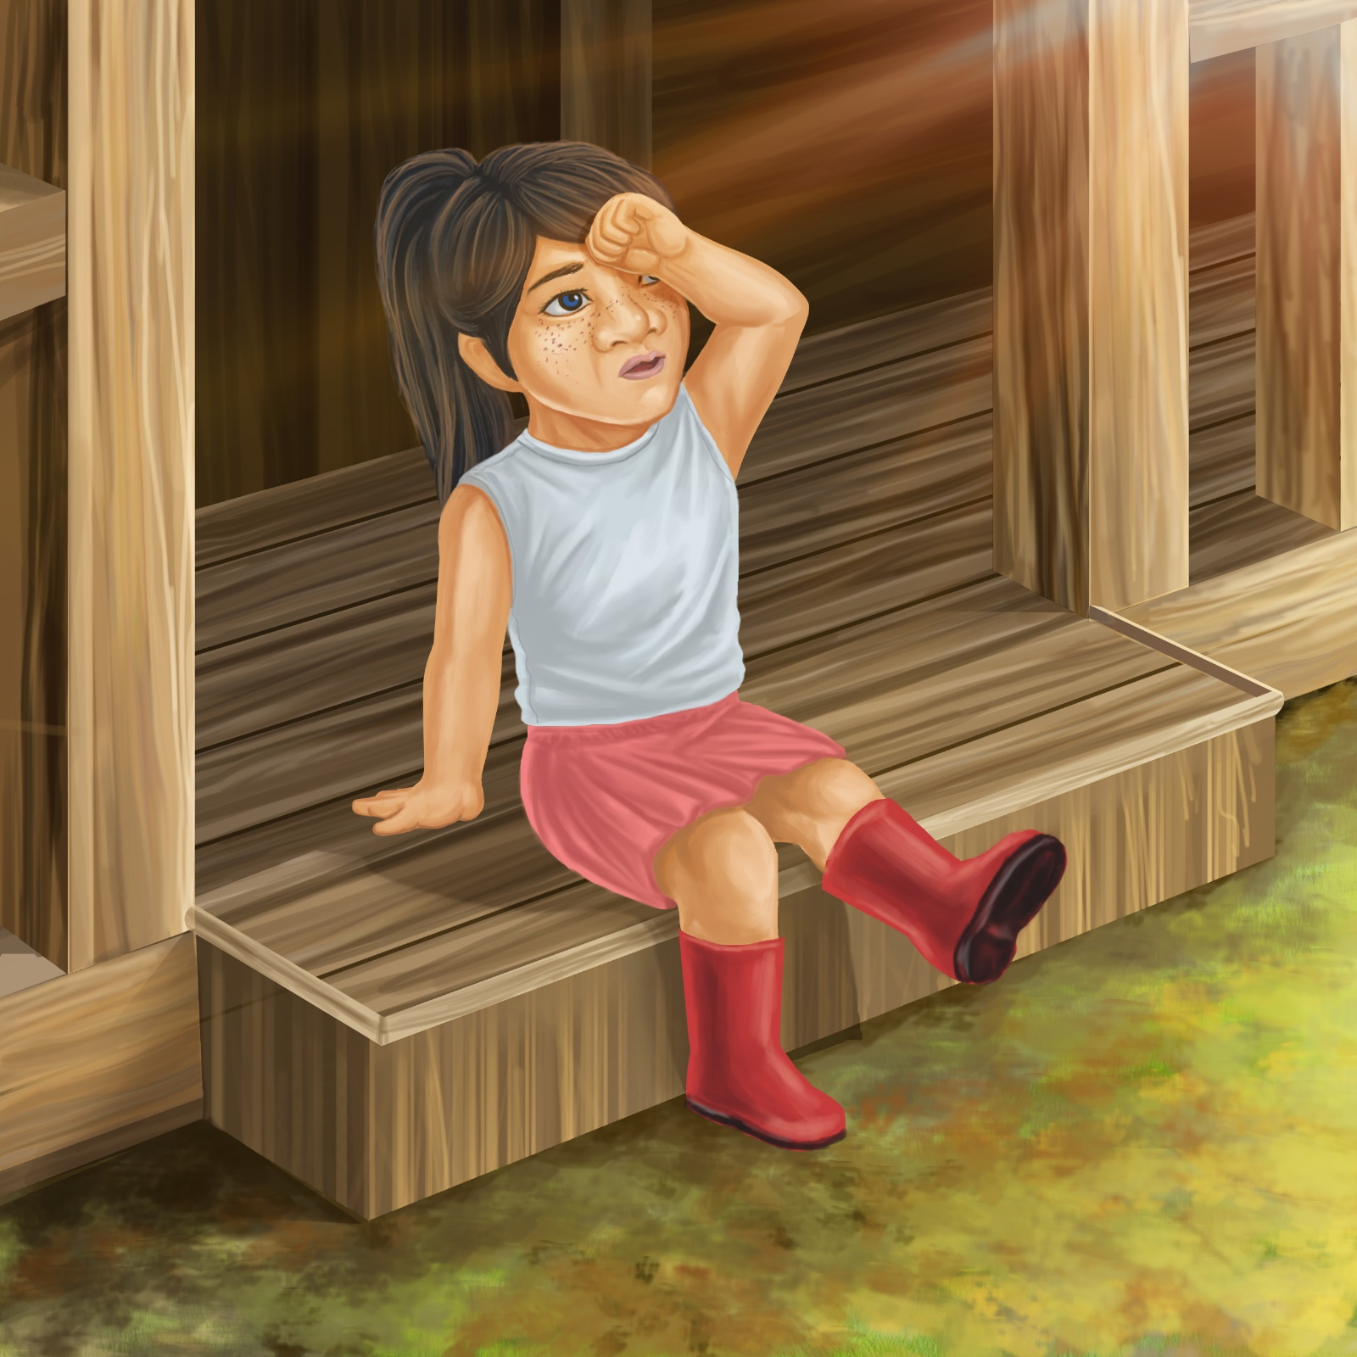

Pam is on Pop’s farm.
It is a hot day.

Little red hen is in the shed.
The sheep are in the shade.
The bees are in the hive.
It is very still.

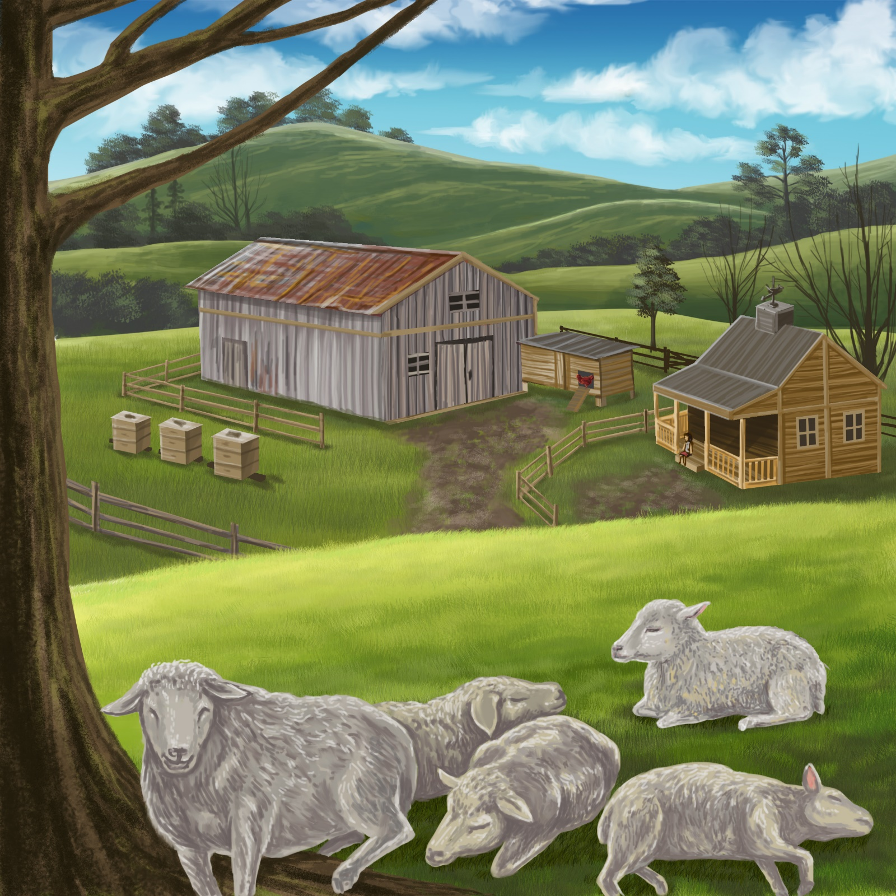
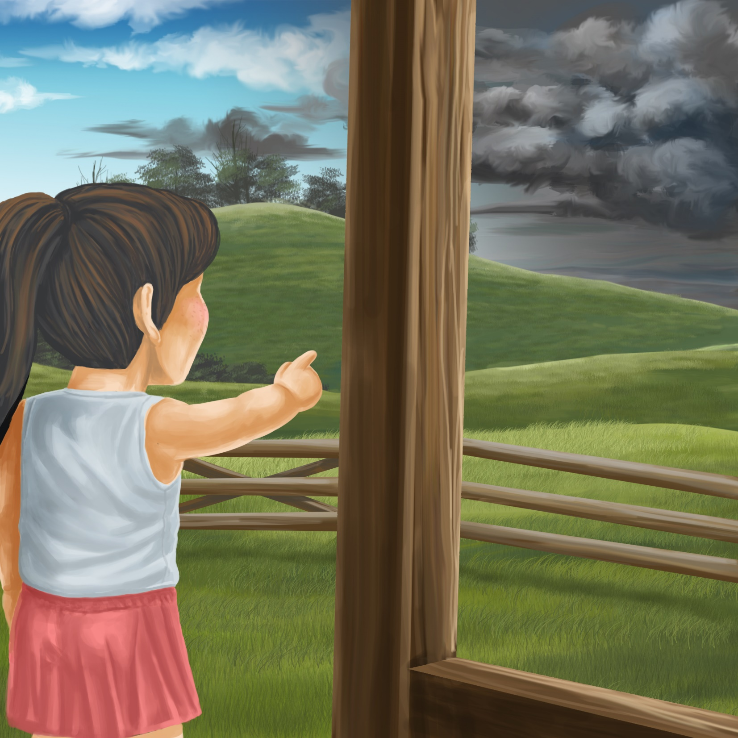

Then the sky turns black.
A big wind begins to blow.

The big wind makes the shed shake.
The wind makes the bee hive shake.

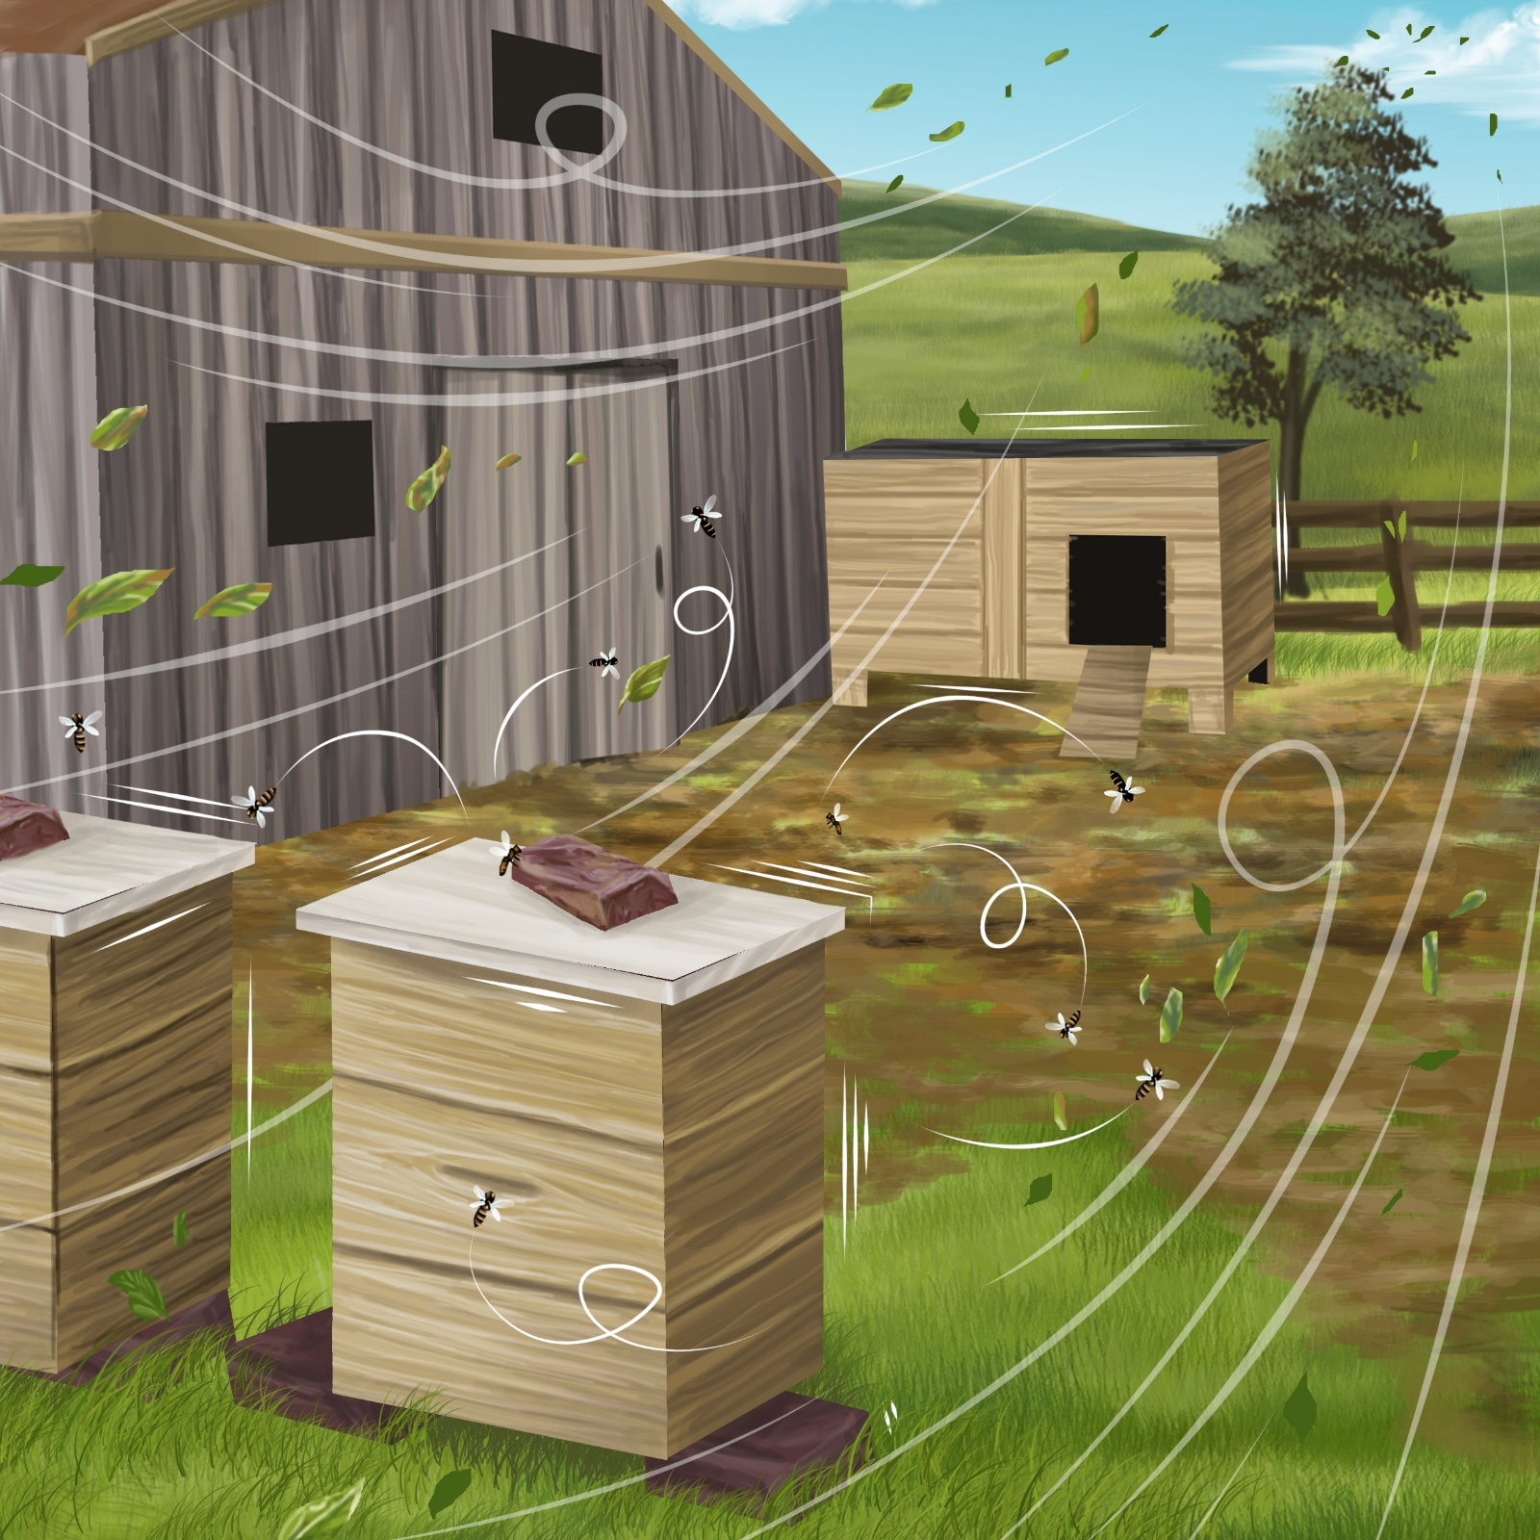
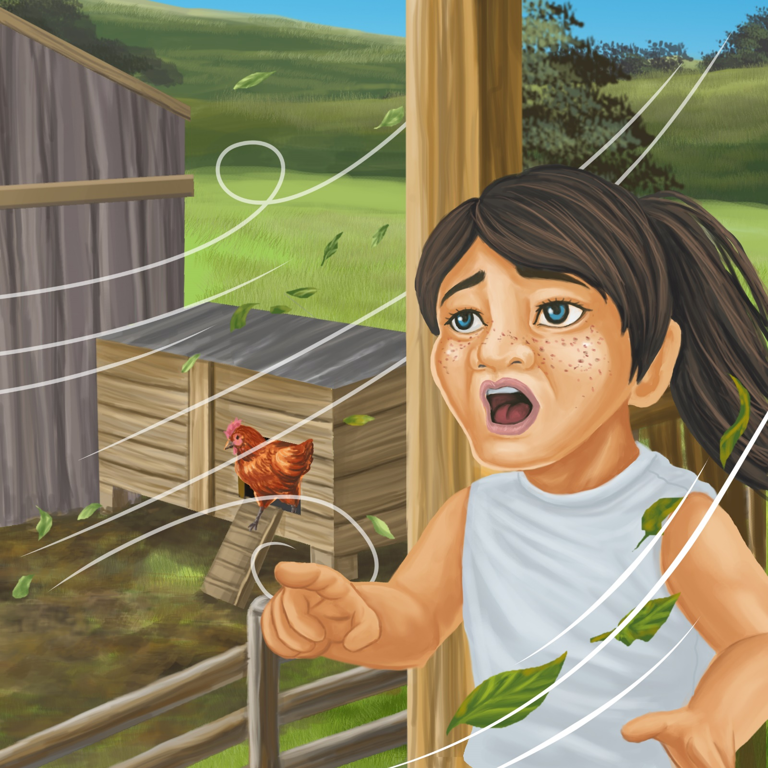

“It is a big storm!” shouts Pam.
Little red hen runs out of the shed.

The dog hides by the hut.
The sheep run down the hill.
The bees fly out of the hive.

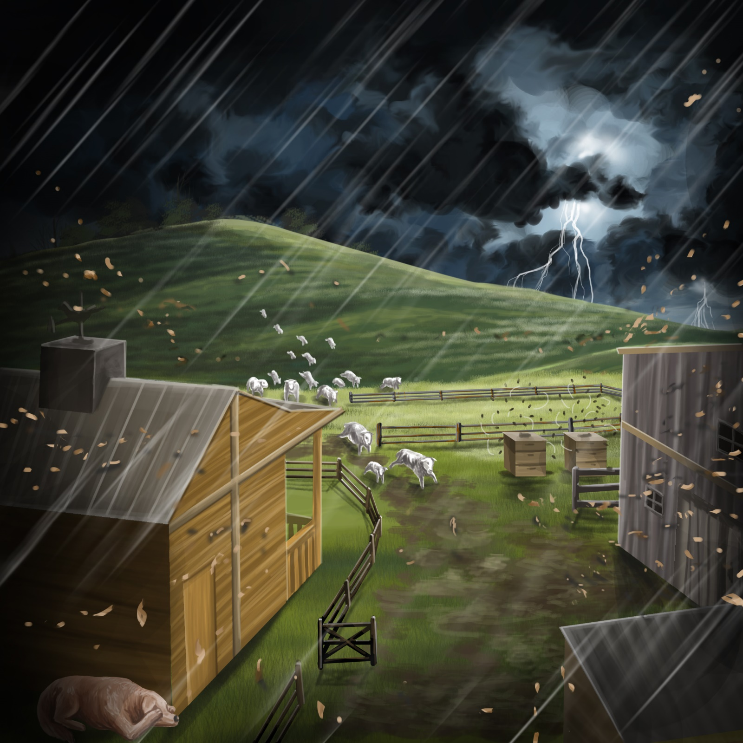

At last the wind stops.
Pam’s Pop gives her a hug.

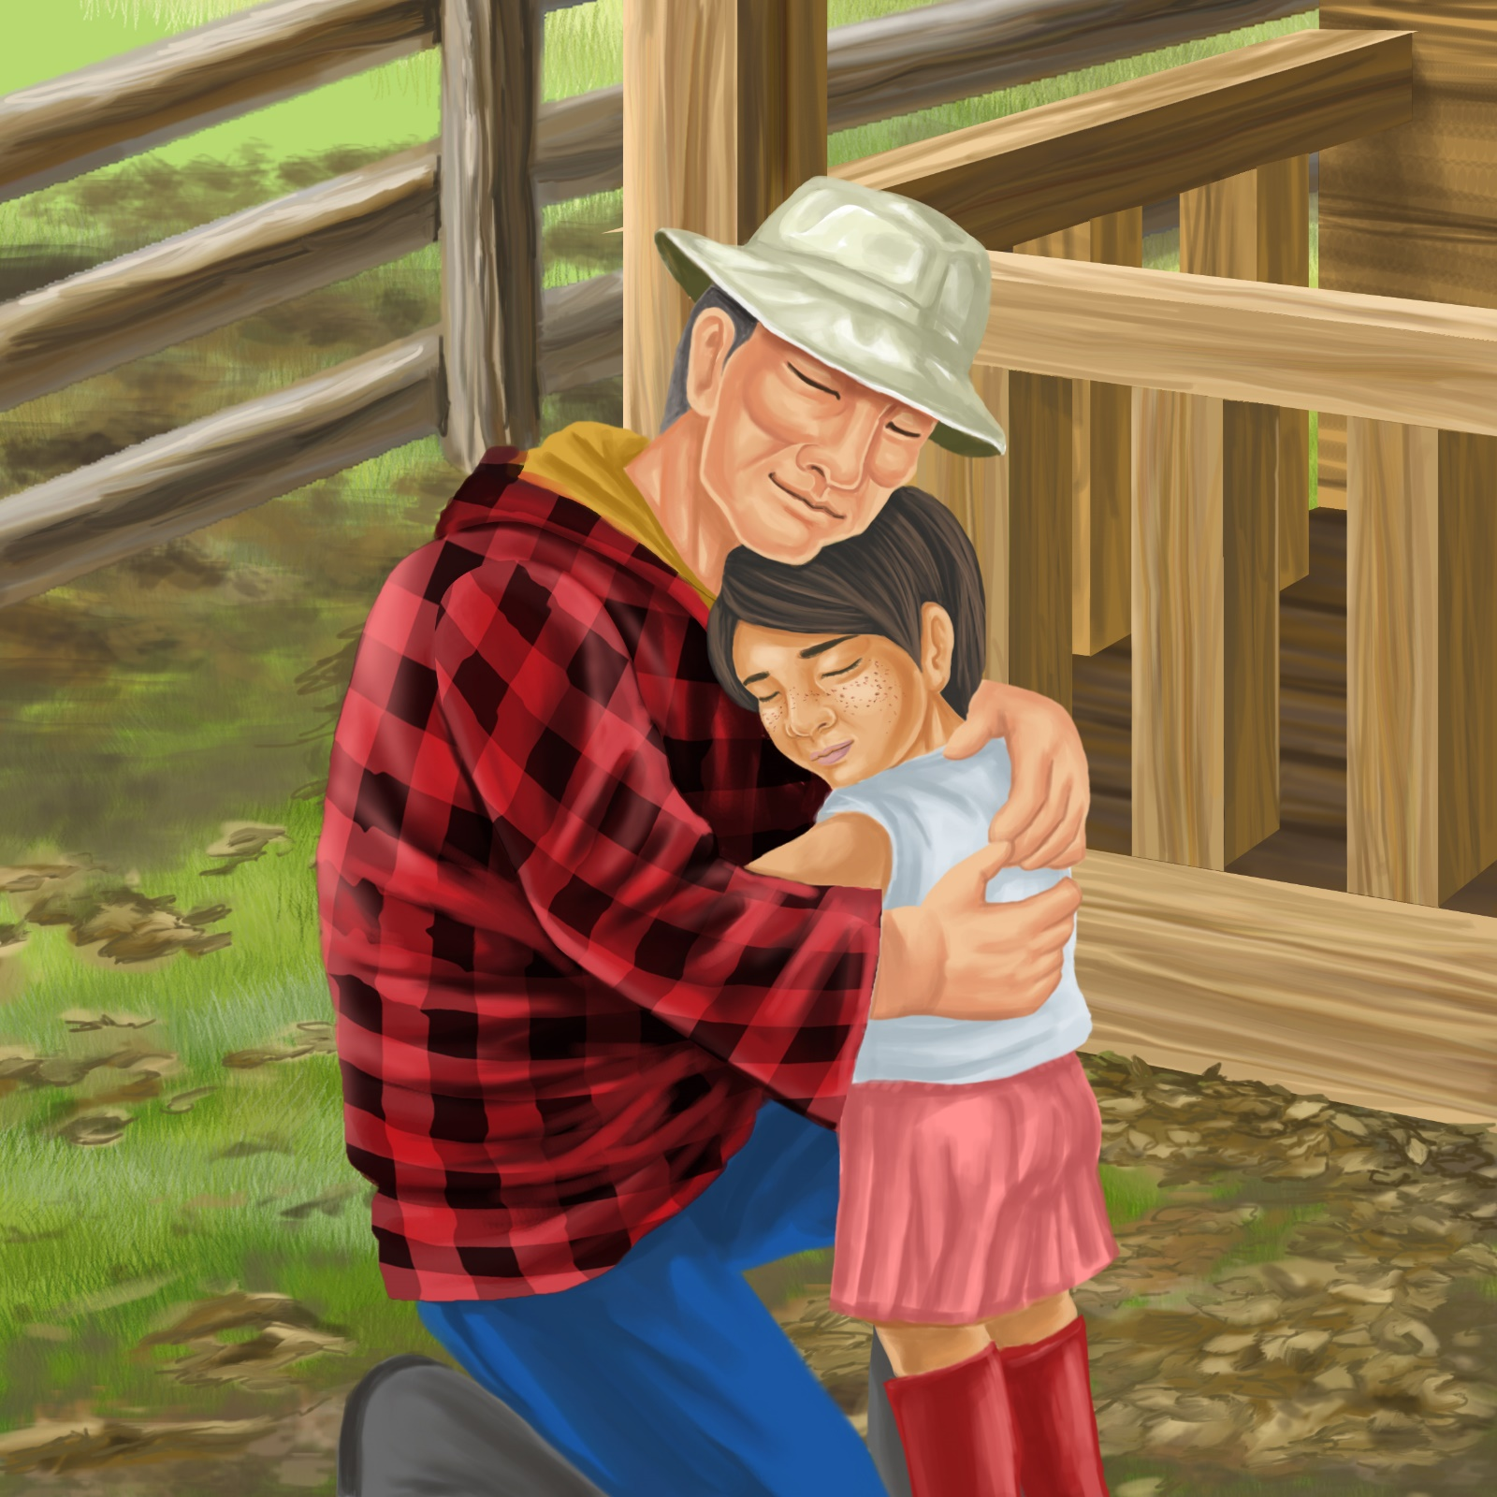
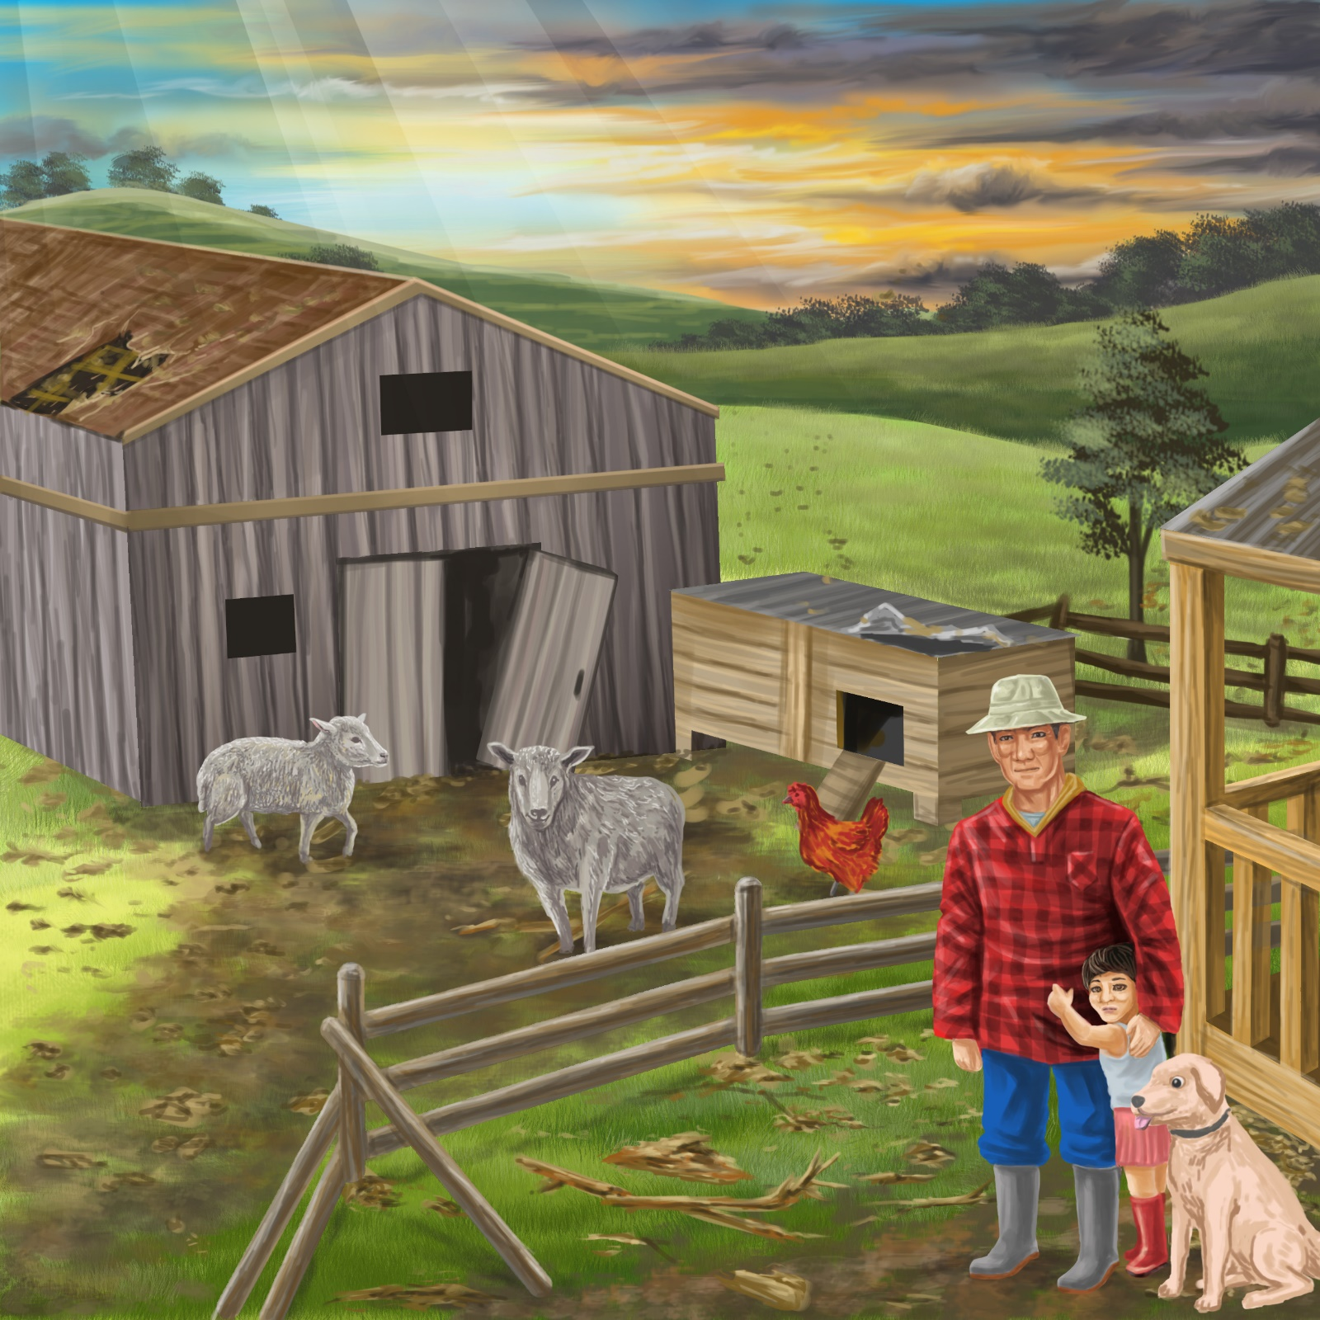
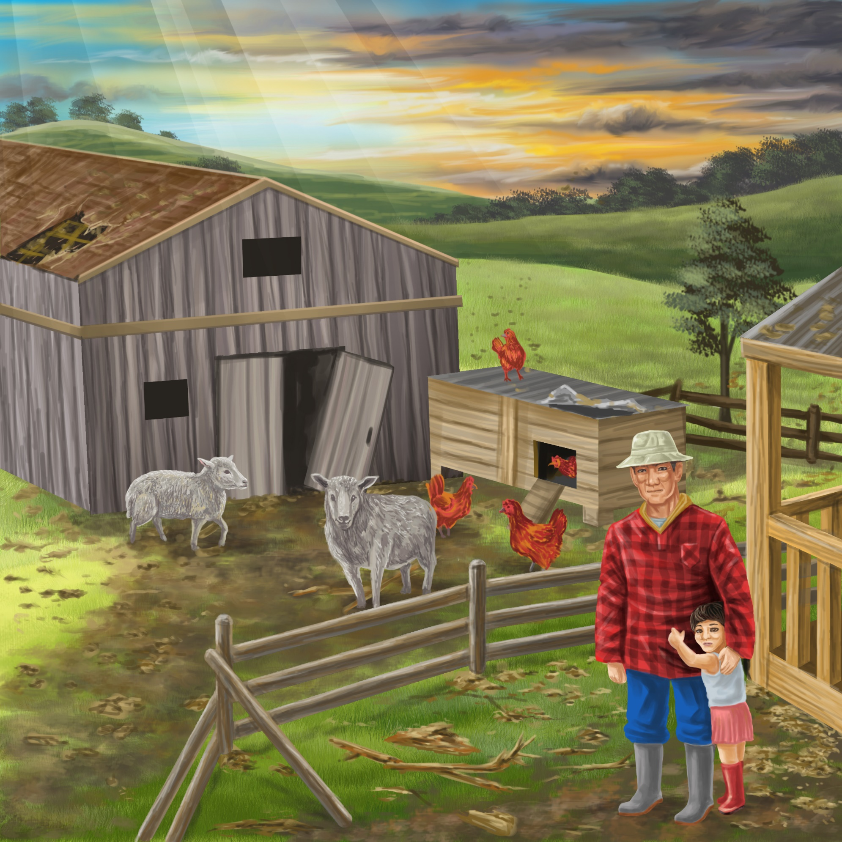
“It is safe,” says Pop.
“The big wind has gone.
We are all safe on the farm.”
Teaching Notes: Book 18 The Big Wind
Reading Practice: This story provides children with practice in decoding short words with a focus on words that start with consonants h and sh and include vowels a, e, i, o and u.

Introduce the text and read the story aloud together, pointing to each word as you read the story. Encourage children to help you “sound out” the regular words in the story. Help children sound out the word and then blend the sounds together, for example, sh-ee-p = sheep. When reading unknown high frequency words (e.g., is, are, says), tell children the words as you read together. Give plenty of praise for children’s reading attempts and encourage re-reading to build fluency and accuracy.

Phonological Awareness
Practice segmenting and blending words. Ask children to clap out each phoneme (sound) in the word: h-u-t (3 sounds), sh-e-d (3 sounds), w-i-n-d (4 sounds), b-l-a-ck (4 sounds), s-k-y (3 sounds).
Help children to find each word you segment on the page.
Think of all the words you can that start with a h sound and a sh sound. Find objects in the room that start with a h sound and a sh sound.

Spelling
Listen and identify where the sound change occurs in words. Use the phrasing: “If this word spells hut, can you make it say hug. If this word says hug can you change it to bug”.
Change hill to till to still to sill
Change pop to plop to lop to lip to slip

Vocabulary
Discuss the word shade and what creates shade. Learn about the different between shade and shadow. http://learnersdictionary.com/qa/The-Difference-Between-Shade-and-Shadow-

Story Discussion
Talk about storms or a strong wind that the children may have experienced. Talk about current weather in your area – for example is it stormy and windy, or sunny?

Story Retell
Ask children to re-tell the story to a friend. Prompt as necessary using picture cues. Give plenty of praise and encouragement.
Print Concepts
Discuss use of capital letters for Pop and Pam’s names. Bring children’s attention to these words on the page.


