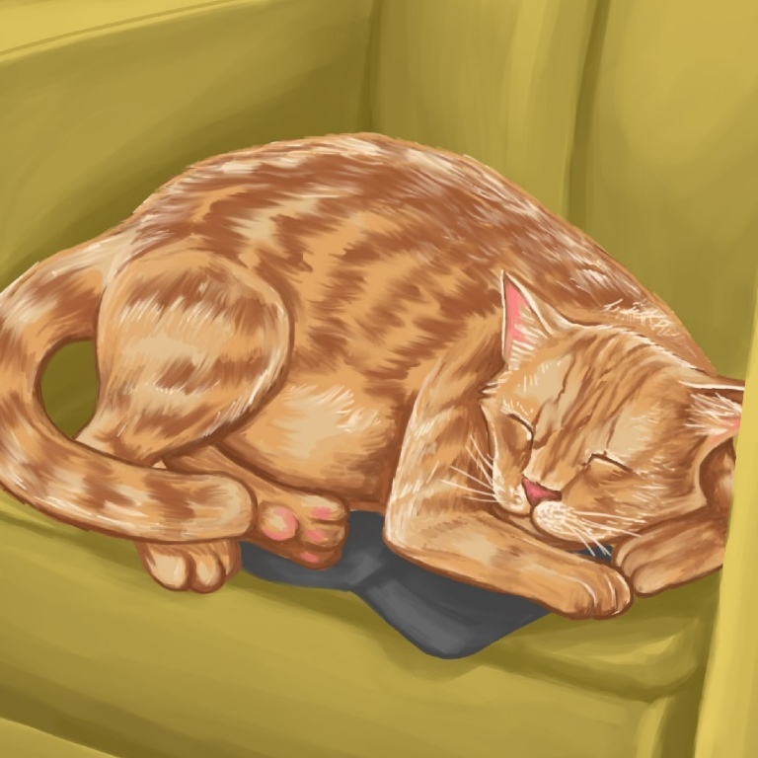

Mot and Don
By Maggie Boston
Illustrations by Susan Trisna

Mot and Don
Book 1

This reader for young children is part of a reading series for the Better Start Literacy Approach. Each book provides reading practice for children to decode short words with a focus on target consonants and vowels. The reader has been designed to support class teaching activities that are part of the Better Start Literacy Approach.

The Better Start Literacy Approach has been developed through the University of Canterbury Child Well-being Research Institute. The lead research team includes:
Professor Gail Gillon, Associate Professors Brigid McNeill and Alison Arrow, Drs Amy Scott and Amanda Denston and Professor Angus Macfarlane.

To access these readers online in narrated and book form, please visit https://sites.google.com/view/betterstart-whānau/home and click on the ‘Children’s Readers’ tab.
Published February, 2020, UC Child Well-being Research Institute.

The Better Start Literacy Approach is supported by the
A Better Start National Science Challenge, a 10-year programme of research investigating practical, evidence-based solutions that make a measurable difference for our tamariki. https://www.abetterstart.nz/



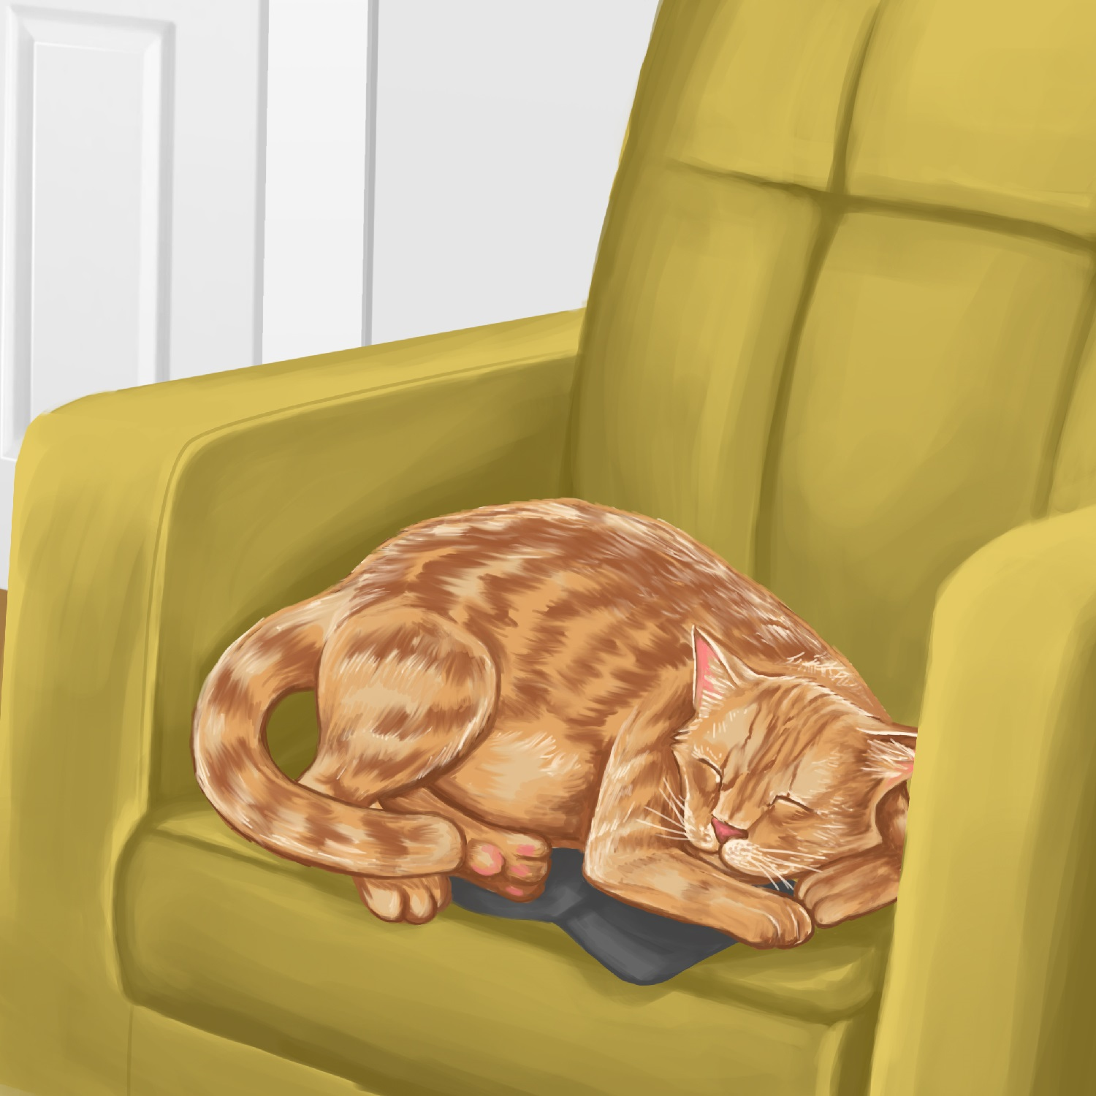

Mot is a cat.
Mot likes to nap.

Mot naps on the chair.
“Good Mot,” said Dad.

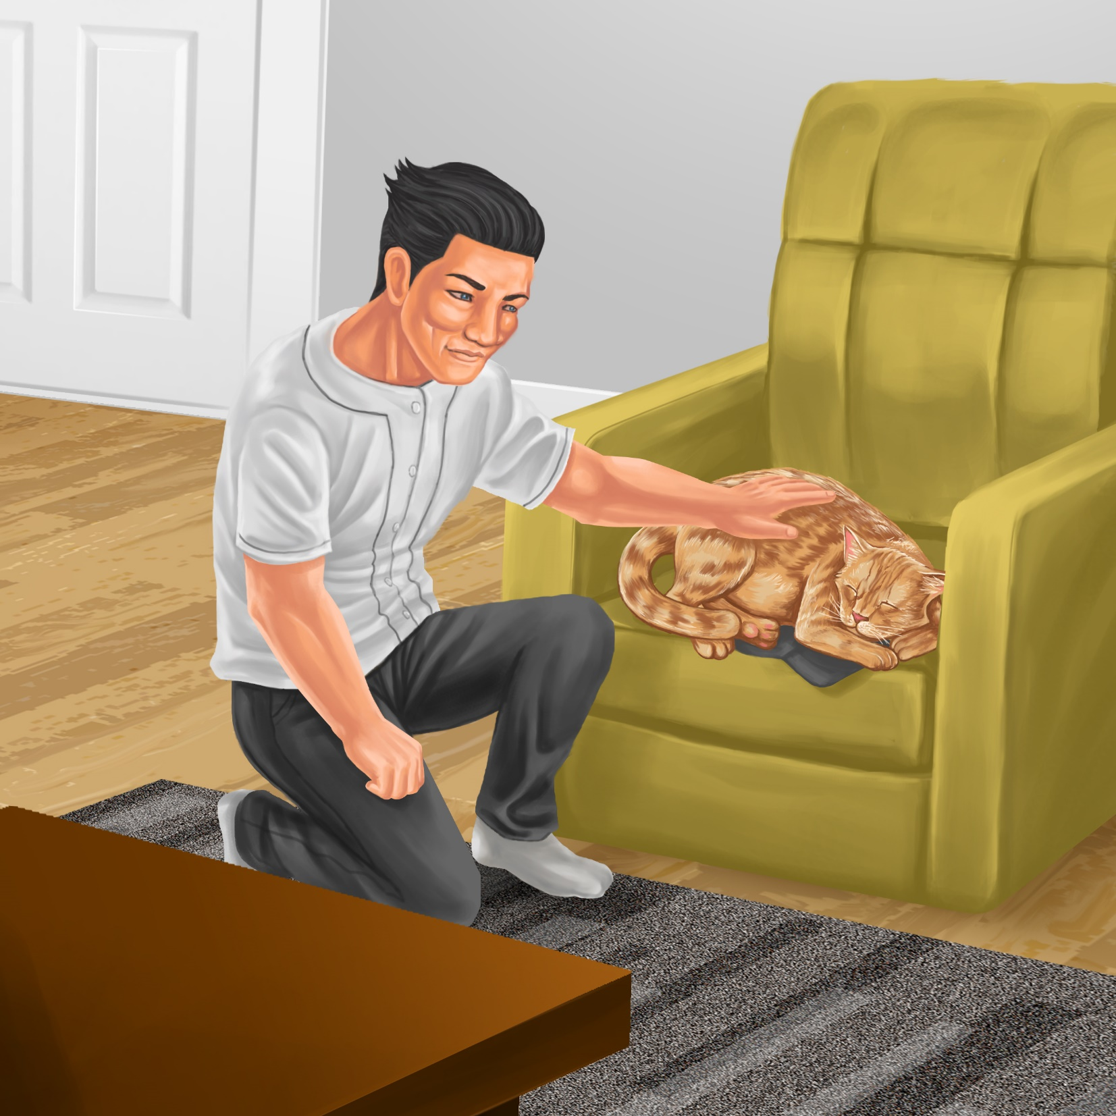
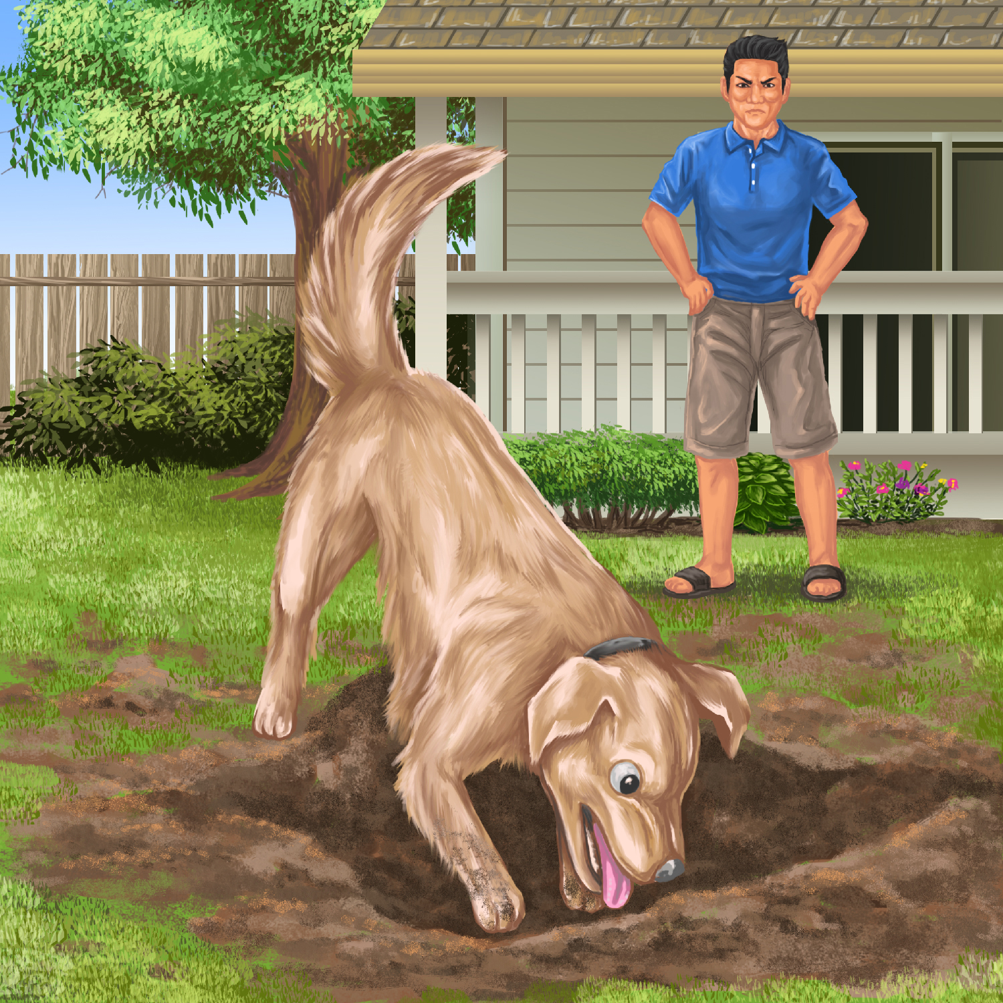

Don is a dog.
Don likes to dig.

Don digs the mud.
“Bad dog,” said Dad.
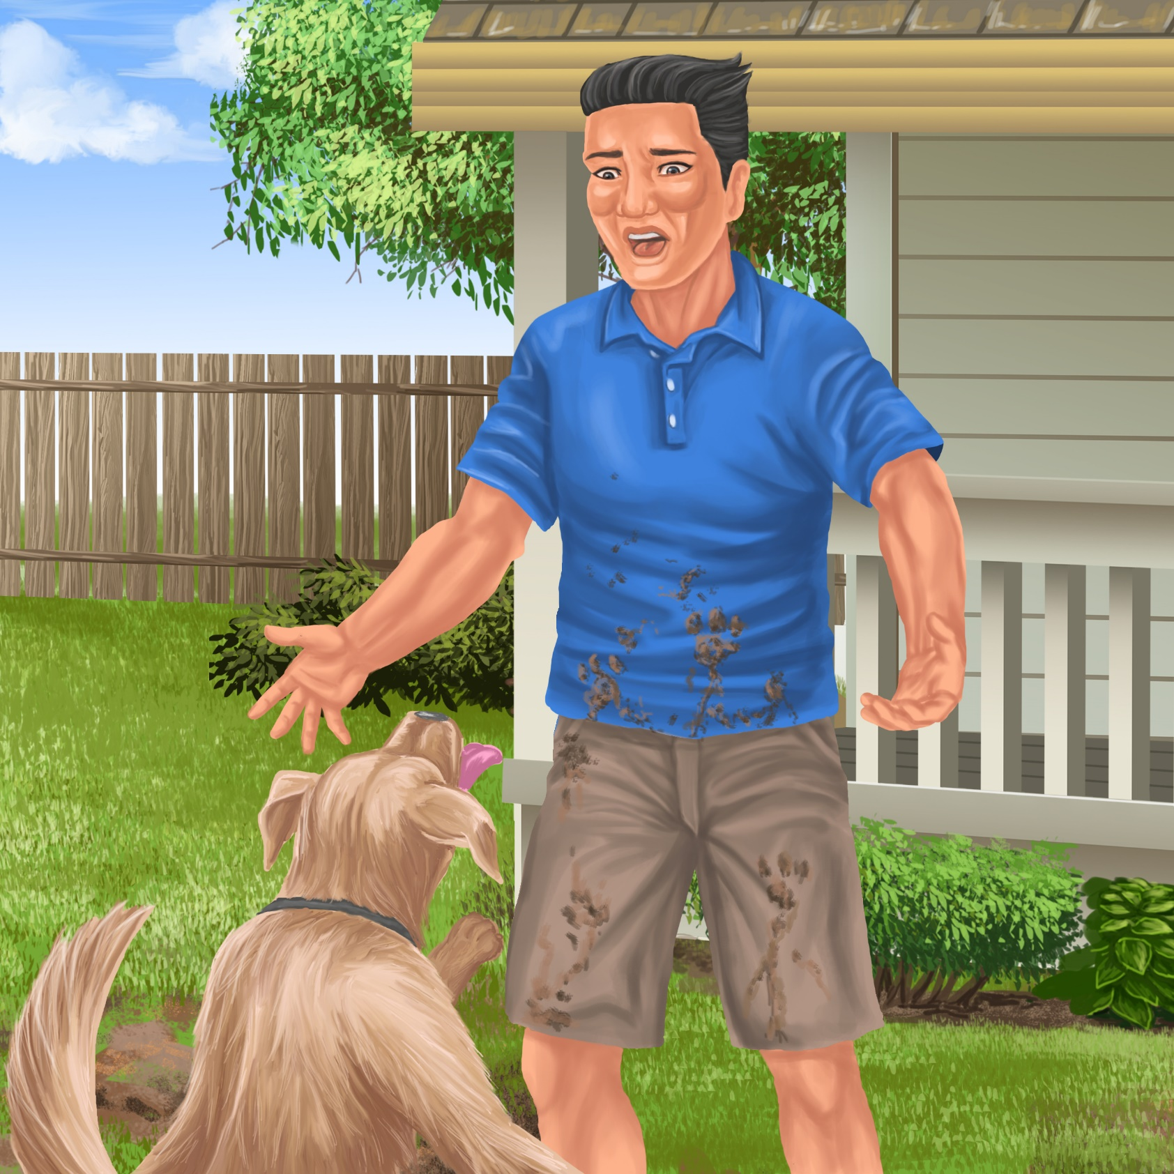
Mud is everywhere!
Teaching Notes: Book 1 Mot and Don
Reading Practice: This story provides children with practice in decoding short words with a focus on words that start with m and d consonants and include a o and i vowels.

Introduce the text and read the story aloud together, pointing to each word as you read the story. Encourage children to help you “sound out” the regular words in the story (see words in bold print below). Help children sound out the word and then blend the sounds together, for example, M-o-t = mot. When reading unknown high frequency words (e.g., said, likes), tell children the words as you read together. Give plenty of praise for children’s reading attempts and encourage re-reading to build fluency and accuracy.

Mot is a cat.
Mot likes to nap.
Mot naps on the chair.
“Good Mot,” said Dad.
Don is a dog.
Don likes to dig.
Don digs the mud.
“Bad dog,” said Dad.
“Mud is everywhere!”

Phonological Awareness
Practice segmenting and blending words. Ask children to clap out each phoneme (sound) in the word: m-u-d (3 sounds, 3 claps), d-a-d (3 sounds), n-a-p-s (4 sounds). Help children to find each word you segment on the page.
Think of all the words you can that start with a d sound, and an m sound. Find objects in the room that start with a d or m sound.
Spelling
Listen and identify where the sound change occurs in words. Use the phrasing: “If this word spells mot, can you make it say dot. If this word says dot can you change it to pot”.
Change Mot to dot to pot
Change dog to dig to pig

Vocabulary
Explain the meaning of nap: nap means to have a little sleep. Make up sentences using the word nap.
Story Discussion
Discuss why Dad was mad with Don. Talk about what makes you mad sometimes and what you do to make you feel better.
Story Retell
Ask children to re-tell the story to a friend. Prompt as necessary using picture cues. Give plenty of praise and encouragement.
Print Concepts
Discuss the lower and upper case version of D d and M m and bring children’s attention to these letters on the page.

