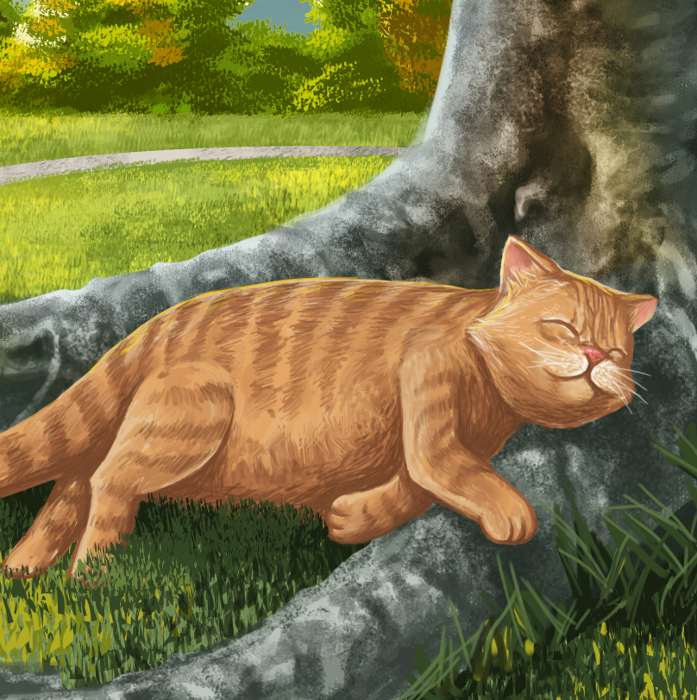

Mot the Fat Cat
By Maggie Boston
Illustrations by Susan Trisna

Mot the Fat Cat
Book 10

This reader for young children is part of a reading series for the Better Start Literacy Approach. Each book provides reading practice for children to decode short words with a focus on target consonants and vowels. The reader has been designed to support class teaching activities that are part of the Better Start Literacy Approach.

The Better Start Literacy Approach has been developed through the University of Canterbury Child Well-being Research Institute. The lead research team includes:
Professor Gail Gillon, Associate Professors Brigid McNeill and Alison Arrow, Drs Amy Scott and Amanda Denston and Professor Angus Macfarlane.

To access these readers online in narrated and book form, please visit https://sites.google.com/view/betterstart-whānau/home and click on the ‘Children’s Readers’ tab.
Published February, 2020, UC Child Well-being Research Institute.

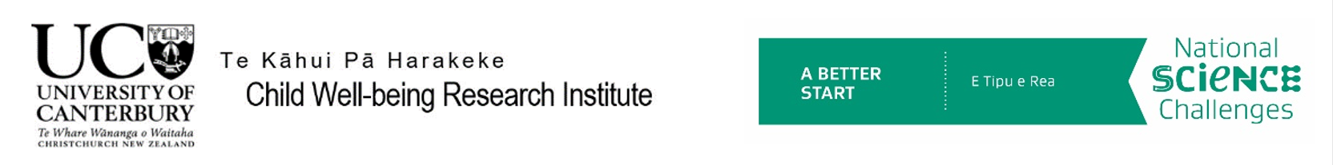
The Better Start Literacy Approach is supported by the
A Better Start National Science Challenge, a 10-year programme of research investigating practical, evidence-based solutions that make a measurable difference for our tamariki. https://www.abetterstart.nz/

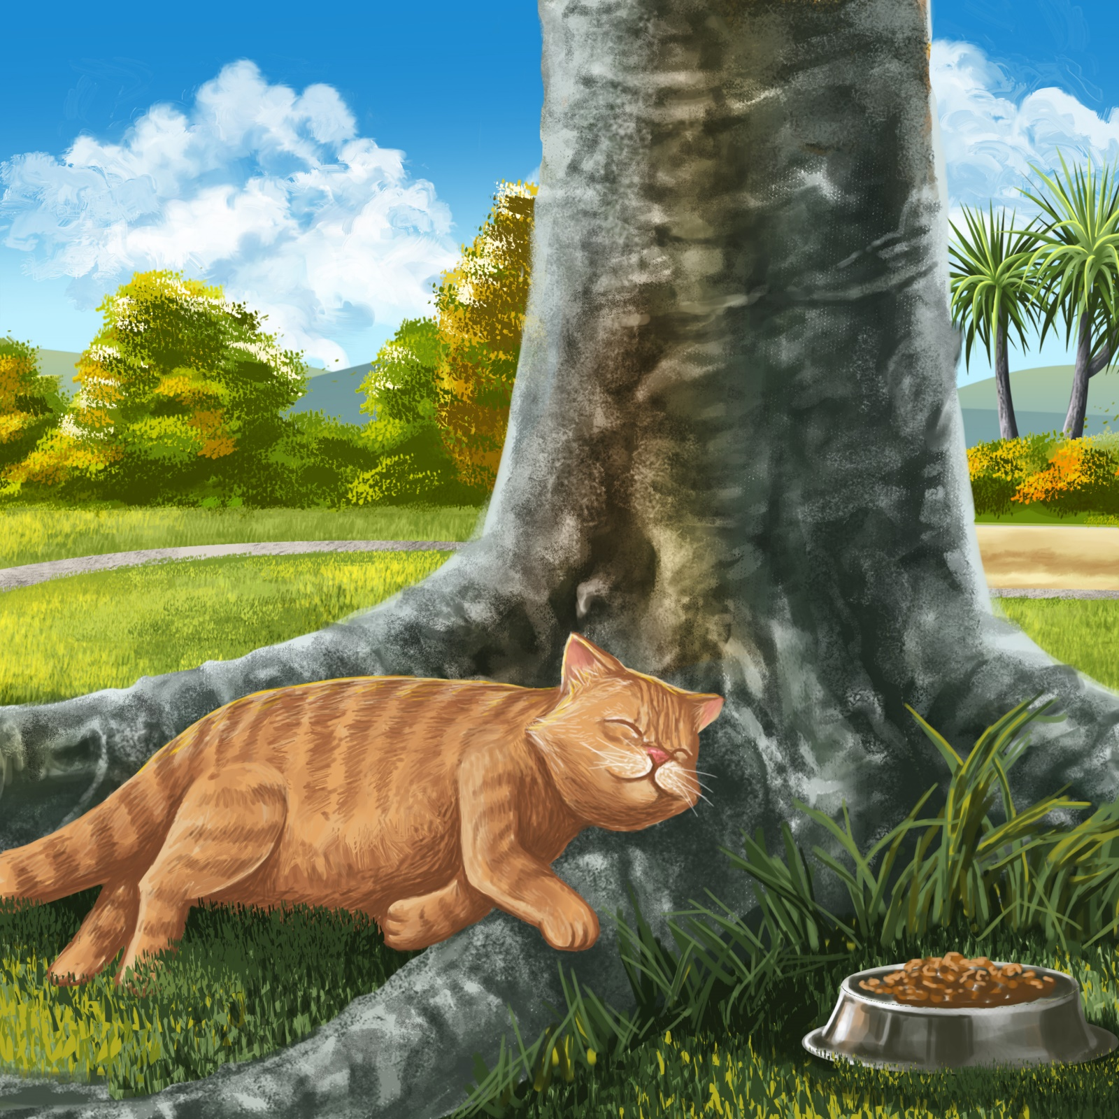

Mot likes to nap.
Mot naps in the sun.
He naps in the sun under the tree.

Mot naps and feeds, feeds and naps.
Mot is getting fat!
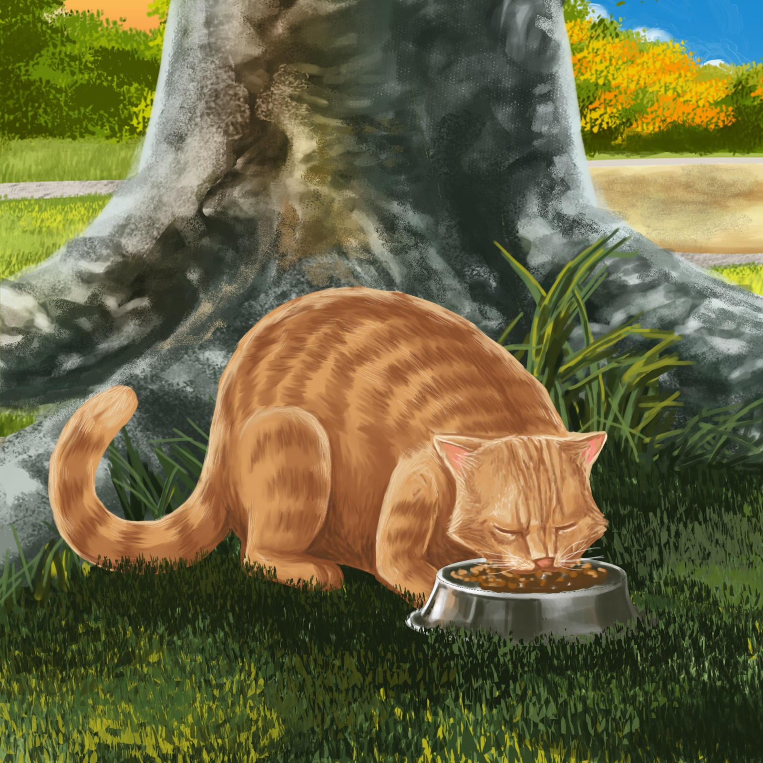

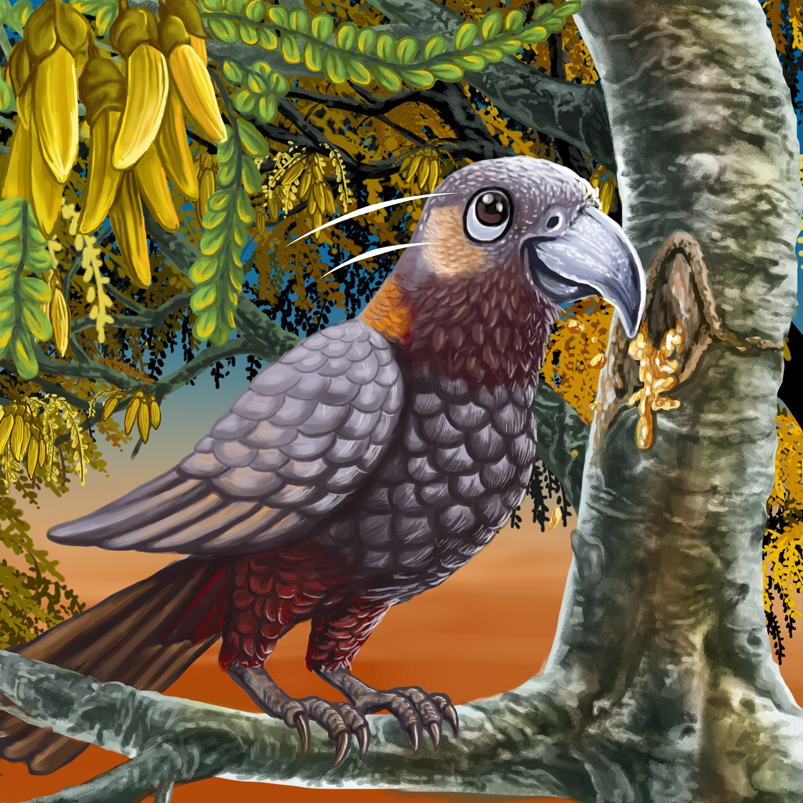

Manu sits in the tree.
He sips the tree sap.
He flaps his wings.
He sings a song.

Mot sits up.
“I can catch birds!” said Mot.
“I can fly,” said Manu.
“A fat cat is too slow for me!”
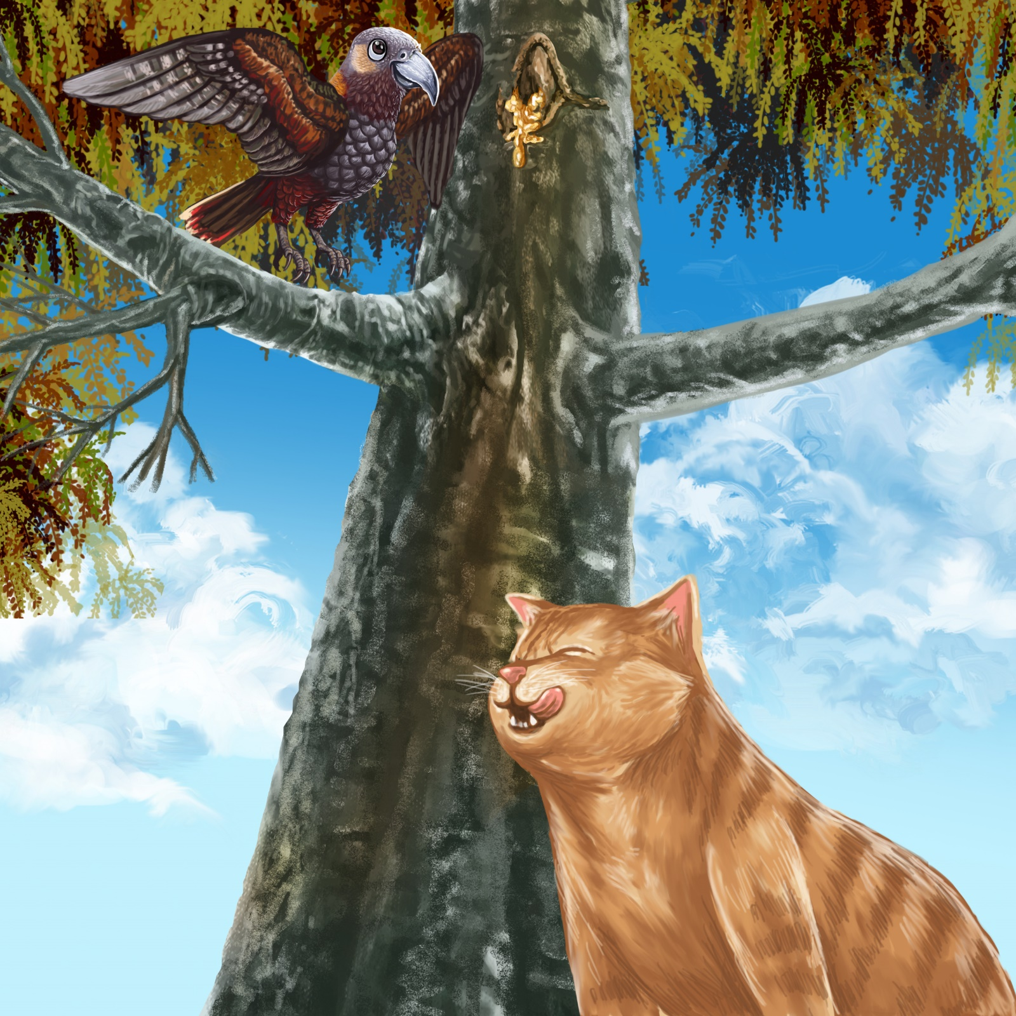
Teaching Notes: Book 10 Mot the Fat Cat
Reading Practice: This story provides children with practice in decoding short words with a focus on words that include s and f consonants and a o and i vowels.

Introduce the text and read the story aloud together, pointing to each word as you read the story. Encourage children to help you “sound out” the regular words in the story. Help children sound out the word and then blend the sounds together, for example, M-o-t = mot. When reading unknown high frequency words (e.g., his, the), tell children the words as you read together. Give plenty of praise for children’s reading attempts and encourage re-reading to build fluency and accuracy.

Phonological Awareness
Practice segmenting and blending words. Ask children to clap out each phoneme (sound) in the word: s-u-n (3 sounds), s-l-ow (3 sounds), f-ee-d-s (4 sounds), s-i-p-s (4 sounds), f-l-a-p-s (5 sounds).
Help children to find each word you segment on the page.
Think of all the words you can that start with an s sound, and an f sound. Find objects in the room that start with an s or f sound

Spelling
Listen and identify where the sound change occurs in words. Use the phrasing: “If this word spells sip, can you make it say sap. If this word says sap can you change it to slap”.
Change sit to sip to slip to slap to lap.

Vocabulary
Explain the meaning of the word sips. To sip means to take a little taste of a drink. Make up sentences using the word sips.

Story Discussion
Discuss how birds and cats live in different habitats or homes. Where do birds usually live? What about cats? How are their homes the same or different?

Story Retell
Ask children to re-tell the story to a friend. Prompt as necessary using picture cues. Give plenty of praise and encouragement.
Print Concepts
Discuss the use of use of speech marks, for example: “I can fly,” said Manu. We use speech marks to show someone else’s words in our writing.


