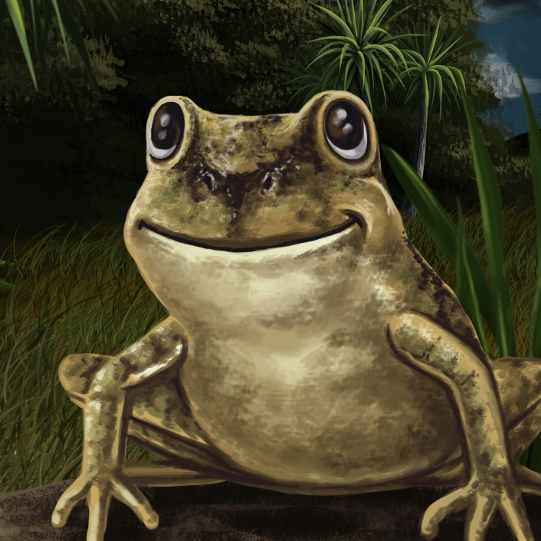

A
New Zealand Frog
By Maggie Boston
Illustrations by Susan Trisna

A New Zealand Frog
Book 12

This reader for young children is part of a reading series for the Better Start Literacy Approach. Each book provides reading practice for children to decode short words with a focus on target consonants and vowels. The reader has been designed to support class teaching activities that are part of the Better Start Literacy Approach.

The Better Start Literacy Approach has been developed through the University of Canterbury Child Well-being Research Institute. The lead research team includes:
Professor Gail Gillon, Associate Professors Brigid McNeill and Alison Arrow, Drs Amy Scott and Amanda Denston and Professor Angus Macfarlane.

To access these readers online in narrated and book form, please visit https://sites.google.com/view/betterstart-whānau/home and click on the ‘Children’s Readers’ tab.
Published February, 2020, UC Child Well-being Research Institute.

The Better Start Literacy Approach is supported by the
A Better Start National Science Challenge, a 10-year programme of research investigating practical, evidence-based solutions that make a measurable difference for our tamariki. https://www.abetterstart.nz/




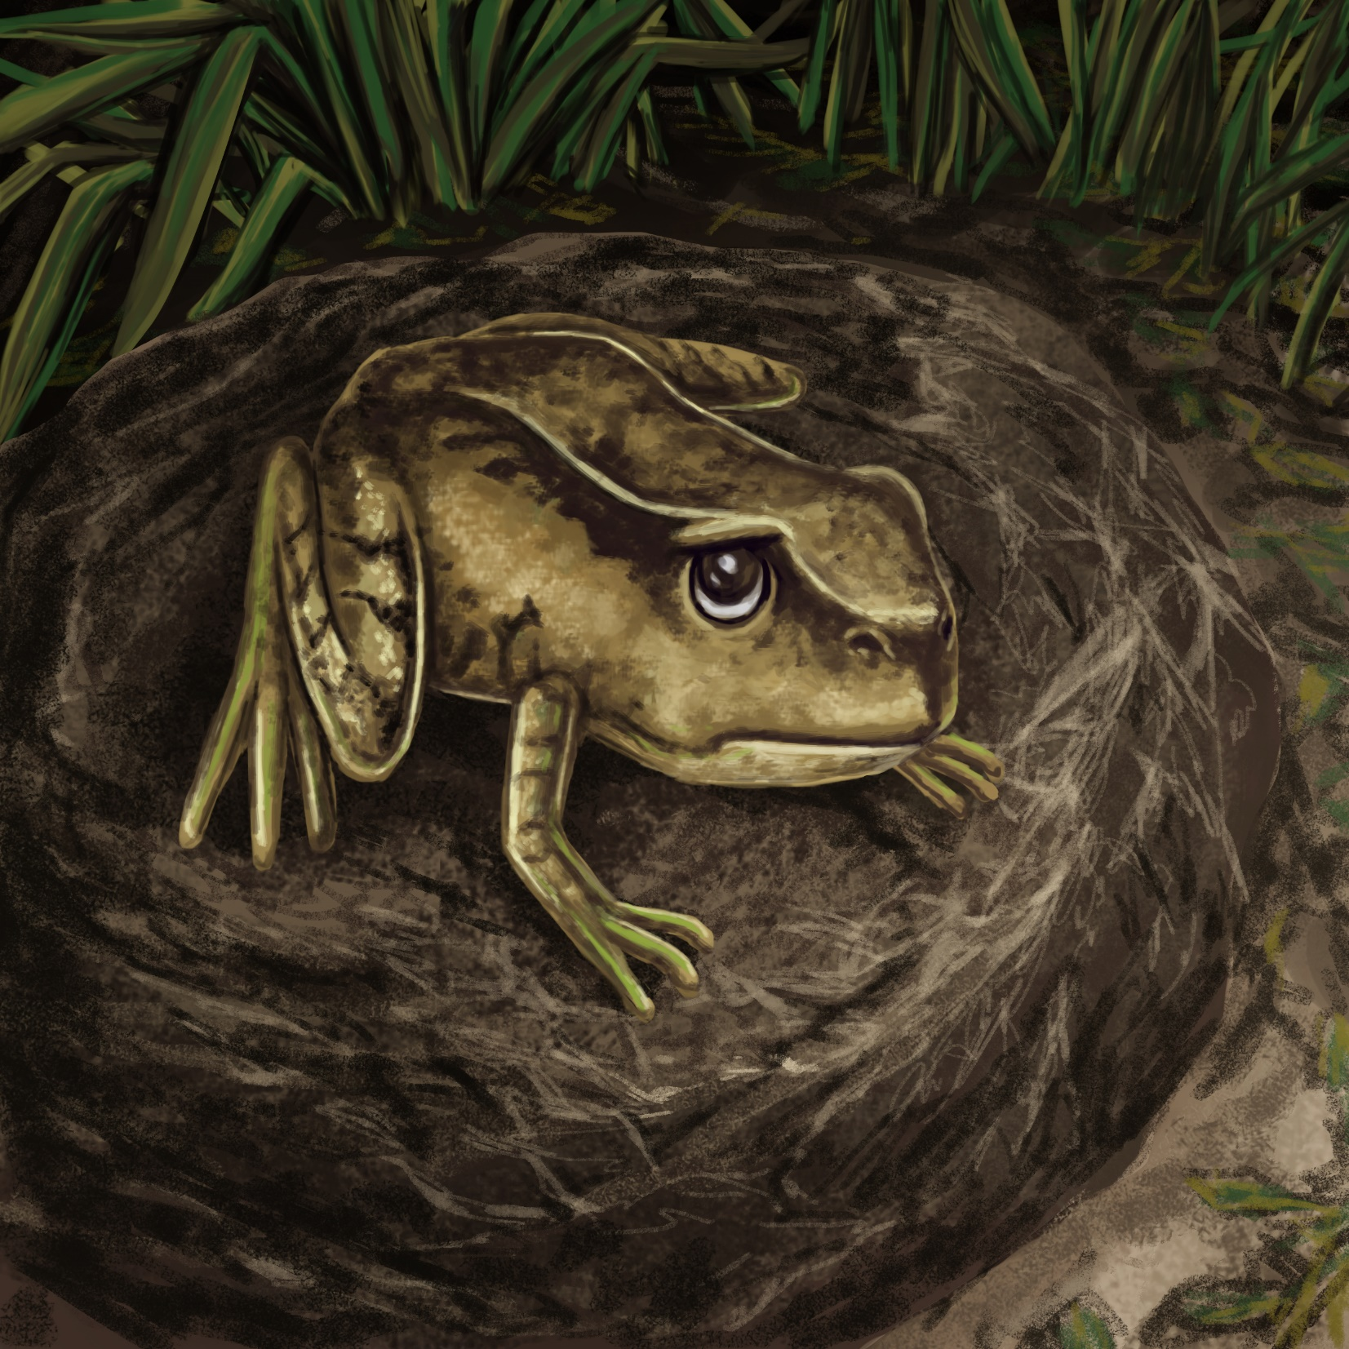

Frog sat on the rock.
“I can swim, I can dash, I can sleep,
but I can not croak,” said Frog.

Frog spoke to Moon.
“I can not croak, Moon,” said Frog.
“Most frogs go croak, croak, croak, but I
do not!”
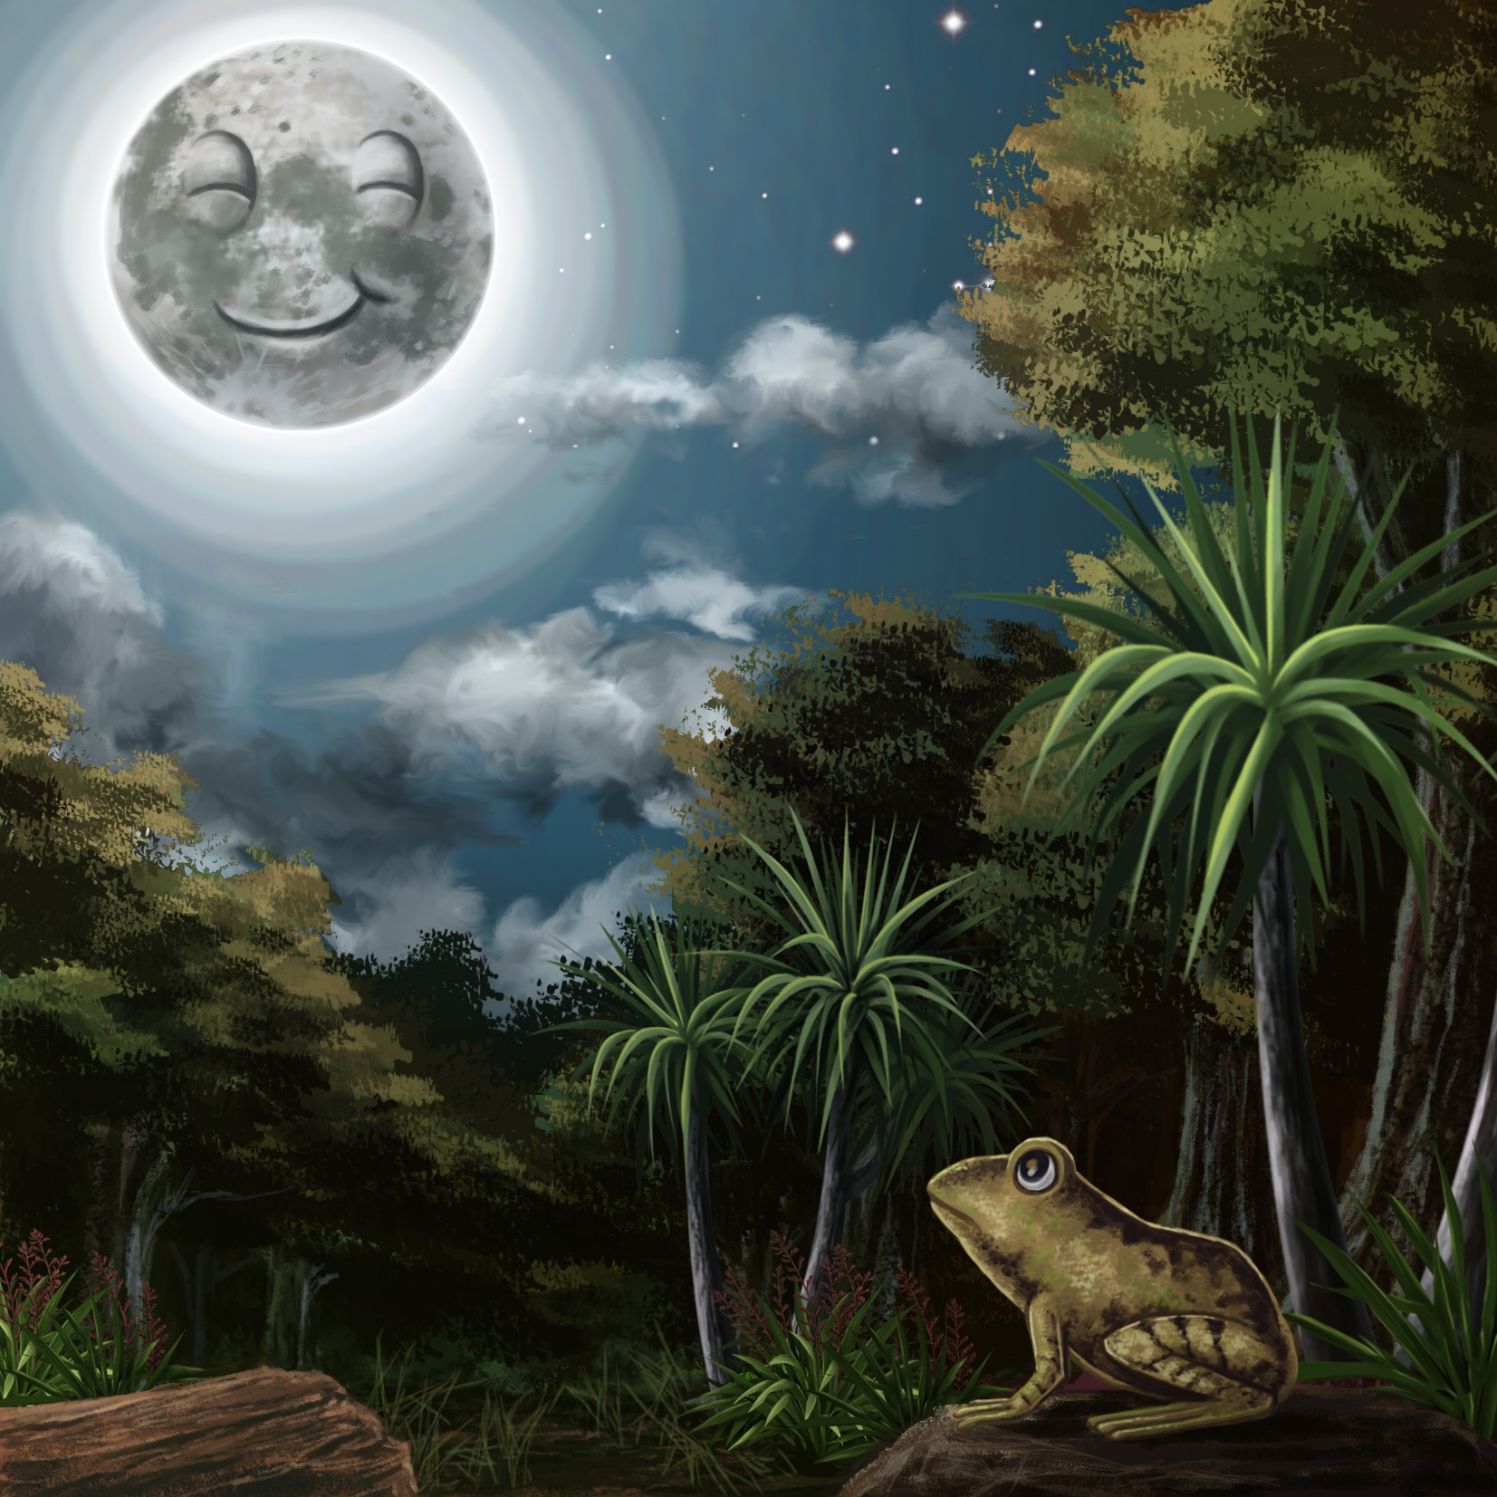

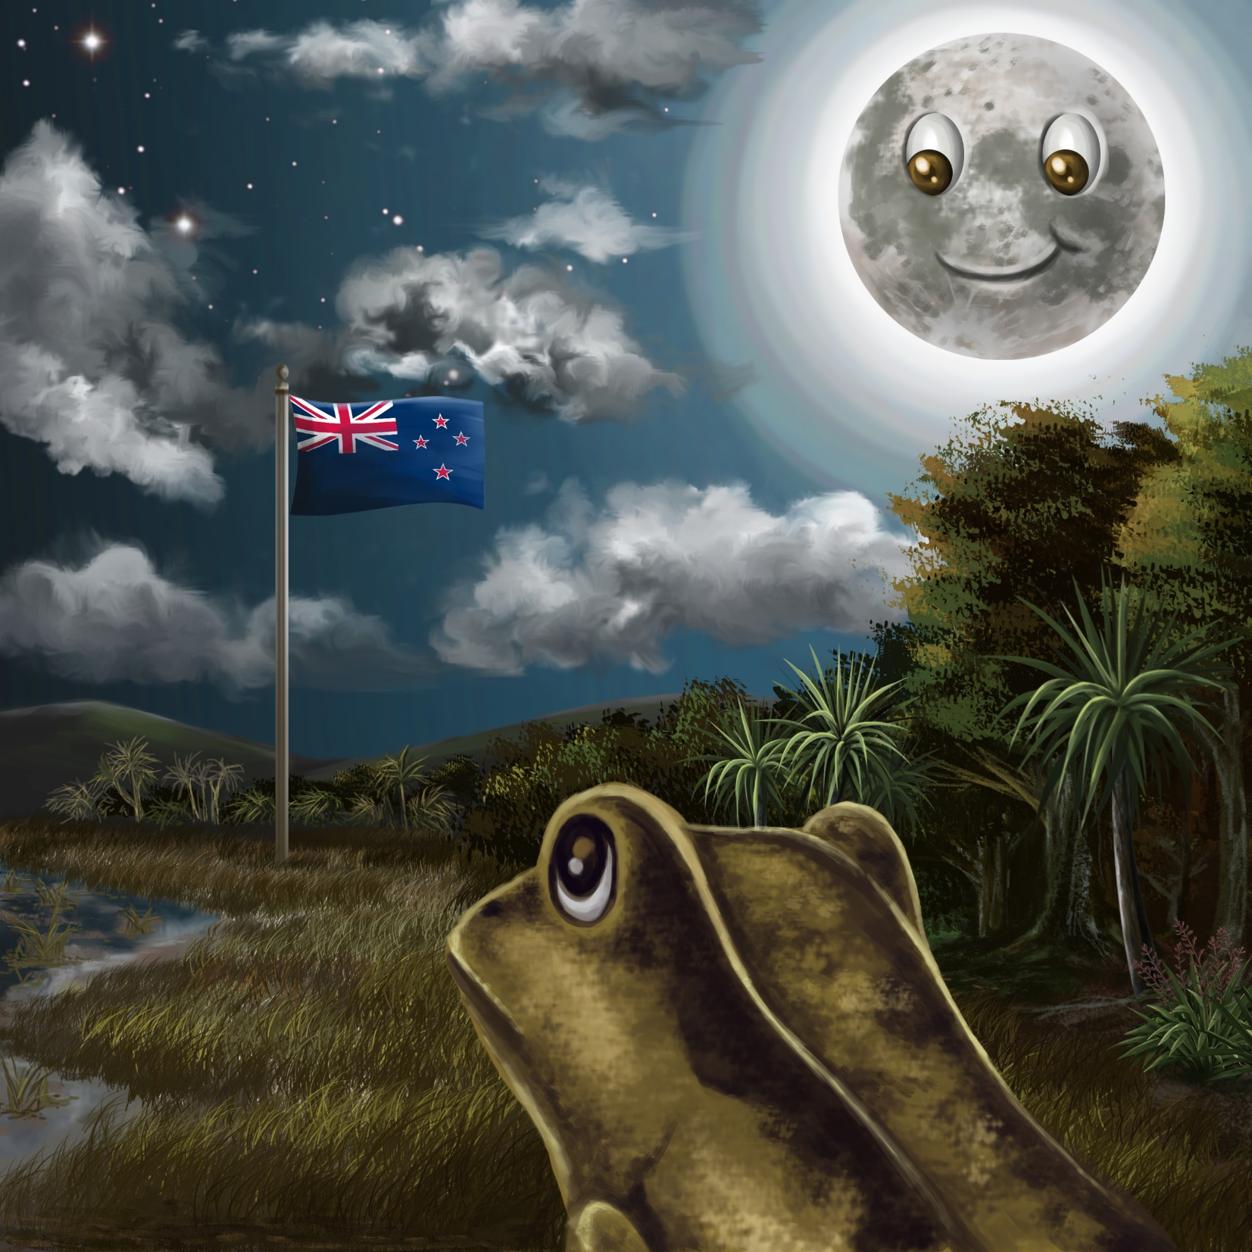

“Your home is
New Zealand,”
said Moon.
“See that flag?
You are not like other frogs.”

“If you do not croak,
the rats will run by,
the cats will go by.
You will be safe,”
said Moon.

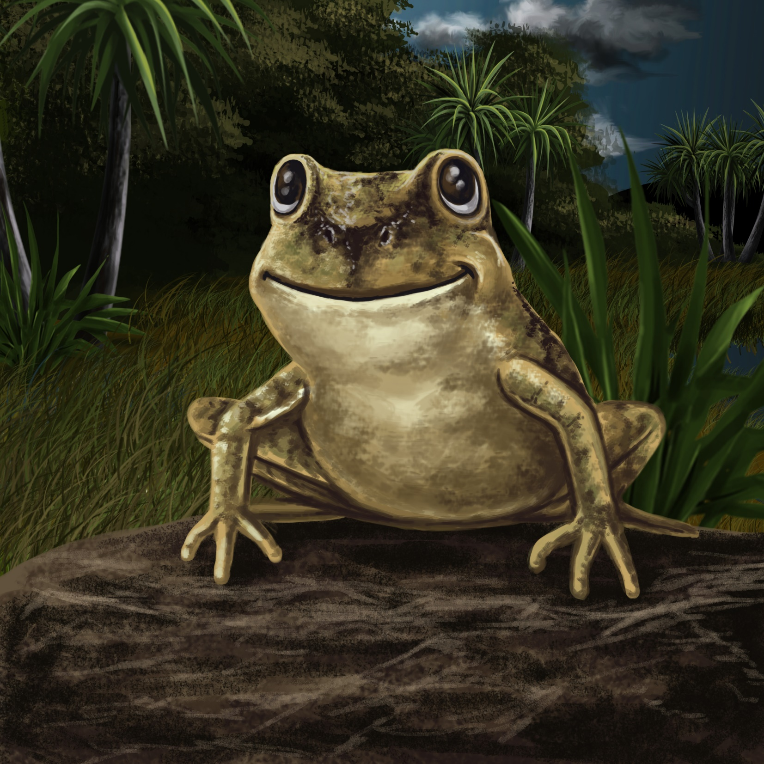

Frog sat on the rock with a smile.
“I like my home in
New Zealand.”
Teaching Notes: Book 12 The New Zealand Frog
Reading Practice: This story provides children with practice in decoding short words with a focus on words that start with f, s, f blends and s blends.

Introduce the text and read the story aloud together, pointing to each word as you read the story. Encourage children to help you “sound out” the regular words in the story. Help children sound out the word and then blend the sounds together, for example, f-r-o-g = frog. When reading unknown high frequency words (e.g., like, the), tell children the words as you read together. Give plenty of praise for children’s reading attempts and encourage re-reading to build fluency and accuracy.

Phonological Awareness
Practice segmenting and blending words. Ask children to clap out each phoneme (sound) in the word: m-oo-n (3 sounds), f-r-o-g (4 sounds), c-a-t-s (4 sounds), s-w-i-m (4 sounds), s-l-ee-p (4 sounds).
Help children to find each word you segment on the page.
Think of all the words you can that start with an s sound and an f sound. Find objects in the room that start with an s sound and an f sound.

Spelling
Listen and identify where the sound change occurs in words. Use the phrasing: “If this word spells rat, can you make it say cat. If this word says cat can you change it to sat”.
Change rat to cat to sat to sap to sip
Change flag to lag to log to flog to flag

Vocabulary
Native New Zealand frogs are nocturnal. This means they are most active at night. Discuss the meaning of the word nocturnal and link to the picture of the moon and the night sky in the story.

Story Discussion
Learn about New Zealand native frogs and why they don’t croak: https://www.doc.govt.nz/nature/native-animals/reptiles-and-frogs/frogs-pepeketua/.

Story Retell
Ask children to re-tell the story to a friend. Prompt as necessary using picture cues. Give plenty of praise and encouragement.
Print Concepts
Discuss use of capital letter for Frog and Moon when used as their name. Bring children’s attention to these words on the page.

