

Mot and the Cap
By Maggie Boston
Illustrations by Susan Trisna

Mot and the Cap
Book 7

This reader for young children is part of a reading series for the Better Start Literacy Approach. Each book provides reading practice for children to decode and understand short words with a focus on target consonants and vowels. The reader has been designed to support class teaching activities that are part of the Better Start Literacy Approach.

The Better Start Literacy Approach has been developed through the University of Canterbury Child Well-being Research Institute. The lead research team includes:
Professor Gail Gillon, Associate Professors Brigid McNeill and Alison Arrow, Drs Amy Scott and Amanda Denston and Professor Angus Macfarlane.

To access these readers online in narrated and book form, please visit https://sites.google.com/view/betterstart-whānau/home and click on the ‘Children’s Readers’ tab.
Published February, 2020, UC Child Well-being Research Institute.



The Better Start Literacy Approach is supported by the
A Better Start National Science Challenge, a 10-year programme of research investigating practical, evidence-based solutions that make a measurable difference for our tamariki. https://www.abetterstart.nz/
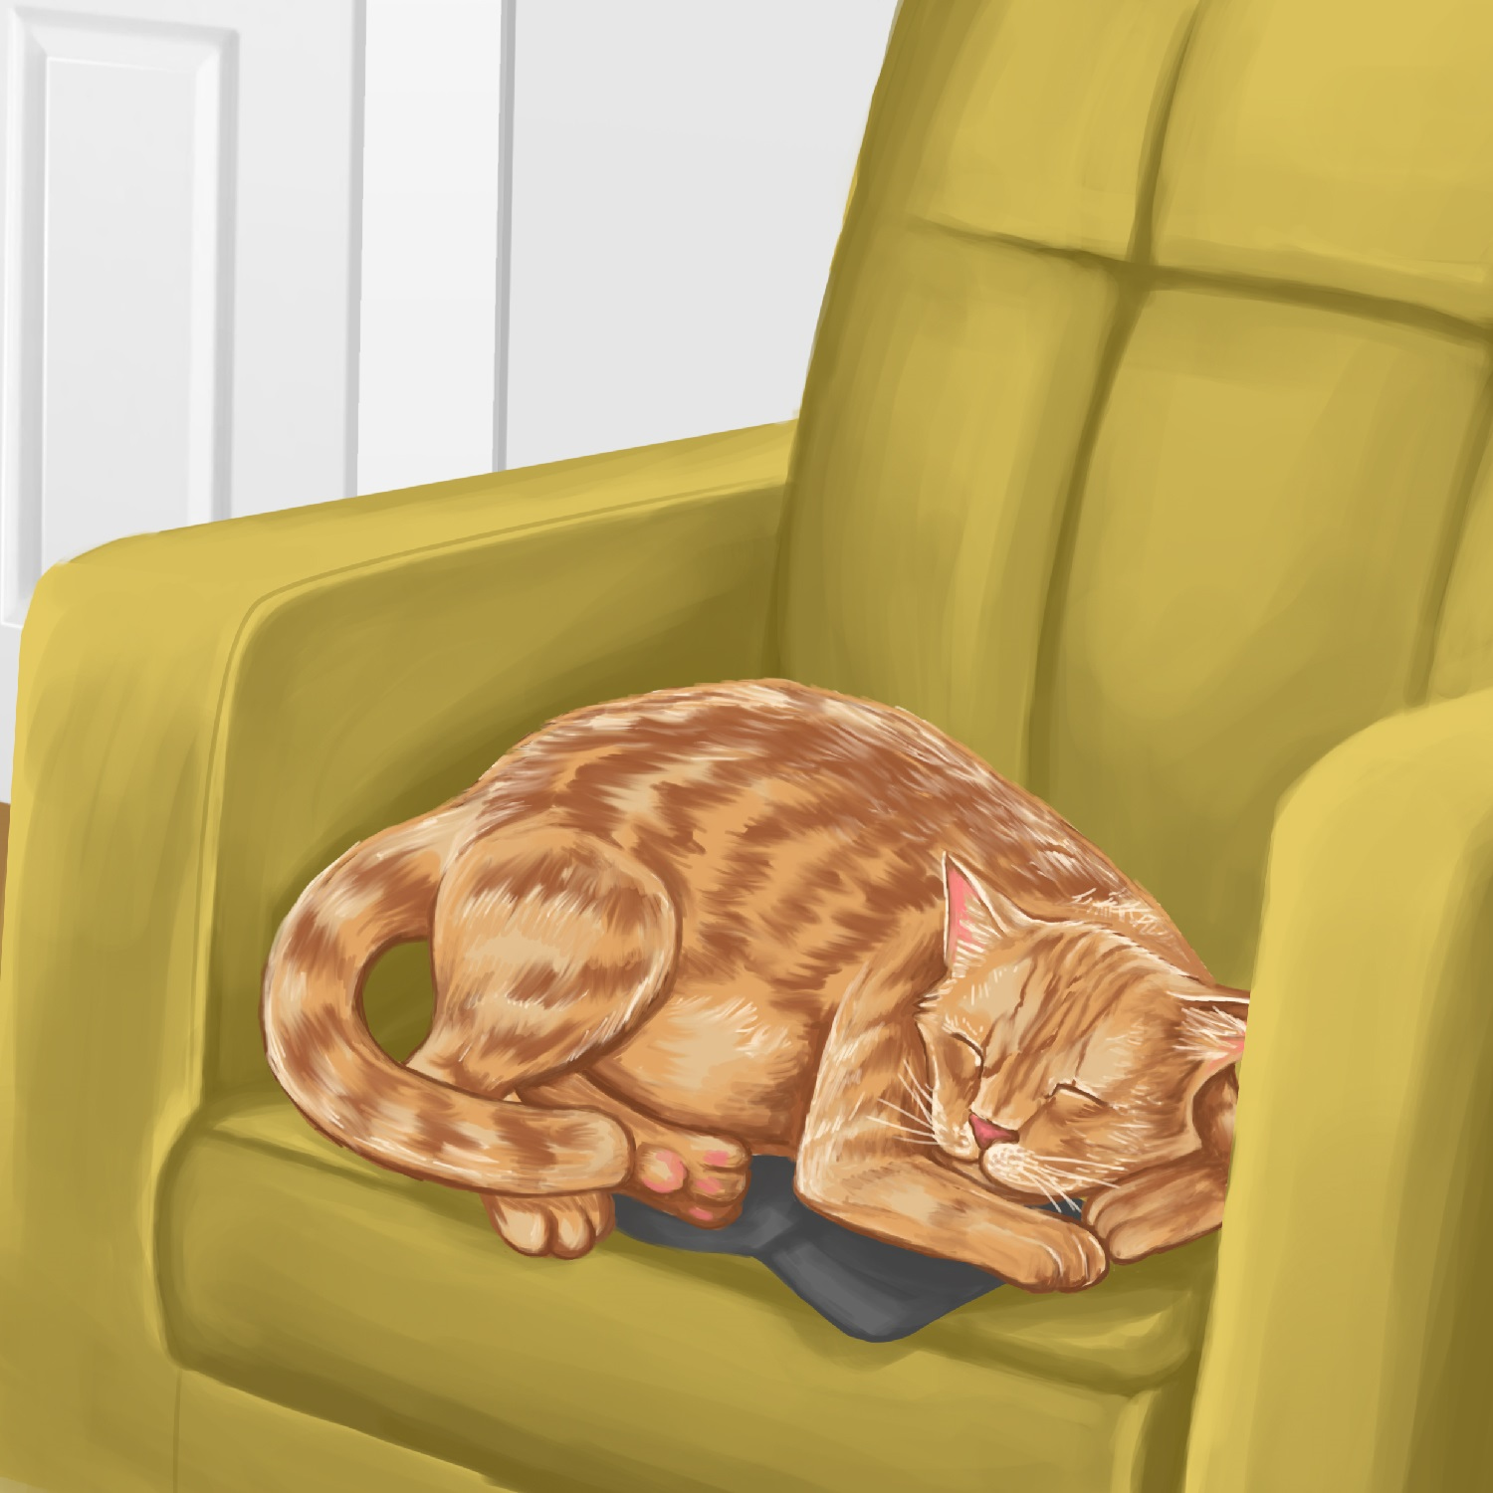

Mot is a cat.
Mot likes to nap.
Mot sat on a cap.
He had a nap.

“I need my cap,” said Dad.
“Let me see.”


“My cap is not in the cup. It is not on the lid,” said Dad.
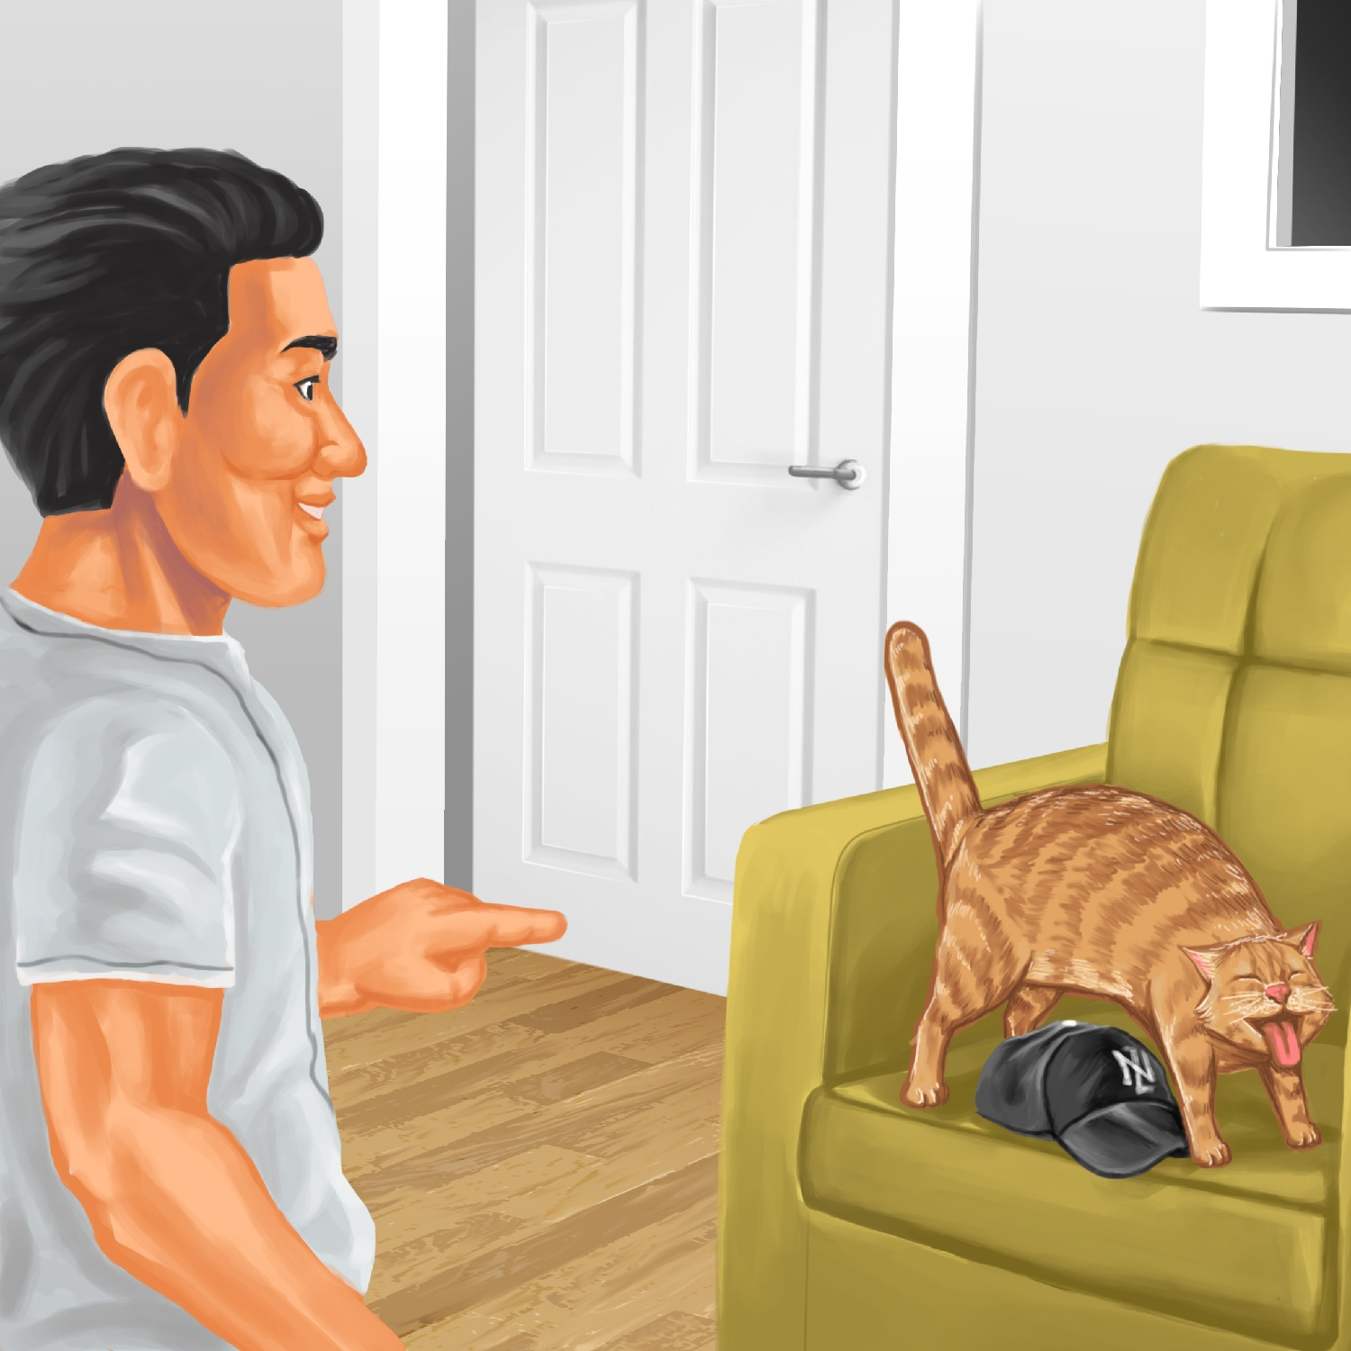

“Look!” said Dad.
“I see my cap.
Mot had a nap on my cap.”
Teaching Notes: Book 7 Mot and the Cap
Reading practice: This story provides children with practice in decoding and understanding short words with a focus on words that start with c and l and includes a, o, and i vowels.

Introduce the text and read the story aloud together, pointing to each word as you read. Encourage children to help you “sound out” the regular words in the story (see words in bold print below). Help children sound out the word and then blend the sounds together, for example, c-a-p = cap. When reading unknown high frequency words (e.g., to, my), tell children the words as you read together. Give plenty of praise for children’s reading attempts and encourage re-reading to build fluency and accuracy.

Mot is a cat.
Mot likes to nap.
Mot sat on a cap.
He had a nap.
“I need my cap,” said Dad.
“Let me see.”
“My cap is not in the cup.
It is not on the lid,” said Dad.
“Look!” said Dad.
“I see my cap.
“Mot had a nap on my cap.”

Phonological Awareness
Practice segmenting and blending words. Ask children to clap out each phoneme (sound) in the word: n-a-p = (3 sounds, 3 claps), c-u-p = (3 sounds), l-i-d = (3 sounds). Help the children find each word you segment on the page.
Think of all the words you can that start with a c or l sound. Find objects in the room that start with a c or l sound.

Spelling
Listen and identify where the sound change occurs in words. Use the phrasing: “If this word spells nap, can you make it say cap. If this word says cap, can you change it to cat”.
Give plenty of praise and encouragement for reading and spelling attempts.
Change nap to cap to cat to mat
Change cap to cat to cot to cop
Vocabulary
Discuss the difference between a cap and a hat.
Discuss other names for hats or clothing you wear on your head: helmet, baby’s bonnet, hijab. The Māori name for hat is pōtae. Look up the internet for the correct pronunciation. Use pōtae in a sentence.
https://kupu.maori.nz/kupu/pōtae

Story Discussion
Discuss why Dad might have needed his cap. Talk about when you need to wear a cap.

Story Retell
Ask the children to re-tell the story to a friend. Prompt as necessary using picture cues. Give plenty of praise and encouragement.

Print Concepts
Discuss the use of quotation marks (or speech marks). We use speech marks when we want to use someone else’s words in our writing.

