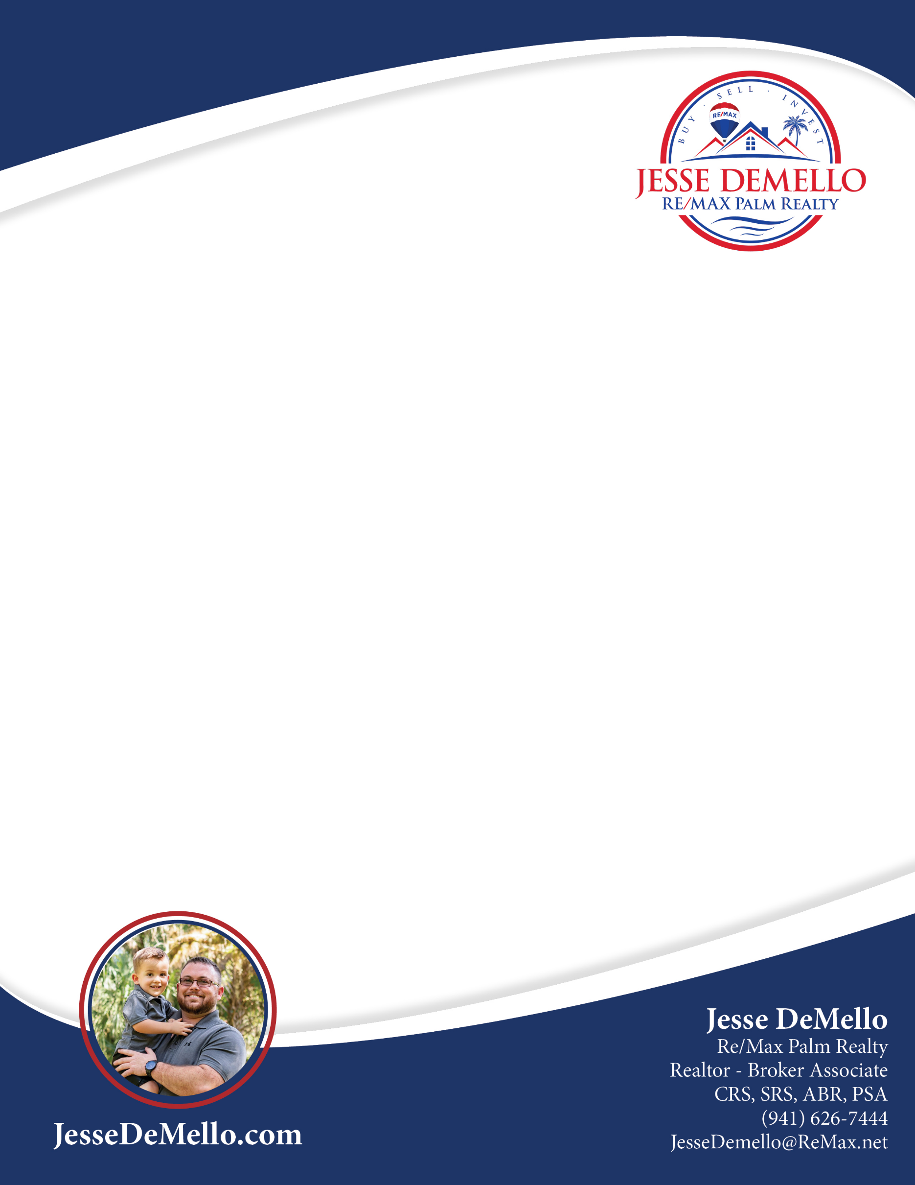
Dear «Owner_Name»,
I hope this letter finds you and that you are having a great day. I have a client that is interested in potentially purchasing your property located at «Property_Address».
If you would be interested in possibly selling this property at fair market value, please reach out to me at your earliest convenience via text, email, or call. Since this buyer is a client of mine there would be NO REALTOR FEES associated with the transaction!
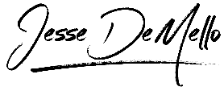
Sincerely,

