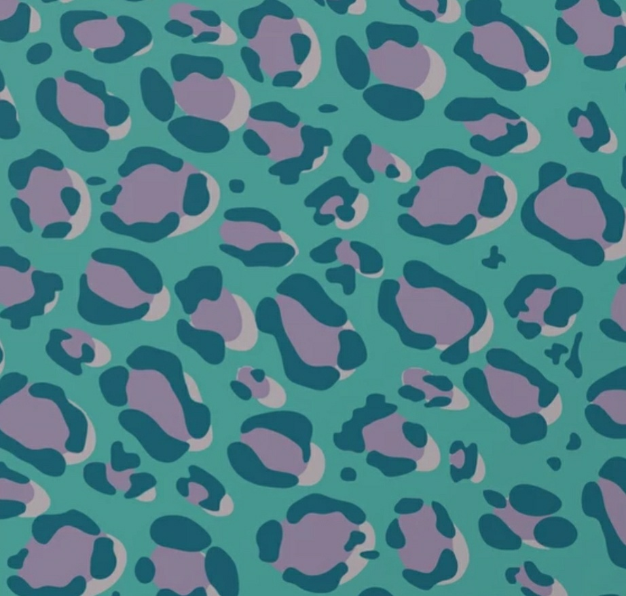

1.Looking for Bold font with the print inside the letters
2. The letters that will be in bold are (P.A.N.)
3. Black shirt and/or Pink shirt pattern
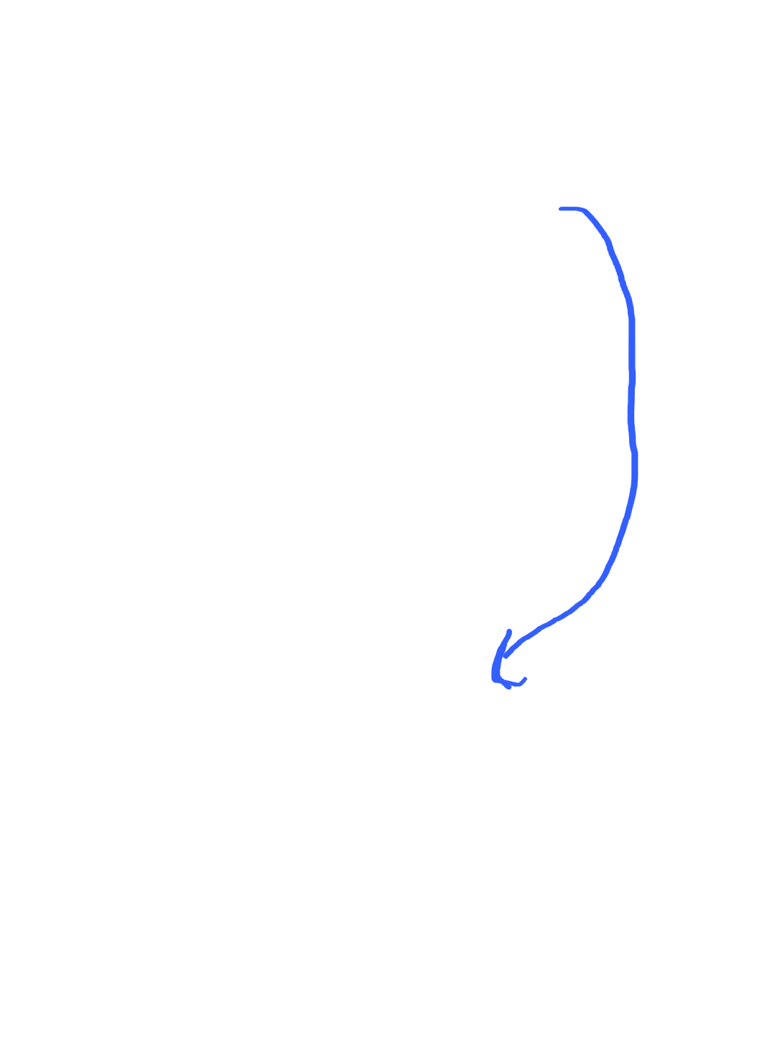
1.Looking for Bold font with the print inside the letters
2. The letters that will be in bold are (P.A.N.)
3. Black shirt and/or Pink shirt pattern

color

