Page 2,

- Re-do all links in the contents links

Page 3,

- Insert my graph

Page 4,

- Make all the vertical lines the same blue colour for all tables (not white/blue/green)
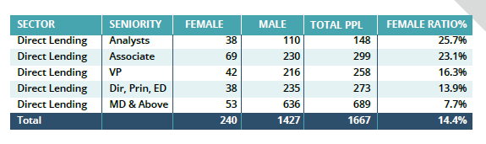

Page 6,

- Change would to ‘may’
- Change can to ‘could’

In this example you would may only need to interview 4 candidates to be able to hire a strong female candidate. You wish to address gender diversity levels in your team which can could be achieved by interviewing 4 candidates.

Page 8,

- Insert my graphs

Page 9,

- Increase the gap between the titles so it is the same size gap as Ethnic diversity

Page 12,

These are all the wrong graphs. You need to insert these:

Direct lending

CLOS

DISTRESSED

BANKS & ADVISORY

Page 14,

- Unbold the text

- Replace your graph with mine.

