We require 4 images that will sit on this webpage > https://wp.eldo.dev/products/
and will also appear on the Products menu, as below:
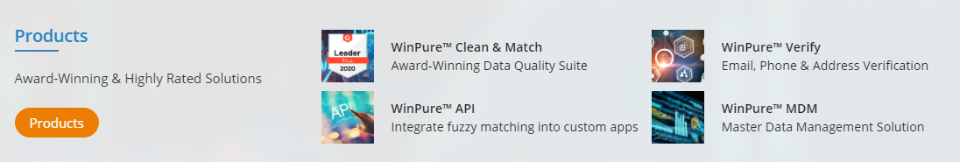

Each image to ideally reflect each of the following products:

WinPure™ Clean & Match - Award-Winning Data Quality Suite. This product performs functions such as data cleansing and data matching. Here is an intro video to learn more > https://youtu.be/8qT6jSJKhGU

WinPure™ Verify - Email, Phone & Address Verification. This product is used to determine if an email address, phone or address is actually valid and correct

WinPure™ API - Integrate data management into your solutions. This product is used by programmers to help create tools like the WinPure™ Clean & Match above

WinPure™ MDM - Master Data Management Solution – This is a complete data management solution that aligns with a business requirement to achieve a single view of their data with functions and features to help them manage all there data.

This company did a similar project for 4 of their products > https://www.dqglobal.com/products/

Ideally this will blend nicely with our new website but we are open to creative designs that will look great and help differentiate our products.

The winner of this I would also like to do other design for the website.

If you need any further clarification about anything on here please let me know

