Graphics Design Brief
All images to have look and feel of van in image below. Facing as per sample images:
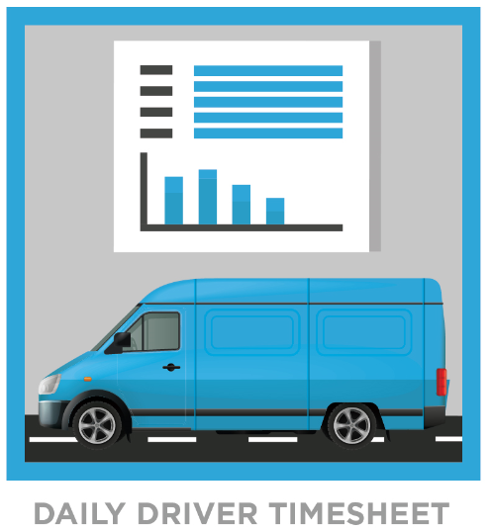

Images to be laid out one under the other.
Colours:
Navy Blue used:
PANTONE Reflex Blue CVC
RGB 57, 73, 156
Gray used on text:
PANTONE Warm Gray 5 CVC
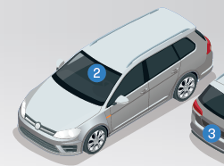
Passenger Vehicle -Single Camera
Notes: remove partial image of 2nd vehicle. Blue circle should be number 1
Single car only image. Blue circle to have number 1 NOT 2
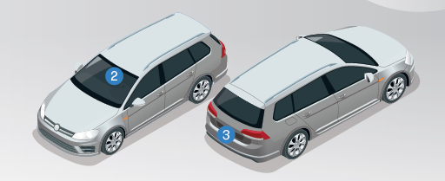
Passenger Vehicle -Dual Cameras: Front & Rear
Notes: Blue circles should be numbered 1 & 2

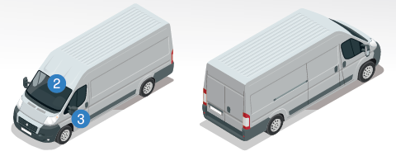
Commercial Vehicle -Dual Cameras: Front & Side
Notes: Blue circles should be numbered 1 & 2

Commercial Vehicle -Dual Cameras: Front & Rear
Notes: circle with 2 to be placed on rear of second van image. Blue circles should be numbered 1 & 2

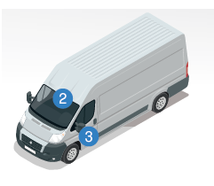
Commercial Vehicle -Dual Cameras: Front & Driver Facing
Blue circles should be numbered 1 & 2 and both on windscreen

