DESIGN BRIEF – 2020 FILM
  - Motoitoi

TITLE
Motoitoi

TAGLINE
Dedicated to the descendants of Motoitoi and Pilot Richard Driver
Wherever you may be, throughout the world.

DESCRIPTION
Motoitoi explores the untold story of the high-born daughter of a prominent Māori Chief. Born during the first contact period of Southern New Zealand, Motoitoi is said to have lived with Richard Driver, an English whaler, in a cave overlooking the beautiful South Pacific Ocean.

The film tells the story a young Kāi Tahu woman, whose life and legacy; from the signing of The Treaty of Waitangi, until now; has touched many cultural and historical milestones that shaped the New Zealand society of today.

Motoitoi is a compelling saga that unveils a local tale of cultural conflict, resilience and gradual resurrection, enabling viewers to discover the importance of whakapapa, whanaungatanga, and kaitiakitanga in the age of Facebook, TikTok, and Instagram.

Tē Pūrākaunui Rōpu Kaupapa gratefully acknowledges funding support from:
- Department of Conservation – Mātauranga Kura Taiao Fund
- Dunedin City Council Arts Grant
- Lotteries Environment and Heritage Fund
- Methodist Pūtea Grant – Te Rūnanga o Ōtākou
- Ministry for Culture and Heritage – WAI175 Oral History Award
- Te Rūnanga o Ngāi Tahu – Ngāi Tahu Fund
- Otago Community Trust
- Stout Trust
- Te Puni Kōkiri – Te Pūtake o te Riri: Wars and Conflicts in NZ Fund
- Te Pūtahitanga o te Waipounamu, and
- The many private donors and volunteers who supported us. Thank you.

Director/ Producer: Lorna Kirk
Writer/ Assistant Director: Roy MacLaren
Executive Producer: Nicola Taylor
Associate Producer: Will Taylor
Editor: Dominique Sicotte
Director of Photography: Mark Hammond
Additional Camera: Kyle Cameron, Lorna Kirk
Drone Operator: Aaron McGrouther

INTRODUCING:
Talia Ellison as Motoitoi

The film is for sale and rent through our website – https://motoitoi.com/
Contact Us – info@motoitoi.com

Produced by Over The Moon Productions for Tē Pūrākaunui Rōpu Kaupapa.
Copyright 2020.

RELEASE YEAR
2020

GENRE
Documentary

PROJECT LOGO
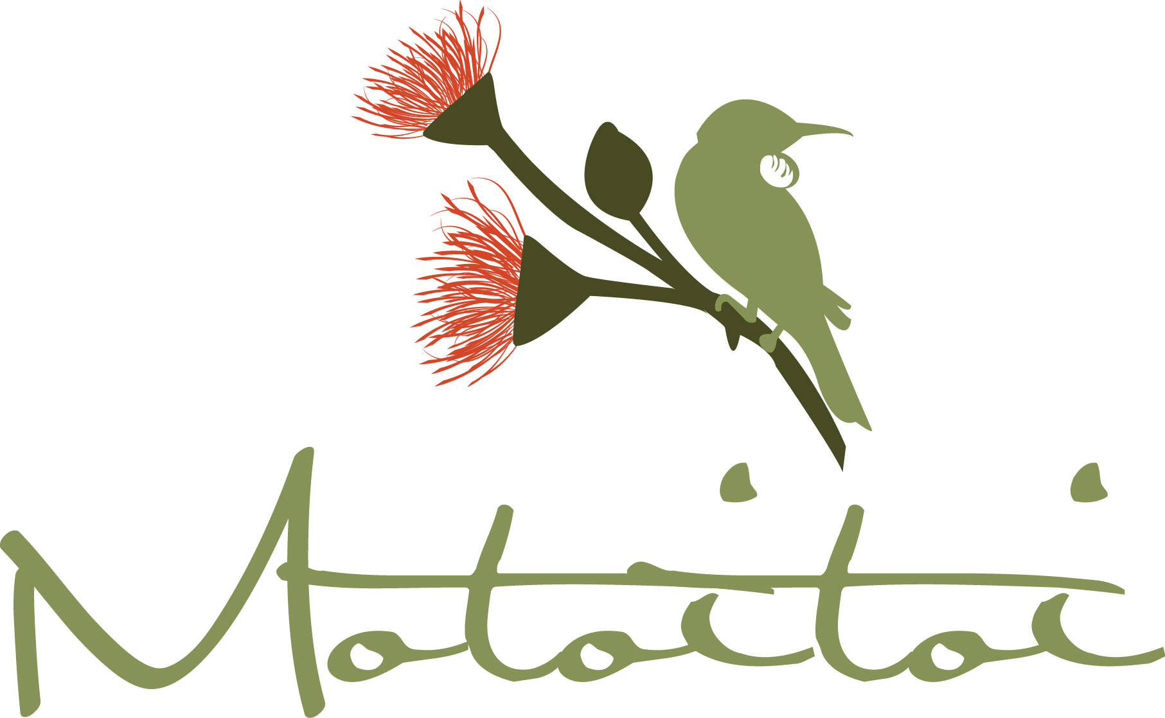
(Previous DesignCrowd project. Source files available on request).

