Character Accessories

Shoes – Gigi loves her shoes – Some ideas below ( I refer to LOL dolls) they are the perfect size.

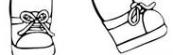Basic sneaker

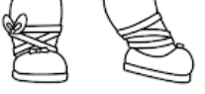 Ballerina Shoe

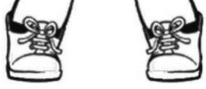 Work boots

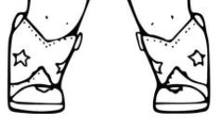Cowgirl boots

Please note the above images are just to provide you with an idea of what accessories I would like the character to have.

