//FIRST PAGE://
//flyer title: //SPECIMEN & TEST SAMPLE MACHINING FROM AEROSPACE GRADE MATERIALS
//photo: “turbo.jpg”//
//bottom bar:// https://test.coupons
//replace Salloytech logo with test.coupons //

//SECOND PAGE://

//Citation//
“A test coupon or simply a coupon is a small sample of the material used to obtain data of specific properties after the testing. More often it is called a specimen or just a sample.”

//Citation should be connected with the picture of test_coupons.png or IMG_9816.jpg//
---------------------------------------------------------

Our Advantages

Quality Assurance
We maintain Quality Management System in accordance with ISO 9001: 2015 and AS 9100D: 2016 by qualified staff of internal auditors.

Manufacturing processes
Using modern machining, loss and additive methods we ensure optimum price / performance ratio while meeting all requirements of the project.

In-time Delivery
Reliable processing from the design phase to the delivery to Customer through the Just-in-Time method.

// Graphics for this section need to be taken from www.salloytech.com //

-----------------------------------------------------------------

test.coupons is a product line of specimens, samples and coupons machined from difficult-to-machine aerospace grade materials such as nickel & cobalt base superalloys, titanium, and hardened steel. The brand is based on experience and know-how of Salloytech company.

Our experience includes manufacturing the specimens:

- Adhesion, cohesion & bond strength test of coating
- Tensile test
- Hardness test
- Microstructure evaluation
- Fatigue Test
- Lap Shear Test
- Bend Test
- Erosion Test
- Stress Corrosion Test
- Hoffman Scratch Test
- The Cyclic Furnace Oxidation Test (FCT)

// Please make a space for about 5-6 more positions in listing //

// Please cut pictures of the parts from the movie and connect corresponding name with the picture of the part

https://studiorondo.pl/clients/salloytech/emisja/old/salloytech_test.coupons_brand_EMISJA_HD_h264_50Mbps.mp4

Please update the list with names from the movie.
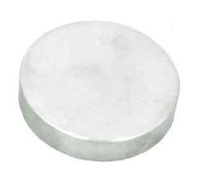
Example:

• Adhesion, cohesion & bond strength test of coating -

//

Test specimens manufactured by our developed technologies will allow you to:

• Obtain better test results for process qualification
• Improve reduced testing and sampling plan
• Stabilize statistical process control indicators
• Decrease warehouse inventory
• Receive continuous and timely deliveries

We guarantee delivery of high quality and functional products as a result of:
• Years of experience of manufacturing and testing in the aerospace industry, mainly surface engineering allow us to provide specimens with the highest quality requirements
• ISO 9001:2015 certification for “
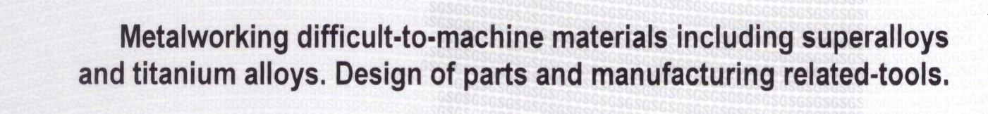”
• proven machining processes of nickel & cobalt base superalloys, titanium, and hardened steel
• fixed manufacturing processes for specimens preparation

Test coupons also called “test buttons” for tensile / bond strength test of coatings are our flagship product. We know how many variables are in testing and we do our best to minimize their influence on the test results.
Thanks to our proprietary manufacturing process we can make test buttons with tight tolerances up to 0.0004 inch or 0.01 mm TIR of:

flatness of flat surfaces

parallelism of flat surfaces
outside diameter
and with:
similar surface finish as the part
for the good roughness correlation of the part and the specimen after grit blasting.

The results of the fabrication are:

TENSILE / BOND STRENGTH OF COATING TEST COUPON/BUTTON

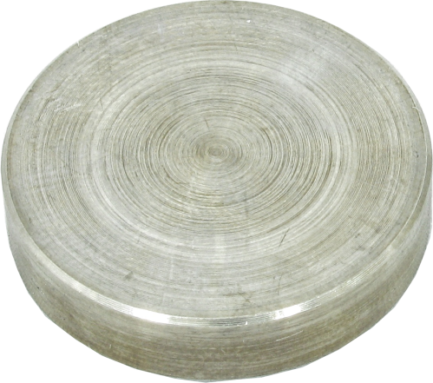
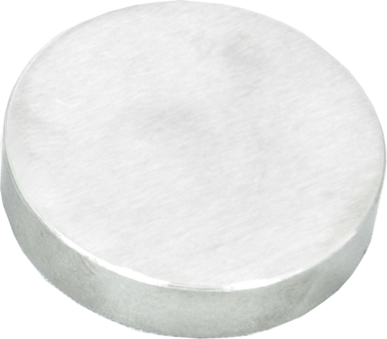
additional material tip
Salloytech fabrication
Conventional machining by turning

Furthermore, our quality inspection staff check each one of them.
Why to use tight tolerance test coupons?
Thermal Spray facilities especially in aerospace industry often need to check coating quality on test specimens by destructive tests e.g. tensile / bond strength test. This need to be done for basically three reasons:
- to obtain approval for coating in qualification process,
- continuous monitor of coating consistency,
- decrease the frequency of testing according to Reduced Testing / Sampling procedure.
The acceptance or magnitude of above activities often depends on a process capability / performance index C_{PK} / P_{PK} calculated with the test results during Statistical Process Control e.g. the more stable test results are the higher testing reduction can be obtained and maintained. There are many factors of test results variation but one of them is quality of test specimens – and here we have a solution for your facility. Using our made test buttons you can:
- obtain better test results for coating qualification,
- improve reduced testing and hold it on a high level.
Please see a visualisation on the graph below.

BATCH NUMBER
High
P_{PK}/C_{PK}

-----------------------
Please insert this section from the email graphic:

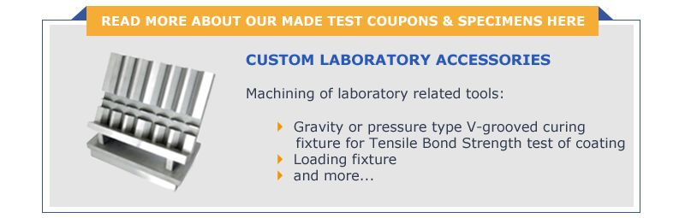

------------------------------

Please feel free to contact us if you have any questions or need further information. It will be pleasure for us to provide free samples of test coupons for your needs.

test.coupons
Salloytech Sp. z o.o.
ul. Andrzeja Sołtana 7 bud. 3AB
05-400 Otwock, Poland
phone: +48 22 308 00 88
mobile: +48 570 070 033
email: info@salloytech.com

