Need “Two” Trifold brochures.
1# will be for Pharmaceutical and Biotech companies. (stock photos and copy should be ALL pharma and biotech related.
#2 will be for food and beverage processing, Packaging & Distribution Center, Automotive, Chemical, Consumer Electronics, Government, Pulp & paper, Oil/Gas, Security & Detention, Water & Wastewater

I have attached stock photo for you to use. But please do not feel limited to these. Please see company web page for a good idea of what we do and use the photos on the website. https://falcoautomation.com

I will be sending you copy to place in the brochures. We like your Apex Automation design, so please present it as one of your samples.

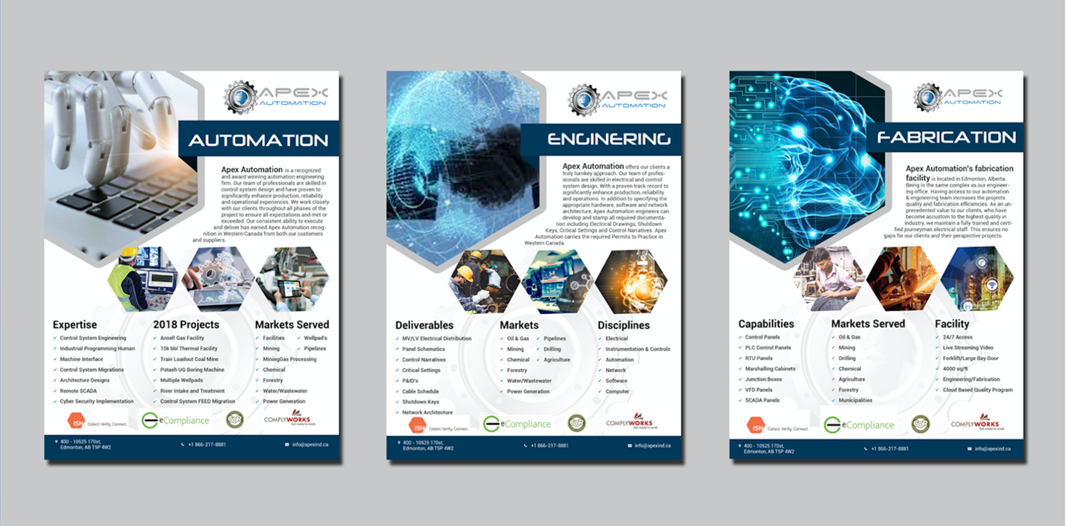

Would also like to see a more simple, clean, minimalist layout with less photos. (See below)

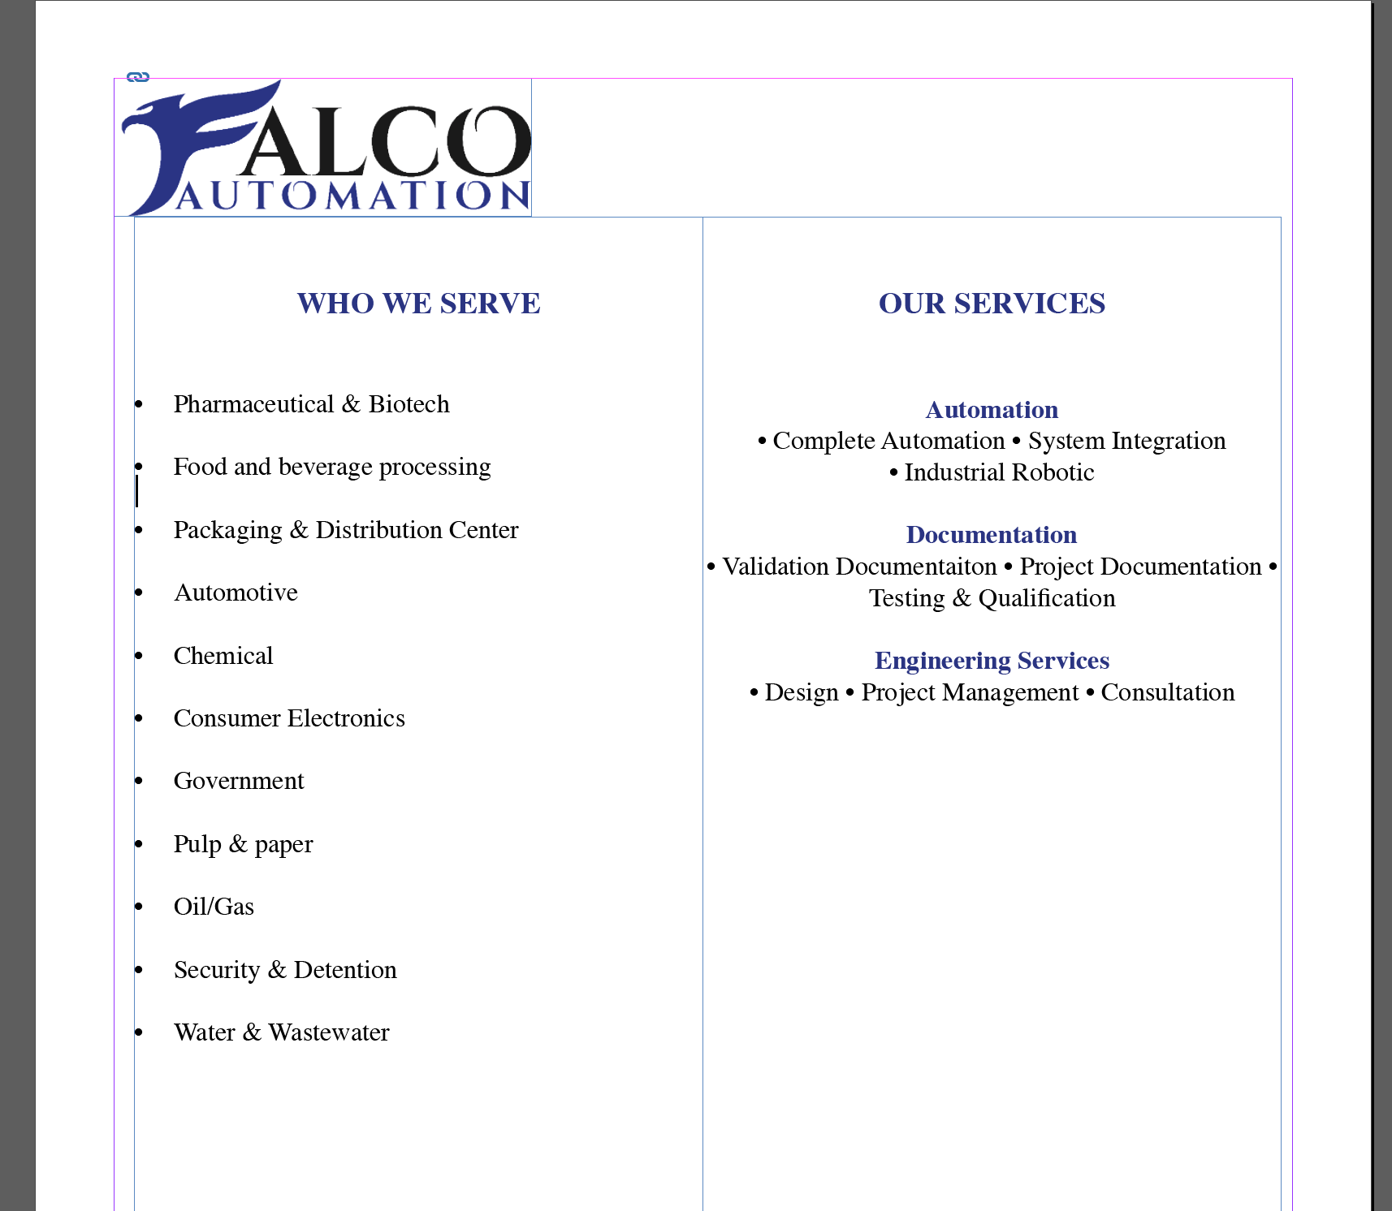

Here are some other examples I found on the internet to give you a good idea of what we are looking to do – please incorporate company colors. (see vectored files sent) Importantly we wish to promote SCADA https://en.wikipedia.org/wiki/SCADA Word.doc attached. Stock photos for SCADA should be incorporated in these designs.

Any questions? Please reach out to me at todd.dale@me.com

Thank you!

