Inside Left
Our Services

BOOKKEEPING

​Let us take over the day to day bookkeeping so you can get back to running your business. We offer QuickBooks Online setup and ongoing bookkeeping, including daily journal entries, accounts payables & receivables, bill pay, sales tax reporting & payments, account reconciliation, and more.

FINANCIAL REPORTING
We'll provide easy to understand financial reports that allow you and your team to manage cash flow, create budgets and make forecasting decisions. Want real time data? Let us provide solutions with the latest in mobile apps and dashboards.

PAYROLL PROCESSING
Whether you have 5 employees or 100+, payroll can be an overwhelming and time consuming task. We offer full service payroll processing, including employee onboarding and reporting.

Inside Middle
Infographic
Outsourcing with Top Marks Accounting
vs
Hiring an in-house employee
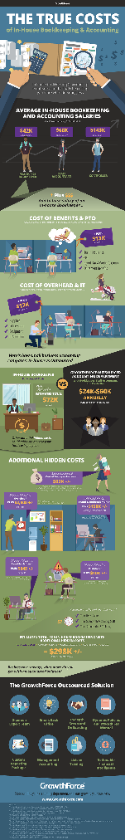

Inside Right
Price List

STARTER
Bookkeeping for businesses with monthly expenses under $25k
*transaction volume not to exceed 100/mo
From:
$750/mo

MID-LEVEL
Bookkeeping for businesses with monthly expenses under $50k
*transaction volume not to exceed 250/mo
From:
$1250/mo

EXECUTIVE
Bookkeeping for businesses with monthly expenses over $50k
*transaction volume over 250/mo
From:
$1750/mo

Outside Fold
Benefits of QBO
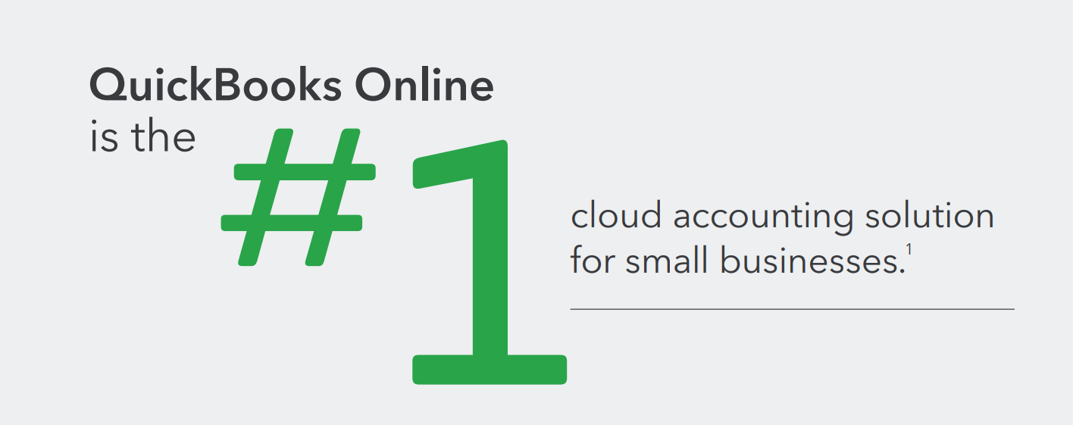
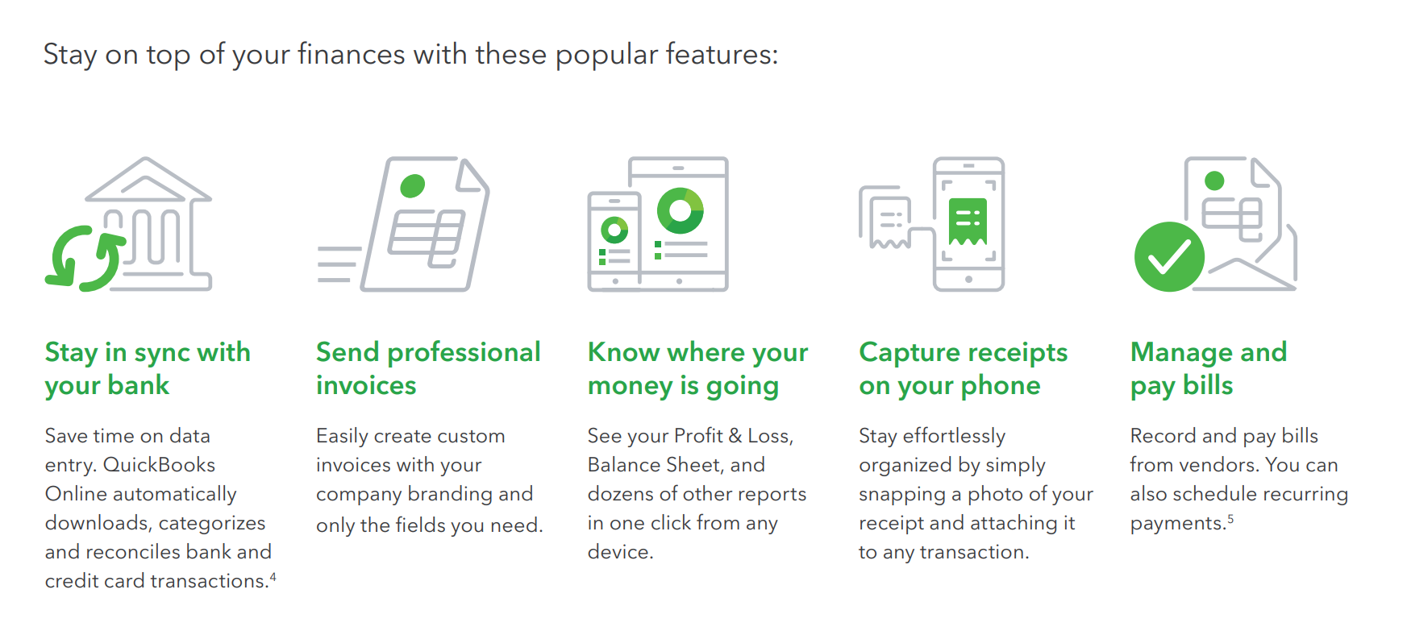
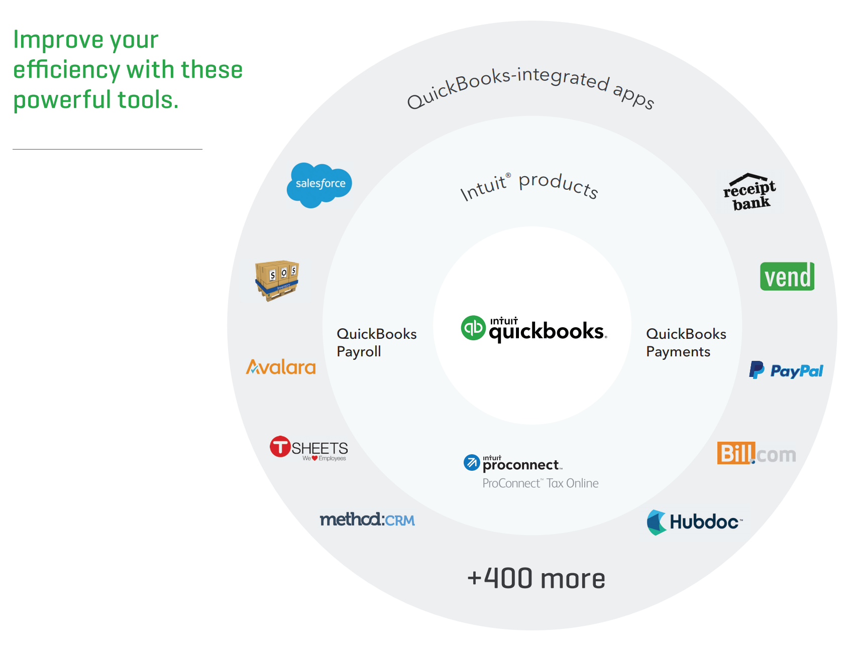

Our Certified QuickBooks ProAdvisors have the Knowledge and Expertise to Ensure Professional, Accurate, High Quality Service.
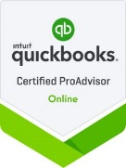
Outside Back Cover
About Us and Contact Info

Lydia Warmsley
Founder & CEO

OUR VISION
At Top Marks Accounting we have one mission in mind... to improve the quality, accuracy and efficiency of your business's back-end bookkeeping and payroll processing, so that you can focus on the nuts and bolts of your day to day operations.

Founded by a former CFO in the San Francisco Bay Area, we bring a team of accounting professionals with over 20 years of expertise from one of the most competitive markets in the world.

We bring knowledge, insight and guidance to your business, offering value for time and money.



Outside Front Cover
Logo, etc

ACCOUNTING FOR YOUR BUSINESS
Specializing in Cloud-Based
Bookkeeping & Payroll Processing with Quickbooks Online by Intuit.



