

Installation Examples

Courtney Gardens Primary School

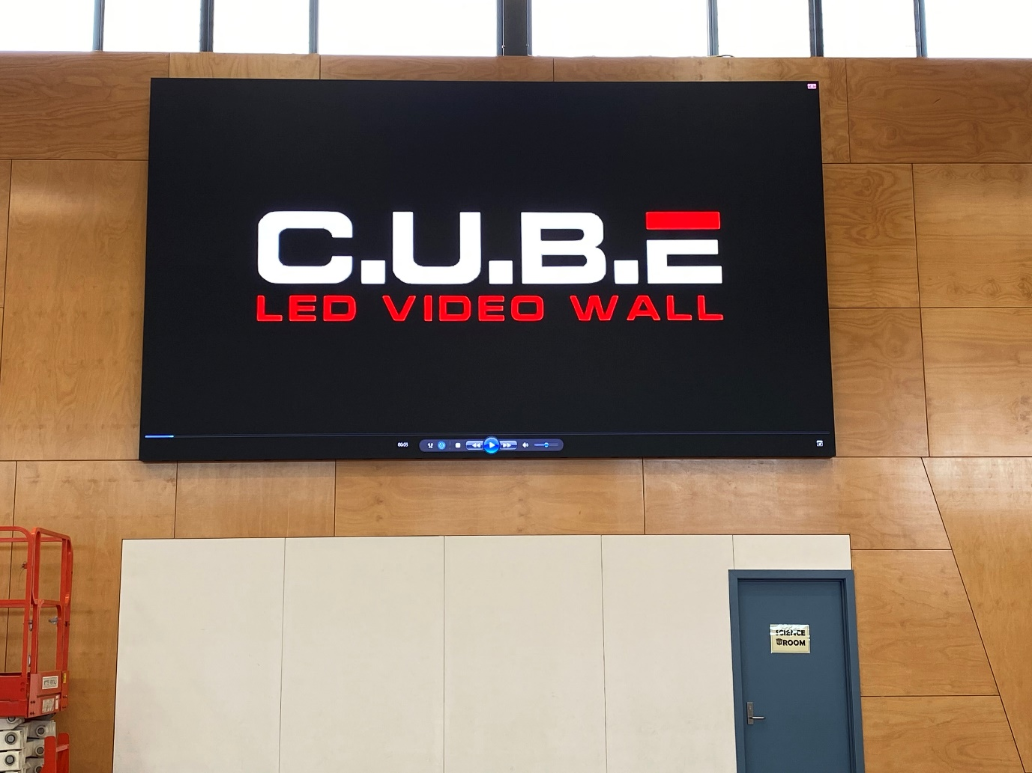

P3, 5376 x 3072mm CUBE
Equipment Rack
2x powered array speakers
2x Wireless Mics
8 channel mixer
$58,154.35+GST

Boronia Heights Primary School

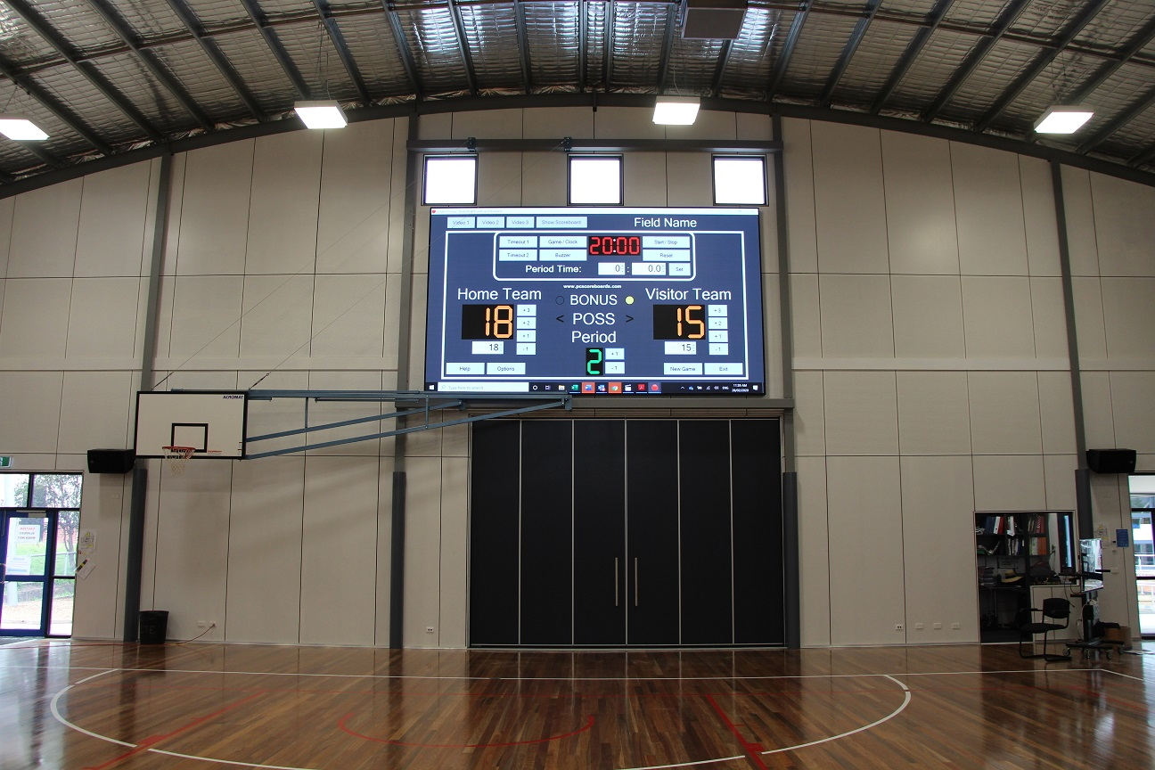

P3, 5376 x 3072mm CUBE
HDMI extender kit
iPad control
HDMI switcher
Wireless streaming
$63,000+GST

Lara Lake Primary School

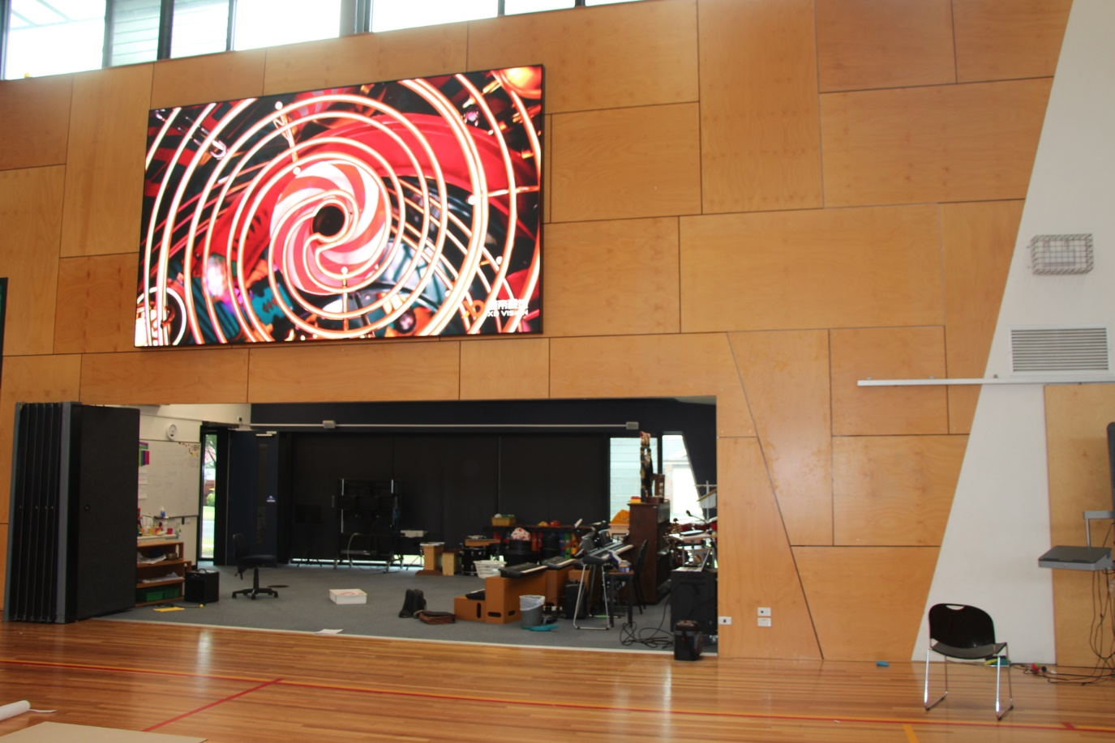

P3, 4608 x 2688mm CUBE
9 channel mixer
2x wireless mics
Existing amp / speakers
$51,401.93

Sunshine College

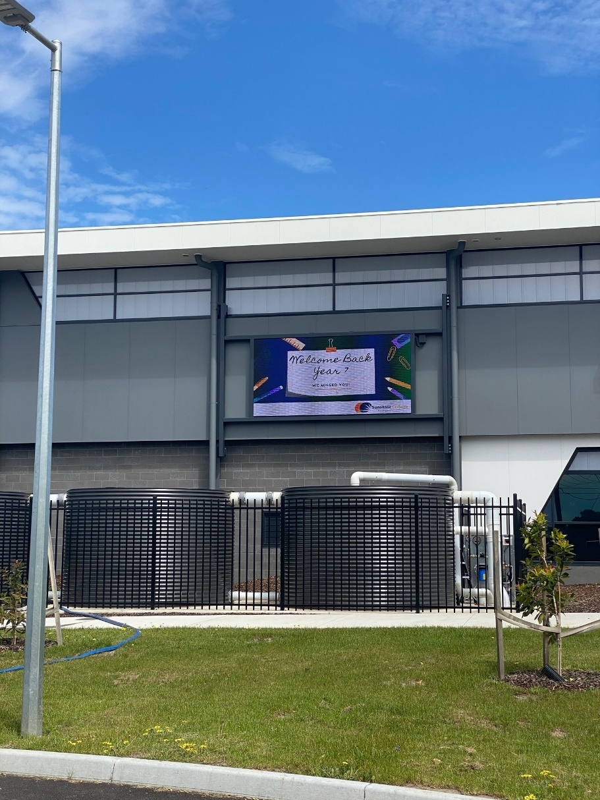

P10, 3840 x 1920mm CUBE
Digital signage media player
$40,570.05+GST

Sunshine College

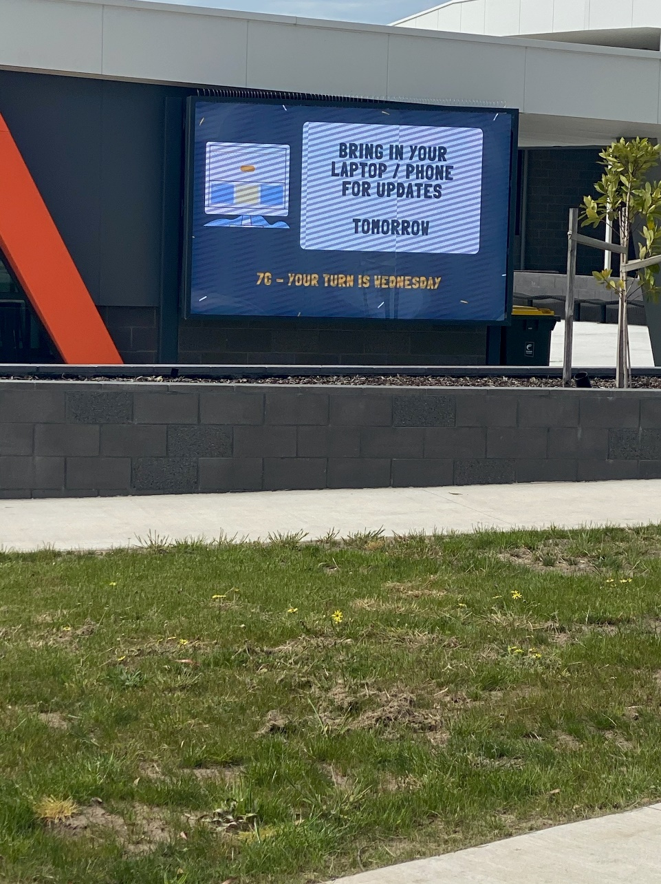

P3, 2688 x 1728mm CUBE
Digital signage player
$41,128+GST

Sunshine College

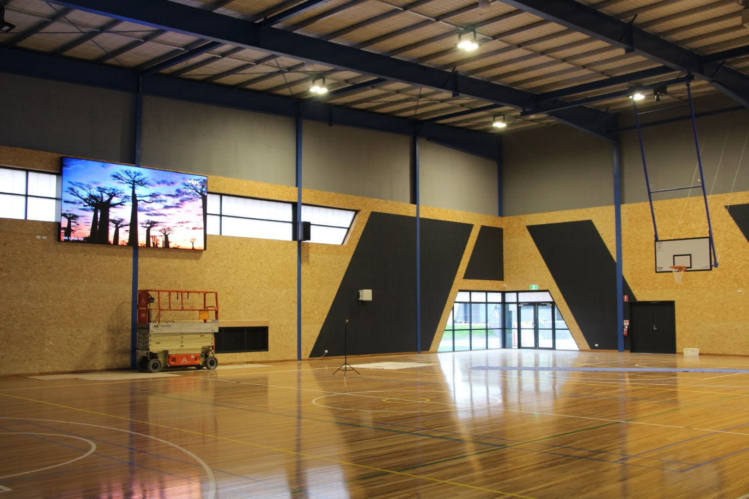

P3, 4608 x 2304mm CUBE
9 channel mixer
HDMI switcher
Equipment Rack
Wireless presentation
HDMI extension kit
2x wireless mics
In wall touchscreen controller
2x Bose speaker array
$68,176.64

Norwood Secondary College

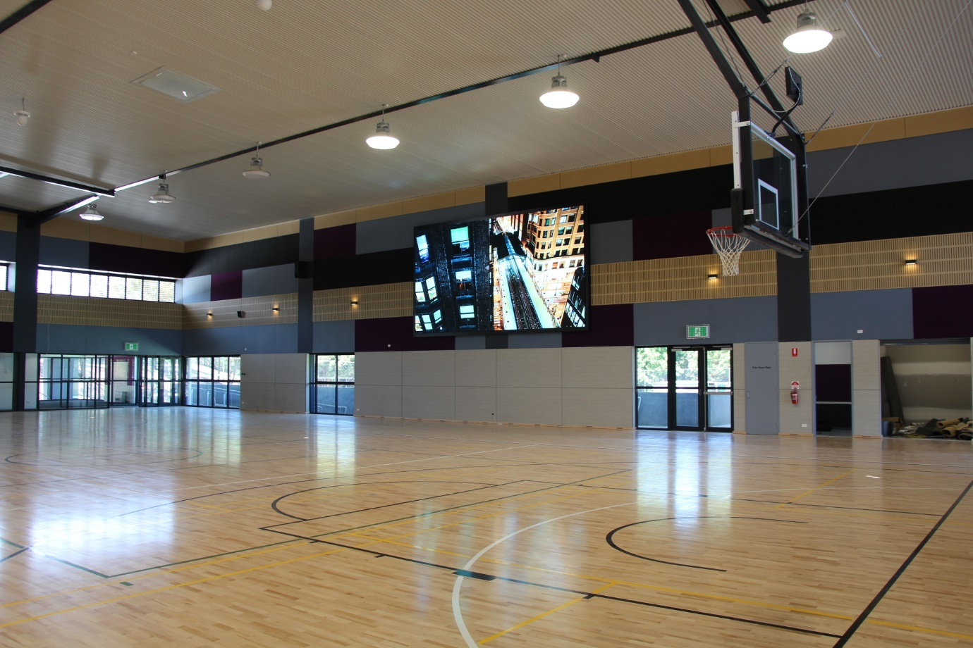

P6, 7680 x 4608mm CUBE
HDMI switcher
iPad control
1x wireless mic
Bose amp and speakers
Streaming audio
Bluray player
Rack
$117,938.03+GST

Holy Trinity Primary School
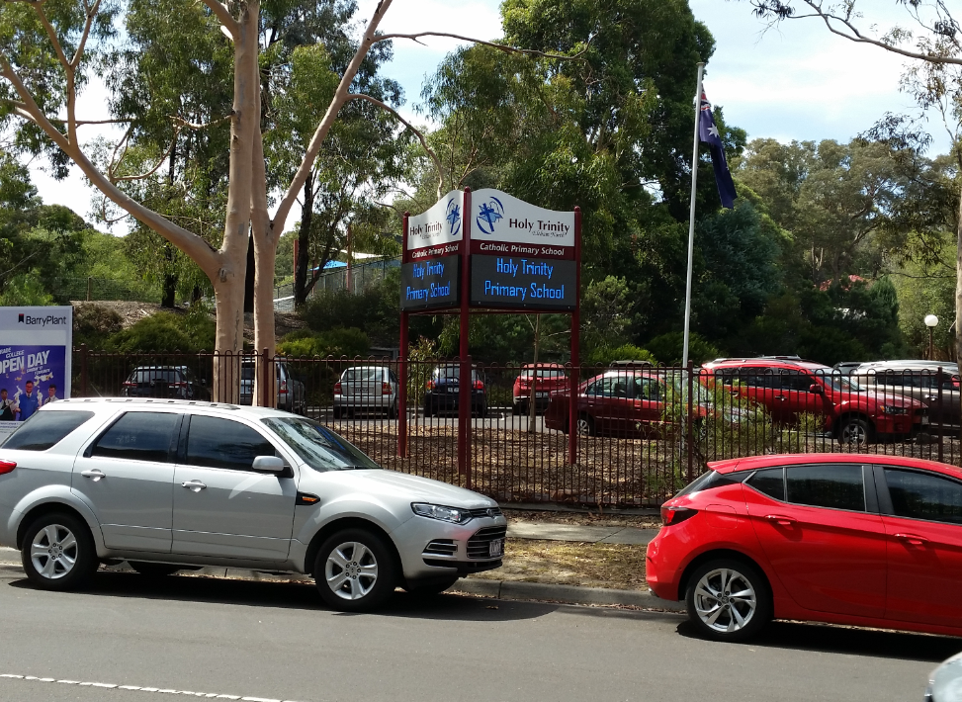

2x P10 800 x 640mm
Framing
$15,168.00

Option was 2x P5 800x640 to enable photos for be displayed $17,456.00

