Burlington Road Brochure
Page 1: Front page
Please use image provided.

Page 2: Content page
Text:
Page 3: About Us
Page 4: Site Description
Page 5: Scheme
Page 6: Analysis
Page 7: Conclusion
Page 8: Contact Details

Please use image provided.

Page 3: About Us
Text: City & Counties Commercial specialise in the acquisition and disposal of development, investment and commercial property in London and the Home Counties. Our consultants advise on a wide range of property types and use classes and are experts in identifying ways in which property owners can maximise value.
Our considerable knowledge of the property market and creative approach to delivering maximum value, has enabled us to become one of the most active development and investment consultancies in London and the South East.
Please use City & Counties Commercial logo provided.
Page 4: Site Description
Text: City and Counties Commercial have been asked by James Heath the representative for Robert Heath Group Limited to advise on the best disposal method to maximise value for their property.
The existing property measures approximately 9,655 square feet internally with parking spaces. We understand the site is in Flood Zone 2, which means it has a medium risk of flooding from rivers and the sea.
The site was granted prior approval in 2016 to be converted into 11 flats with 11 parking spaces but this was no implemented.
We understand that the vendors operate their business from the premises and the property has a designated use class of B1(a) Office/Class E (Commercial, business and service).
Please use image provided.

Page 5: Scheme
Text: We have taken advice form Formation Architects who have reviewed the site. They believe the site potentially could be up to 5 stories in height with 30 residential units and a ground floor commercial.
Scheme Proposal
Residential Units (Total 30 units)
• 1b2p _ 14 units (47%)
• 2b3p _ 11 units (37%)
• 2b4p _ 5 units (16%)

Car Parking
Car Park: 3 spaces (10%)

Commercial Unit
395 sqm / 4,250 sqft

Heights:
4 storeys plus 1 recessed top floor on Burlington Road
5 storeys at the corner
3 storeys on Cavendish Avenue

Please use image provided on the right side of the page.

Page 6: Analysis
Text: When analysing your site, we took into consideration the planning background and constraints study provided to you by HTA Design LLP. HTA mentioned the affordable housing requirement form the council could be 40%, but the draft New London Plan introduces a “fast track” policy which provides 35% affordable homes. We are currently advising on a 25 unit scheme in the borough and have found Merton Council to be fairly stringent regarding their affordable housing thresh hold of 40%. As a result, we would expect the same rules to apply with this site which will significantly reduce the land price a traditional residential developer could offer for this site once consented. Consequently, we would expect a Housing Association to be the most competitive buyer as they will be providing 100% affordable housing.

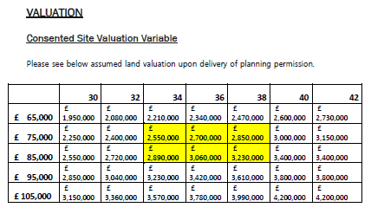

Please use image provided.

Page 7: Conclusion
Text:
Package Led Land Sale Involves selling the site to a Housing Association with a contractor already in place.
Benefits:
- Housing Association has build cost certainty.
- No need to tender build.
- More interest from HA if builder in place.
- HA responds better to contractor.
- Contractor will identify potential issues coming from HA.
- No SDLT or CIL.
Private Sale
- Likely to be of interest to private market but beholden to market conditions and market appetite.
Alternative User
- Limited Experience in Private Rented Sector and income led purchasers as is a relatively new market.
Please use image provided.

Page 8: Contact Us
No changes, thank you.

