Headline:
The Ultimate Quality Management System for SharePoint Has Arrived

Summary:
QMS is a next-generation quality management system that enables unprecedented levels of transparency, collaboration and approval process within all phases quality management and the team to execute integrations to digitally transform your organization.

Key Features:

ISO 9001:2015 Focused - QMS adheres to the highest level of international standards – QMS, is an ISO 9001:2015 process-based quality management system centered around risk-based thinking and features automated sequential reviews and approvals processes associated with the ISO “Plan-Do-Check Act” standard
. 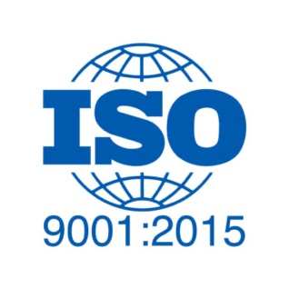

Built-In Audit Trails - QMS features built-in audit trails history functionality. This ensures that the system complies with all major quality compliance and regulatory requirements.



Automated Workflow Processes - Workflow processes, interrelationships, and interdependencies are uniquely presented in a simple and user-friendly interface and ensures that no critical steps are overlooked.



Advanced Progress Tracking - QMS delivers advanced progress-tracking for any quality record while providing stakeholders with real time transactional alerts at every decision point. This ensures stakeholders within the quality management team always receive approval tasks on time and in the correct order.



Cloud & On Premises - QMS is available as a hosted cloud service, and can also be integrated into existing on premises environments, including SharePoint 2016 & 2019.



Single-source-of-truth - QMS offers normalization and annotation of over 450 file types, embedding of thumbnails, and intuitive viewing of all files, without the need for plug-ins, downloads, synching or other software applications. This enables all files to be centralized and viewable in-place to dramatically change the user experience.



Middleware Integration - Powerful APIs allow QMS to act as a middleware solution to existing legacy systems. By doing so, QMS greatly improves QM by providing automated and fully ISO 9001:2015 compliant review & approval process and quality audit suite functionality



Complete Integration of full Digital Asset Management features - Centralized viewing in-place, batch uploading, and batch tagging of assets is just the beginning. The QM System is built on a full-fledged digital asset management system and technology used by companies like the Department of Energy and Architect of the Capital.

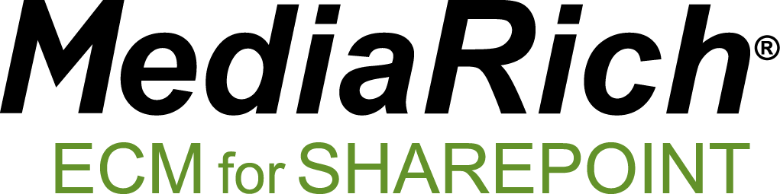

Bluebeam link extraction and RenderStream™ technology – By creating a simple universal viewing experience with annotation capabilities, it’s possible to give real-time feedback on any document, incident report, image or video file.



Call to action:
If you are interested in learning more about QMS please visit www.equilibrium.com/qms or call Call +1 855 EQUILIB

