Website Design Doc – StaceyHan.com
Project
I need a modern, updated design for my existing portfolio site (https://staceyhan.carbonmade.com/). I want to stay simple and clean, but also can be a little whimsical, fun, and a little colorful to go along with the logo I just selected. (Parts of the logo can be difficult to see, we may need darker colors for contrast).
I have an animated GIF, but it does not have to be used, especially if it is blurry.
I have a domain on Wordpress (staceyhan.com), but I’d be willing to move my domain to another site for the right design.
I would like it coded/configured and deployed, but I need the ability to easily update the site myself later to switch out my portfolio pieces. I’m not very good at html/xml.

Navigation
Navigation should be static or have breadcrumbs so user can jump to any page at any time:
- Homepage
- Who I Am
- What I Do
  - By Brand
  - By Craft
- How to Reach Me

Example portfolio sites I like
https://www.panteracapital.com/
http://britcochran.com/
https://www.mpkelley.com/
https://www.sidneydiongzon.com/

Pages
- Homepage
  - Nav
  - LinkedIn icon linking to: https://www.linkedin.com/in/stacey-han/
  - Main banner
  - Footer (optional)
  - Maybe include a banner with the logos of companies I’ve worked with (but not as the main banner): 
- Who I am
  - My photo
  - Include paragraph/bio from “Paragraph Content” doc
  - What people are saying
  - Awards/honors (optional)
- What I do
  - By Brand
    - Modules (or carousels) of my work by brand
  - By Craft
    - Modules (or carousels) of my work by craft
Example:
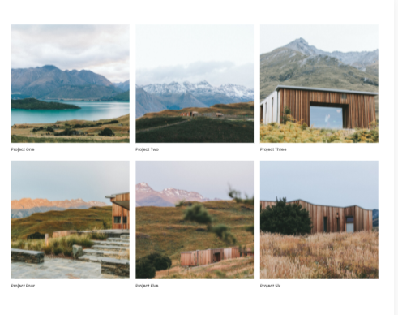
- How to reach me
  - Email
  - LinkedIn profile
  - Resume
  - Short paragraph:
Work with me
I’d love to hear from you! If you have questions, comments, or just want to geek out over all things content, please reach out.

Images can be found here – you do not need to use all of them (especially if they are blurry), and I am open to new images as well:
This is imagery from Unsplash that I like that could maybe be used for topic tiles (I am open to other suggestions!):
https://photos.app.goo.gl/QgnZtrH9dPMUeikk8

Website: Brands I've worked with logos
Website: Stacey Han Logo + Animated GIF

Website: What I Do -> By Craft -> Writing & Editing
Website: What I Do -> By Craft -> Publishing & Production
Website: What I Do -> By Craft -> Creative & Branded
Website: What I Do -> By Craft -> Content Strategy & Architecture

Website: What I Do -> By Brand -> Microsoft
Website: What I Do -> By Brand -> Expedia
Website: What I Do -> By Brand -> T-Mobile
Website: What I Do -> By Brand -> AT&T
Website: What I Do -> By Brand -> Tongal

Sitemap example
