TRADESOUK GROUP LIMITED
4 TINTAGEL ROAD
ORPINGTON BR5 4LQ
UNITED KINGDOM
Landline: (44) 1689 600 118
Mobile: (44) 7713 097 673

24 September 2020

The cosas

Brand

NAME

‘The Cosas’ (translates in English to “The Things”. ‘Cosas’ is a Spanish word for “things”.)

MESSAGING

‘The Cosas’ is a Private Label brand specializing in Home Essentials (Décor) category.

It aims to include products that adds to the positive energy and harmony of a home. Products that are non-intrusive, gels with the surroundings and give the home a light and airy feeling. Use of natural or pastel colours are encouraged for any product that we aim to add to our portfolio unless they are not applicable to the kind of product that we wish to include.

LOGO DESIGN

Word: The Cosas (Optional inclusion: Home Essentials)

Features that can describe our ideal logo could be; (or a combination of these)

Minimalistic

Classy and luxury

Creative

Easy to remember or identify

Single or Double colour options are ideal. Two or more colour options can be considered if the designer recommends.

INTENDED USE

The logo is to be used for variety of purposes such as (but not limited to);

Website

Product Packaging

Product inserts (leaflet, tags etc.)

Newsletter

Business Cards

Business Stationary

Infographic

OTHER REQUIREMENTS

In addition to the logo design, we have other requirements immediately after this. These are;

Package Label design

Package Tag

Thank You card

Business Card design

Website Design

PRODUCT DESIGN OPTIONS
Script to outline Crisil requirements to the candidate.

OPTIONS:

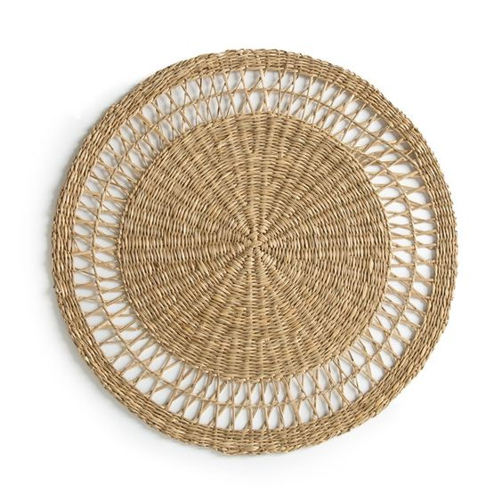 | 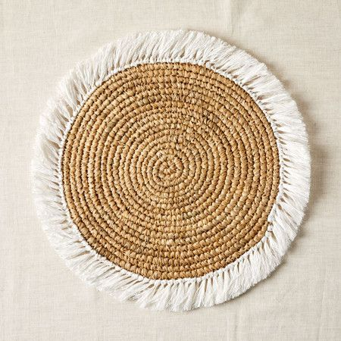  Diameter: 46cm  Thickness: 2.5cm | 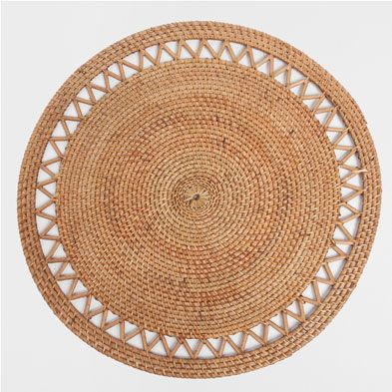
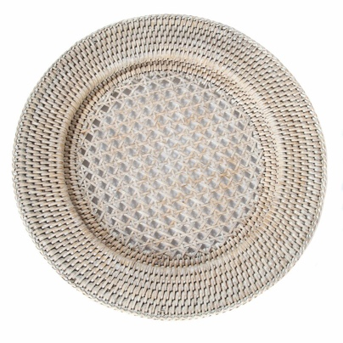 | 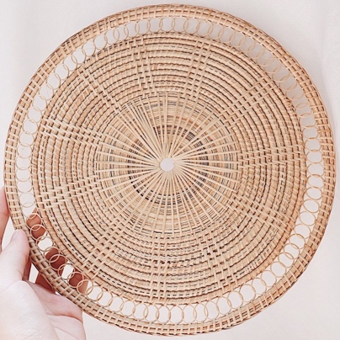  Diameter: 9.5 inch/24.1cm  Thickness: ?cm | 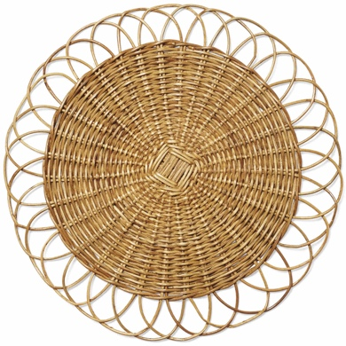  Diameter: 16 inches  Thickness: ?cm

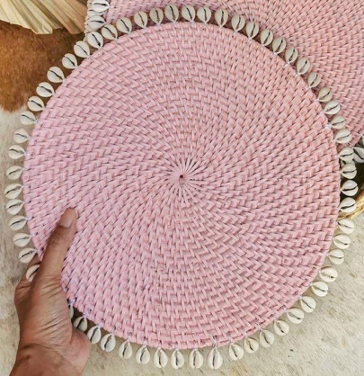

PREFERRED DESIGN

TBC (Depends on supplier quotes)

PRODUCT SPECIFICATIONS

Material

Pure Rattan (no Seagrass or any other mixed material)

Key Dimensions

Diameter: 14-16 inches

Thickness: 1-1.5cm

Acceptable Variations

Preferred colour is pure Rattan. However, colour variations can be considered.

