EXECUTIVE SUMMARY

Cure Ventures Management is a venture capital investor in seed and early-stage biotechnology companies. The experienced investment team is raising its inaugural fund targeting $400 million in committed capital. The firm is led by the three founders and supported by a number of operating professionals with long tenured careers in the biotechnology and the pharmaceutical industries. The firm is headquartered in the greater Boston area which is within the highest concentration of life science and biotech companies in the world, and home to leading hospitals and medical research institutions. The founders are focused exclusively on establishing nascent companies that develop new therapeutics from ground-breaking biotechnology research.

The firm’s strategy is focusing on de novo company formation surrounding pioneering scientific solutions with strong intellectual property positions. The team will focus on areas of discovery with disruptive technologies targeting unmet patient need. The optimal investment being sought will have: clear genetic validation, substantiating and rigorously derived scientific data, provenance of a distinguished scientific laboratory, biology with mechanistic clarity, multiple commercial applications, large uncrowded markets, an expedited clinical route, strong partnering interest from large pharmaceutical companies and an articulable path to an exit.

The current pace of innovation within the life sciences industry is unprecedented. Investors in research-driven innovation have been rewarded with some of the highest returns across the private equity asset class. Biotechnology is experiencing an era of discovery which is comparable to the innovation during the industrial revolution or the start of the information age. We are at the very beginning of a period of exponential growth regarding the understanding of human biology and pathophysiology.

MARKET OPPORTUNITY

The average age of the populace of Europe, Japan and the United States is rising, the percentage of those over 65 is projected to increase every year for the next thirty years. Unfortunately, this population often suffers from chronic disease with high co-morbidities. In the U.S. the average American’s weight gain has compounded these health problems. This situation has created increasing unmet medical needs in already very large markets. Present day we also a face backdrop that health insurers no longer wish to pay for expensive drugs simply providing incremental improvements in health. Cure Venture’s strategy addresses this backdrop by avoiding drugs that provide small incremental health improvements. The firm will target discoveries providing dramatic improvements in health, and when possible, the firm will seek cures.

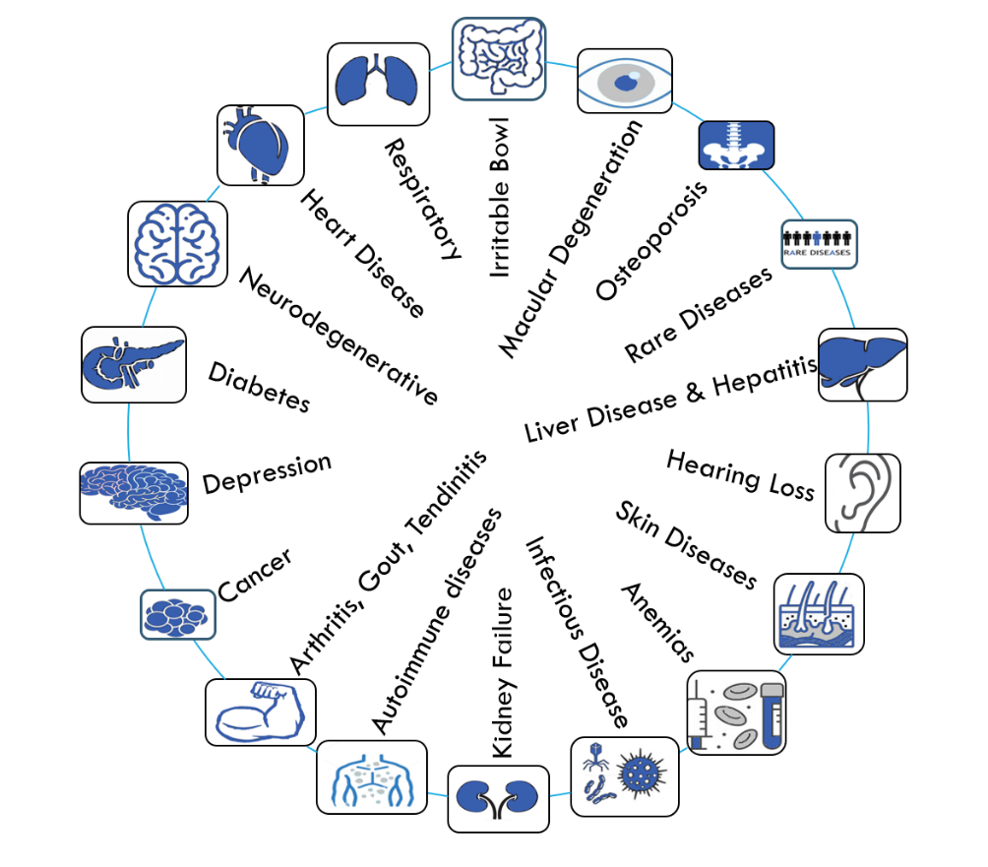

There is a tremendous amount of current unmet medical need as every area of the body has multiple associated diseases. Diseases such as diabetes, kidney disease, heart failure and Alzheimer’s not only have devastating impacts on patient populations, but also have tremendous costs on society and will likely explode the cost of the federal entitlement Medicare and ultimately its burden on the federal budget. We recently witnessed that infectious diseases and especially viruses (e.g., AIDS, COVID-19, Zika, SARs, Swine flu) can cause major disruptions and can shut down portions of the world economy during a pandemic. Concurrently we have observed that the larger pharmaceutical companies have been losing their research and development prowess, the industry has been relying more and more on acquisitions from venture funded companies. Given these trends we are frankly surprised how few viable biotech venture capital funds exist today, we assert there are fewer than 20 funds that are focused on early-stage biotech investing and many fewer that engage true in company building. We believe this anomaly exists because the barriers to start a new biotech venture capital fund are among the highest in the asset class given the sheer number of skill sets required: licensing; scientific understanding of pathology, pharmacology, molecular biology and chemistry; financial; clinical; regulatory & FDA expertise; legal and intellectual property; skills each of the Cure Ventures Founders has had to utilize to excel in their past deals.

THE PROMISE OF GENETICS

History will prove that the mapping and sequencing of the human genome will be one of the most important innovations of all time, launching a ‘Golden Age’ of biotechnology and medicine. James Watson, Francis Crick, Maurice Wilkins and Rosalind Franklin are credited with discovering the double helix structure of the deoxyribonucleic acid (DNA) molecule, whose paired nucleotide bases of adenine, cytosine, guanine and thymine provide the basis for DNA replication and transcription. The sequence of nucleotides bases in DNA or RNA, or genes, that result in the production of proteins ultimately make up all living organisms and the total of all the genes and non-coding DNA in an organism is known as its genome (in humans our ~20,000 genes are stored in our genome on 23 pairs of chromosomes). Completed in 2003, the sequencing the human genome gave us the initial blueprint for uncovering human physiology. We now have all the pages in the manual for making and understanding the human body, but we still have to put the pages in order.

The implications of genome sequencing are profound and the impact will be wide ranging. Mapping the approximately 3 billion nucleotides base pairs and sequencing the first human genome took 13 years and cost $2.7 billion. Today the cost for whole-genome sequencing has dropped below $1,000 and can be performed in less than an hour. Currently we can not only sequence whole genomes, we can also perform genetic engineering with great specificity, where specific nucleotide groups can be detected, targeted, deleted, modified, inserted and replaced in any organism. New gene editing tools such as CRISPR-Cas9 are used to edit the DNA of organisms in vivo and eliminate individual genes or entire chromosomes; today commercially sold CRISPR kits cost less than $200.00.

Currently, scientists can perform rapid and less expensive experiments than ever before, they can produce animal models more closely resembling our genetic make-up, which better reflect human disease providing stronger corollary data. Scientists can create animal models that knock-out one gene at a time to determine each gene’s function, over time building a repository of understanding. In animal models, gene disruption paired with the study of the phenotypic consequences -genetic traits observed when interacting with the environment- provides insight into gene function, assisting with drug targeting and safety. Genome-wide association (GWA) studies in human populations have been conducted across many diseases and traits. These studies are genetic screens performed on a population in order to uncover genetic mutations associated with a particular disease. Success has been reported across a number of disease areas. One example of a GWA study was across a form of blindness due to aging, known as macular degeneration. Several studies found that alterations in the CFH gene, which produces a protein called complement factor H, is involved in regulating inflammation as a key contributor to macular degeneration. This finding has already led to drug programs in the complement factor pathway for the treatment of macular degeneration. These breakthroughs, when coupled with advances in computing and functional genomics, enable researchers to more fully understand human pathophysiology. The benefits from these insights will be broad and far-reaching across the industry.

Because of the high cost of failures in drug discovery, any insights that increase the probability of success of bringing a drug successfully through Federal Drug Administration (FDA) approval are critical to boost the efficiency of drug development programs. Studies have shown when determining drug target leads that link genetic support to the underlying indication leads to a two to three-fold improvement in the probability of a drug approval. A recent observed example are drugs that target the PCSK9 gene, a gene that provides instructions for making a protein that helps regulate the amount of cholesterol in the blood stream. Investigators identified coding mutations in this gene that correlated with reduced levels of low-density lipoprotein (LDL) cholesterol levels. Clinical trials have now shown that inhibiting this protein lowers LDL cholesterol levels substantially and consequentially reduce coronary heart disease. Every day new genetic studies provide guidance to drug hunters. To successfully launch novel drug programs, human genetics needs to be matched with biological insights from the mechanism-of-action, (i. e., specific interaction through which a chemical or biological agent produces its medicinal effect.) and pharmacological targetability to ultimately create a drug.

In addition to having more data on the genetic causes of disease we have more weapons in our armamentarium to fight disease. In the 1980’s we had two tools to attack diseases, small molecules and peptides, today, depending on one’s definitions, there are between ten and fourteen different modalities. The newer modalities provide opportunities to interdict unique targets to address diseases in ways that couldn’t be done before. These advances will be particularly important for prosecuting targets uncovered through human genetics, as many of them are intractable when targeted with standard modalities.

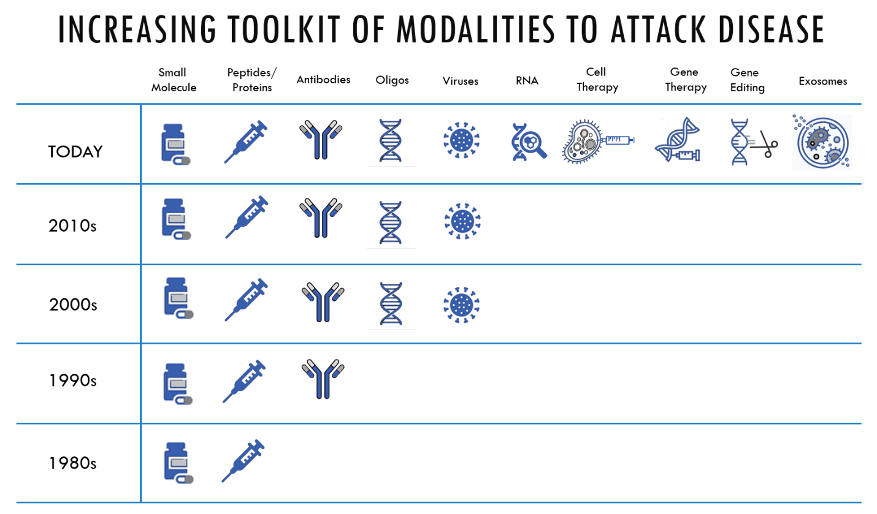

An example of a new technological innovation is ‘gene editing’, where today we can cut out a mutation with a single ‘defect’ and normalize the gene and its protein product. This is a potential one-time treatment that ‘cures’ an individual. At first, scientists started targeting monogenetic diseases using gene editing, including diseases such as Sickle Cell, Cystic Fibrosis, Hemophilia, Tay Sachs, Fragile X and Huntington’s disease. However, as the technology advances and becomes more sophisticated, the targets and associated diseases could expand to many genetic mutations that lead to other diseases caused by defects in multiple genes.

There are a number of firms evaluating various gene-editing technologies to cure sickle cell disease. Each approach aims to literally cut out the mutation in the hemoglobin-Beta gene found on chromosome 11 to fix the mutation in that causes the disease. The possible outcome is profound, as an individual with sickle cell disease can suffer long bouts of pain during their lifetime and unfortunately, on average, live 37 fewer years versus an individual without the disease. Today that gene can be cut out and replaced with a corrected gene.

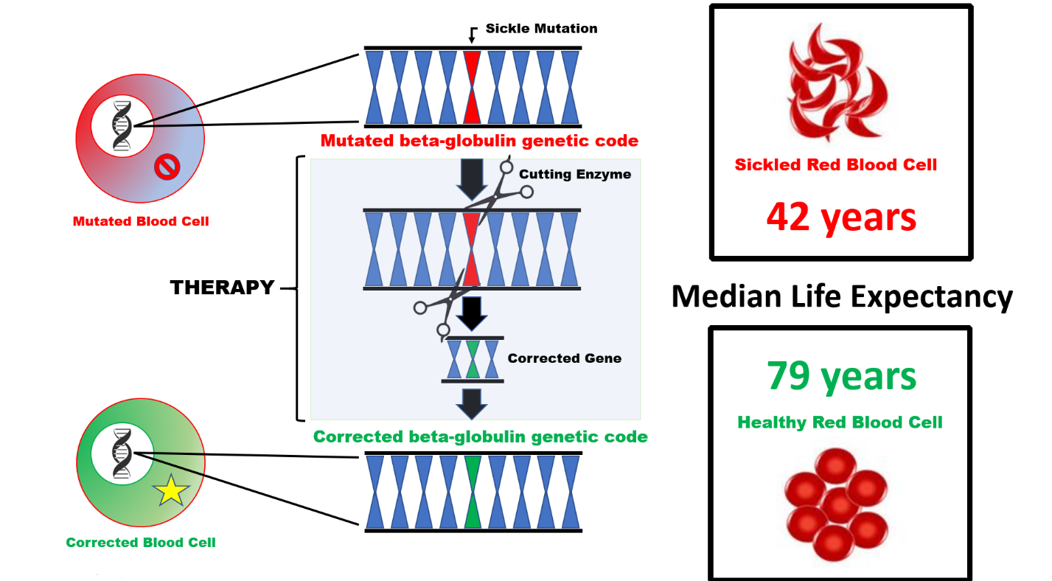

Today, all of these rapidly advancing technologies are allowing us to better understand and manipulate human biology; our understanding of cellular biology is leading us to new insights. We are able to leverage human biology to identify drug targets, while computational capabilities have brought a quantitative sophistication to biology that historically did not exist. Cure Ventures understands that bioinformatics and the new empiricism will help with discovery and toxicity predictions. The combination of sequencing and understanding the human genome combined with the decrease in the costs of these technologies has led to an explosion of research and our understanding of human biology. Cure Ventures is investing in internal infrastructure and hiring partners supporting bioinformatics and genetics capabilities. Through these bioinformatics investments, the Firm will set itself apart as a venture investor and leader with this internal capability.

CURE VENTURES STRATEGY AND APPROACH
We are dedicated to deliver exceptional returns to our limited partners by harnessing our passion for creating innovative companies that will make a true difference in patients’ lives, which is to cure them. As ambitious as this is, we believe given the rapid pace of scientific and medical development, there is no other acceptable objective, except to cure disease. It can be done. The time is now.
Fundamentals of our approach:
- Identify and nurture the most promising curative technologies. The Cure Ventures team has a long history of identifying and translating multiple innovative technologies into valuable therapeutics. The team has an unparalleled track record in finding and interrogating promising therapeutic opportunities, before others do, and choosing to move forward only with the most compelling ones with the strongest chance of success. This core competency is marked by insight, pattern recognition, patience, creativity, and lack of bias.
- Launch new companies and point them in the right direction. By being at the outset of a new company’s life, we gain great control and influence on what the fledgling company will become. With a world-class team of operating partners, we intend to be actively involved during a new company’s nascency, to provide an experience-based path for future success, which includes defining the vision, articulating the strategy, identifying management needs, instilling lasting culture, and installing initial operations. It is here that we will supply the company with necessary technical and capital resources to take its first steps forward.
- Build world-class companies with leading visionaries in science and business. Once the new company is poised for success, the Cure Ventures team aims to address the most important resource…human resource. If we have done our job with our fledgling companies, we will attract the best science and business management teams available, all eager to steer the new company through its defined plan forward. These management teams view us as important catalysts, with valuable history and insight, and will rely on us to guide them as we transition to seats on the board. The process is collaborative, seamless and organic. If we attract these teams too early, before we have de-risked the fundamental science and attracted capital interest from multiple sources, we will get caught in the trap that venture investors without company building capability fall into. Specifically, settling for management teams that are willing to take positions at companies that are under-capitalized and whose foundational science has not been tested. It has been our observation that such management teams can neither drive toward upper decile exits, nor develop drugs that make the most impact of patient lives.
- Realize the vision with flawless execution…and clear purpose. Every successful business endeavor depends on execution and Cure Ventures’ portfolio companies will be no exception. Meticulous milestone achievement will propel our companies to success and bring important products to patients. What makes new companies truly exceptional (and highly valuable) is execution with purpose. Each Cure Ventures company will aim to solve and eradicate life-debilitating or life-ending disease by bringing curative products to market. It is this pursuit of the cure, that is our purpose and underpins every single step the Cure Ventures team and its management team partners take. The members of the Cure Ventures team have been directly involved with bringing to patients, sixteen (16) FDA approved products.
We plan to make significant seed/first round investments in to build companies and complement our investment with strategic capital (both industry partners and long financial investors) to minimize dilution. We plan to leverage our vast and non-overlapping networks to build broad syndicates of investors to participate at later stage financing rounds, as well as bring in significant non-dilutive financing through strategic business development transactions.

The following illustrates the key tenets of the Cure Ventures investment model:
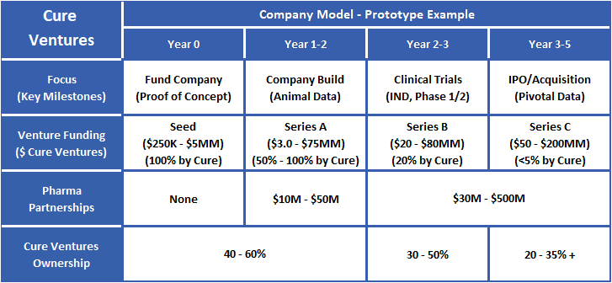
Cure Ventures anticipates that it will invest in 12-15 companies (that we have de-risked subsequent to a seeding process) with the following allocation:
- 60- 80% - Platform-based drug discovery opportunities anticipated to be in clinic within 24 months
- 10- 15% - Opportunistic Investments
- 10- 15% - Product focused thematic asset bundles
The Cure Ventures team believes that each of its companies will achieve ‘escape velocity’ and become highly valuable companies that can remain independent, but will be sought after acquisition targets. The world’s most valuable biopharma companies, many of which were investments of the Cure Ventures team members, create durable value for patients and investors. These valuable companies are highly coveted and are not wanting for liquidity, but these companies have the most options to realizing liquidity available to them. It is our view that if we do what we say, we will replicate what we have achieved historically, which is realize our investments through trade sales or going public, but doing so on the company’s terms, and at the highest valuations.

DIFFERENTIATION OF THE STRATEGY

Investment Stage and Company Building
After inquiring with the acquisition and science teams at the large pharmaceutical companies (Pharma) the Firm will identify the disease areas and modalities that have the highest chance to be acquired. With the guidance from Pharma the team will then look for the cutting-edge research addressing these diseases across its extensive networks in the medical research community.

Cure Ventures will primarily invest in seed-stage companies with pioneering science which will have the potential to generate at least ten-fold returns. The Firm will target markets where innovation will make dramatic clinical improvements in large patient populations. The Firm will have a preference for drugs that address disease with new biological mechanisms which will provide durable value, more rapid clinical development and commercial adoption.

Core to Cure Venture’s investment strategy, is de novo company formation. Each of the fund’s founders brings individual strong track records as well as extensive networks in starting new companies. The firm’s investment team will originate, found and build cutting-edge, disruptive, start-up companies that develop novel medicines which target high unmet medical needs. Cure Ventures believes it is uniquely positioned to excel at this strategy as it was founded by highly experienced investors who are at their core, are company builders. Each of the founders were previously leaders at top biotech venture capital funds that specialized in company building. The partners are focused exclusively on founding and investing in companies that develop new therapeutics, and will lead the Firm’s strategy to form new companies around ground-breaking biotechnology research. The founders will work closely with operating partners and other investment staff to execute upon this strategy.

It is anticipated that for the majority of its investments that the Fund’s team members will take leadership roles serving as executive management team members running the day-to-day operations of portfolio companies. After raising the A round for each new company, the Fund’s team members will then hand over the company to professional management teams. The fund’s team will continue to influence control over these portfolio companies by serving as members of the boards of directors, as well as actively advising the companies’ permanent management teams on an ongoing basis to maximize the Fund’s return on its investments. Consistent with its highly active role throughout the lives of its portfolio companies, the Fund seeks to own at a minimum 20% of each portfolio company at the point of liquidity.

The Firm has multiple major differentiating approaches to driving value creation. Several of these differentiating approaches are enabled by our best-in-class de novo company creation and company building / operating expertise:

Sourcing
Pre-competitive sourcing of breakthroughs that overlap with unmet medical need becomes possible through our de novo company creation experience. Traditional venture capital firms source opportunities through receipt of business plans or presentations by early management teams. We are able to source company concepts prior to this, by directly contacting researchers responsible for breakthrough science, interfacing with university tech transfer offices, cultivating our serial entrepreneur networks, or creation of companies around biopharma divestiture of more advanced assets. This is because we do not have to wait for embryonic companies to be built around these discoveries. Rather, we can partner preemptively with the inventors and help them cost effectively build start-ups around their discoveries.

Early de-risking
De-risking of breakthrough science and assets is possible through a seed-led venture creation approach. Prior to all investments, every possible measure will be taken throughout the due diligence process to assure that only the highest quality breakthrough science in the areas of the highest unmet medical need receives our financial and management support. Nevertheless, almost all science and medical breakthroughs initially have some holes that result is some degree of risk. Fortunately, it has been our experience that most of this technical risk can be eliminated through a limited set of studies, prior to the investment of significant capital.

Company building capability allows for relatively modest amounts of infrastructure to be put in place during a parallel process of reproducing critical data and filling any “data holes” prior to placing more capital at work. Thus, our de novo company building ability, enables us to de-risk technology on a relatively small initial seed investment. This insures that prior to making significant investments we have eliminated the possibility of early failure, due to lack of robustness of the science or significant hurdles in translation of the scientific work from academia to a commercial setting. In a minority of cases, the validating experiments cannot reproduce the initial data or are unable to confirm the robustness of the science as it translates from academia to a biotech setting.

This evaluation process prevents losses due to critical technology failures after large series A rounds. When the science is validated under our management, together with further strengthening of the business case and initial company build, it then becomes justified to lead a large series A investment with the Fund as the largest investor.

Value Creation
Although ‘company building’ is resource intensive for the Firm (i.e., setting trajectory, vision & planning, legal & intellectual property, IT & informatics, human resources, business development, finance and accounting, facilities, culture, communications & public relations, etc.), it creates tremendous long-term value. The returns from the benefits of company building can be significant, both in the short-term, such as through the issuance of founder’s equity and investing at the lowest cost-basis, and also in the long-term by controlling the management team hires and scientific advisory board, syndication investors, the company’s narrative, and the Fund’s cost-basis and ownership percentage.

Concentration
Competing venture capital funds invest in 25 – 40 transactions, we contend this over-diversification spreads their business risk at the expense of returns. Cure Ventures maintains that our Limited Partners are in the best position to diversify their portfolios and not us. Overdiversification spreads finite resources too thin at best, and at worst undermines the returns for the level risk taken in the Fund.

To execute upon its strategy, the Firm is seeking to invest across 12 – 15 visionary start-up therapeutics companies that have been de-risked through our seeding process. Generally, the Firm will commence its company formation process with a small initial “seed” (generally $100,000 - $5.0 million) investment to establish control and direction of the foundational science, and to make certain that if failure is possible, failure is fast and on minimum capital risk Once the underlying technology is determined to be valid and commercially viable, the Firm will lead and syndicate a larger A round where the Firm will wield significant control in dictating the Fund’s investment basis. The Fund will endeavor to be the majority equity owner in its portfolio companies (A Round of $20MM - $40MM of invested capital from Cure Ventures) following the A investment round; maximizing strategic direction and maintaining investor syndicate control. The Fund will not exceed investing more than 20% of its capital commitments in any single company.

Genetic Target Identification, Validation and Bioinformatics
The Firm will build internal genetic target identification, validation and bioinformatics capabilities, which will interrogate new disease targets, select optimal patient populations, and assist in navigating away from higher risk technologies. Our understanding from sequencing the human genome is finally maturing enough for the promise to be realized. The Firm plans to utilize genetics systematically in evaluating its investments. The cost of gene sequencing has now fallen enough where large population pools have now been sequenced and the data within these pools continues to grow. The Firm will continuously develop its informatics capability to assess the genetic implications of certain drugs. Studies have demonstrated an increased probability of success through Phase II clinical trials where clinical scientific work utilized genetics. The Firm envisions that genetics will not only help with efficacy, but assist with patient pool identification, managing toxicity, and help identifying appropriate biomarkers for clinical trials. As such, the Firm will generate and utilize proprietary algorithms generated from data obtained in the genetic databases within certain diseases which will be difficult to replicate. These proprietary capabilities will enhance the screening of the team’s vast sources of deal flow. Genetics will not only help with identifying new potential targets but will assist the team’s navigate toxicity and best position the asset for success.

Geographic Focus
The Firm will source Intellectual Property (IP) globally from a broad array of pharmaceutical and biotech companies, academic institutions, large medical research centers and other sources of life science technology innovation. The Firm may combine the scientific work from several different sources to form a single company. The Firm will focus geographically on sources of IP in the U.S. and Canada; outside the U.S., the team will search for innovation regularly in the United Kingdom, Switzerland, Germany, and the Netherlands. Successful biotech investing often requires picking the single scientific best solution across multiple approaches, active participation of leading scientists and entrepreneurs, and attracting the best management. Accessing the best expertise, the company’s manufacturing, and management team ultimately drive the company’s location. The portfolio companies will primarily be based in Boston metropolitan region; however, San Francisco, San Diego, New York and London could also be viable locations as they are home to some of the top management teams and academic laboratories.

Deal Structuring and Long-Term Perspective
Biotechnology investing requires patience and a certain level of control as investors. The team will guide and direct its portfolio companies’ management teams, through board participation, tranching of capital and linking capital deployment to milestones to engender disciplined spending. Monetary incentives need to be provided for long-term success but equally importantly incentives need to be provided for risk-taking and failing rapidly. Additionally, the founder’s experience has demonstrated that the most successful companies in biotech, incorporate a culture immediacy and sense of urgency. Successful companies should be able to choose when to access the public markets or when to be acquired, and not forced to raise capital during down markets. Each of the Fund’s partners has historically demonstrated an ability to attract other sophisticated investors into portfolio companies they have been involved. The ability of the founding partners to attract capital provides companies with a competitive advantage taking the pressure off of the management team and enables the management teams to focus on the long-term.

A peculiarity of the pharmaceutical industry is that large pharmaceutical companies need to replace the drugs in their pipelines due to intellectual property protection expirations. These expirations force Pharma to constantly be looking for new acquisitions. Because of this distinction Pharma often partners with smaller biotech firms by providing them with large pools of capital to give themselves access or an option on that specific technology in the disease areas that interest them. The founders have a history of attracting both dilutive financings at high valuations and non-dilutive pools of capital through partnership structures with Pharma; this is a risk management tool the team expertly uses to de-risk its investments. These partnerships enable the firm to offload much of the cost of later stage clinical trials on large pharmaceutical company partners enhancing overall returns.

Contrarian Focus
We understand investor psychology, the tendency of many to follow the crowd, and the importance of looking beyond the near-term noise to the value we are seeking to extract from investments over time. A contrarian approach in assessing technologies has served the partners well in the past, we believe independent thinking will provide the fund with its best ideas. Even though more money has been flowing into biotech, the money has become more and more concentrated in fewer deals, we believe this is merely an indication of money following the crowd. We contend that some of the best investments will be areas of science that are not considered mainstream or are out-of-favor, the Firm will maintain discipline in evaluating data from research in an unbiased open-minded fashion and pair it with our strategy of seeding and conducting validating experiments.

Significant Ownership Target
The Fund will target a majority ownership stake in the company with a low cost-basis after the A round.
Consistent with de novo company formation and taking an active role in our companies. Cure Ventures seeks to own at least 20% of its portfolio companies at its exit. The team will initial seek to own 40 – 60% stake in a company upon its completion of the A round, and to invest in subsequent rounds to maintain its ownership goals in each company. However, even with the overarching goal of large ownership percentages the team views each round of investment as a discrete investment and require each invested dollar to provide venture-like returns. By investing in fewer companies than competing venture funds and making more concentrated bets, the fund will be able start with and maintain very large equity stakes in their portfolio companies. The firm is very valuation sensitive and views each round of investment as a discrete investment decision requiring ‘venture-like’ returns.

COMPETITIVE STRENGHTS

Attracting Management Teams
Perhaps the most important decision the Fund and a company’s board can make is the selection of the CEO and executive management team. Generally, managers who have had substantial experience and successful executive management careers in the pharmaceutical industry and/or in biotech start-ups exhibit stronger performance. We target management teams with strong leaderships skills, substantial clinical trial experience, history of navigating the FDA, relevant scientific backgrounds, who have the attributes to successful run and thrive in a start-up, who are demanding and exhibit a sense of urgency, who believe and understand the modality and disease.

The team has a strong reputation of success of creating the best-in-class companies with pioneering science within new modalities. The portfolio of companies that the three founders have been directly involved with in their previous firms have had high hit-rates and low loss ratios. This track record of success and high hit-rate in difficult new scientific areas provides the founders with a competitive advantage in attracting the best in-class management teams.

Given our de novo company creation focus and through supplying ourselves as the early interim management, we not only ensure expert navigation of that first critical year of setting company’s trajectory, but we also position the company to recruit top-tier executive management (C-suite) teams. C-suite executives capable of building multi-billion-dollar companies are often difficult to recruit early in the life of a company. But after we have de-risked the science and positioned the company for attracting significant investment as well as non-dilutive financing, it is then possible to attract the most talented C-suites that can drive product development and profitable exits.

Network
The Cure Ventures team has far reaching relationships. On aggregate the founders have a history of working at five of the premier biotech venture firms, each founder having broad networks with wide exposure to many of the top academics and management teams across their previous firms. The partners have regular conversations with the top award-wining academics (e.g., Nobel Prize Physiology and Medicine winners, MacArthur Foundation Genius Award winners, Wolf Prize Winners, Lasker Awards winners, members of National Academy of Science, Howard Hughes Investigators, member of National Academy of Medicine). The founders work closely with more than two dozen medical research institutions, including the premier research institutions like Harvard University, Yale University, Massachusetts Institute of Technology, Sanford University, John’s Hopkins University, and the Broad Institute. This network acts as a repository of knowledge and new ideas as well validation of technologies during each step in our portfolio companies’ development. These relationships and other carefully cultivated networks of entrepreneurs and scientists help with sourcing and validating technologies. This diverse and expansive network provides precise expertise in evaluating science, attracting executives and creating corporate partnerships.

Operating Focus
The firm prides itself on its heavy emphasis in its operating and company formation capabilities. The Boston area is the loci of the biotechnology revolution and is home to a plethora of start-ups and provides a deep pool of operating expertise. The founders can call upon a deep bench of internal operating partners which represent the top 1% of their network of start-up operators as well as select from their larger network of relationships in the Boston start-up ecosystem. The internal operating partners on average are MDs or PhDs, have at least 15-years of biotech experience, are widely published and named on patents, and served as executive management of several start-ups.

Teamwork and Reputation
We put patients and our limited partners ahead of all of our other interests; we realized with these tenants as our guiding drivers for everything we do we best position the firm for long-term success. The partners shared-values drives all aspects of the culture of the firm, we believe this is where teamwork, our desire to seek ‘cures’ for various diseases and how the team behaves, all intersect. The founders came from five different biotech venture capital firms, we witnessed what worked well and what did not work well. We approached the formation of the firm with the ideals of putting a firm together where the best prospective entrepreneurs, scientists and employees all want to be associated with our firm.

Our relationships are prized and fostered and we understand that our reputation for integrity, humility, fair-dealing and doing what we say we will do. Our behavior on board of directors, treatment of academics, will each differentiate us and makes our fund a preferred investor and will be in investors long-term interest.

Led by the founders the team operates in a cohesive, collaborative and consensus driven manner. Every partner and senior staff member are invited to participate in all investments meetings and collaborate add-value in all deals. The founders share: a passion for improving people’s lives, a fierce commitment to teamwork, consensus driven decision-making, derives its strength from a foundation of mutual respect, shared values and a passion for making the world a better place by delivering cures. A strong firm culture and commitment to putting patients and limited partners first guides every decision at the firm.

Experience

The Cure Ventures team’s extensive venture experience, deep networks, technical expertise and operational capabilities matched with the firm’s capability of genetics and bioinformatics enable the firm to address a wide range of technologies and opportunities. The three founding partners have more than 50 years of aggregate experience working in biotechnology and 40 years working in venture capital. The founding partners have the requisite backgrounds necessary to successfully navigate the path enabling biotechnology and pharmaceutical companies along their path to development success. The three founding partners were previously leaders at other biotech venture capital firms, including 5AM Ventures, Third Rock Ventures, MVM Partners, Omega Funds and Polaris Partners. The founding partners history within the entrepreneurial communities has engendered the team with a reputation that allows the team to attract entrepreneurs seeking capital and the very top management teams that are key for long-term success.

The assembled team possesses some of the strongest track records in the industry. These individuals have deep and complementary expertise across the biotechnology and pharmaceutical sectors across most disease types of modalities targeting disease. The Firm contends that it can field a senior team with relevant knowledge and experience that not only facilitates efficient investment evaluation, but also helps foster portfolio company success. The senior team will actively be involved with key decisions driving portfolio companies, including serving on boards, assessing clinical and commercial plans, augmenting management as needed, arranging follow-on financings, and most importantly driving companies towards exit. The team respect and like each other and works well together. We are seeking persistence of our culture of excellence for long-term.

INVESTMENT PROCESS

The founders developed a systematic investment process for generating superior returns. A disciplined approach is taken with each stage of the investment process and each round is made as a discrete investment decision. We contend our approach and rigor is the key to our competitive advantage: from sourcing new investment ideas, screening decisions and due diligence, structuring and negotiating terms, seeding the initial technology and interrogating the science, driving the initial validating experiments, building the investment syndicate, recruiting and actively working with management teams, to ultimately achieving investment liquidity.

Sourcing Deal Flow
The founding partners of the fund have been involved with some of the most successful, scientifically pioneering and financially lucrative biotech start-ups of all time including: Agios Pharmaceuticals, Denali Therapeutics, Editas Medicine, Gossamer Bio, Juno Therapeutics, Replimune Group and Rhythm Pharmaceuticals. The founders past experience almost entirely covers the disease landscape and modalities targeting disease.

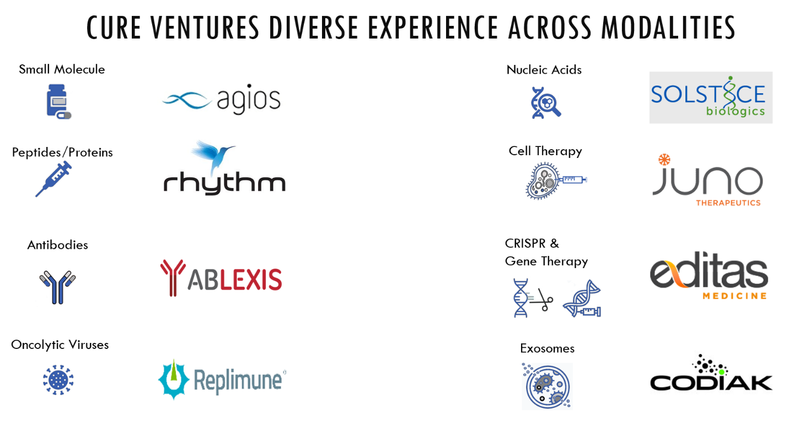

The founders have established a broad range of relationships and industry contacts which lead to a robust flow of potential investment opportunities. A pro-active approach is taken to the sourcing of new investment opportunities. The founders maintain an active network of individual contacts in the biotechnology and pharmaceutical industries as well as in the scientific and academic communities. The founders also benefit from their well-regarded reputation for financing high quality opportunities and their performance and experience in working with early stage technology companies that have operations in the United States and abroad.

Screening and Due Diligence
The founders have developed a systematic process for screening and evaluating potential investments. Cure Ventures has a propriety due diligence checklist which each deal is assessed. This process is structured to identify the most compelling opportunities quickly, and eliminate unattractive situations as early as possible. Initial screening is typically handled by the founders individually, with a focus on scientific data. The founders and operating partners meet weekly to review prospective opportunities, and information is documented and shared openly. Unanimous approval is required to conduct a more thorough due diligence review.

The due diligence draws upon all available resources, both internal and external, to evaluate the criteria which are critical to the success of an investment. This includes, in the least: (i) full evaluation of the academic lab and scientist; (ii) review of scientific research; (iii) a review and understanding of the biological mechanism-of-action; (iv) an assessment of potential toxicity; (v) an evaluation of the genetic underpinning of the disease and targeted pathway; (vi) assessment of market and patient need, competing drugs in the clinical pipeline and potential pricing; (vii) clinical trial construction and pathway through the FDA; (viii) full review of the intellectual property and any licensing agreements; (ix) identification of syndicate members; (x) assessment of the appetite from Pharma surrounding the disease for partnership potential and acquisition; (x) preparation of a detailed return analysis using several cases of financial performance and exit timing.

Recommendations for investments are prepared by the sponsoring partners and presented for consideration by all founders and operating partners. Decisions to proceed with negotiation and consummation of an investment are made by consensus of all founders.

Company Creation
After an investment idea has been screened and it survives due diligence review to receive a seed financing, certain team members are assigned to the new venture in executive management roles. Cure Ventures has a propriety company formation handbook which will guide the team on the initial steps for seeded entity. At this stage the seed investment is used to validate the underlying technology and to determine if the underlying technology is commercially robust. The team will run a variety of experiment to replicate the science. The team will also run experiments to help determine which diseases to target.

Portfolio Monitoring
Since Cure Ventures is typically a lead investor in the Fund’s initial portfolio investments, the founders and operating partners take an active role in the management of portfolio companies. In the vast majority of investments, the founders serve on the portfolio company’s Board of Directors and often start out in roles as the CEO, CFO, CSO and CBO. At times the partners may take on these roles for a year or more and for multiple start-ups. Once a company has been de-risked the Firm’s model is to then bring on a world-class management team and the partners step away as operators and move to solely being board members.

In the role as a board member, the partners provide: (i) advice and consultation on business strategy; (ii) assist in identifying and screening additions to the management team; (iii) helping set and review priorities and operating goals; (iv) identity specific disease targets; (v) evaluating and securing strategic partnerships; and (vi) assisting in planning and securing additional rounds of financing.

The Firm will support all of its portfolio companies that it believes will produce strong returns for the fund and must be approved by the investment committee. However, each investment is a discrete decision and an investment in the A round is no guarantee the Fund will participate in the B round. Each investment is monitored by two of the partners where one or both partners (at first) are on the board and one might later be designated as a board observer. An associate and a principal, and one of the fund’s Finance staffers, will also be assigned to duties related to specific portfolio companies on an ongoing basis. Often times, but not always, the team that was on the assigned deal team will continue to monitor and be responsible to informing the partnership and investment committee of all material updates related to the company and follow the company until its exit.

Exit Strategy
Each investment decision includes the consideration of likely exit strategies. Portfolio Company management teams are fostered to continuously contemplate a path to an exit. Investments will be realized most typically through the sale of the portfolio company to a large pharmaceutical company for cash, marketable securities, or a combination thereof, or a public offering of a portfolio company’s stock. While specific company needs and prospects, as well as market conditions will determine the nature and timing of exits, the active involvement and board positions held by the partners in portfolio companies are important in managing and influencing the exit strategy. Evaluating and planning for the Fund’s liquidity options will be an on-going process throughout the life of the fund.

Generally, Initial Public Offerings (IPOs) are thought of as financing events and not necessarily as exit events. After any of our portfolio companies achieve an initial public offering the Firm may sell or hold the public shares after any lock-up expiration. A specialized committee, called the Public Markets Team, is responsible for evaluating the portfolio companies that underwent their IPOs and the capital markets generally. This team will make recommendations to the Investment Committee on the plan to sell shares on the open market. The Public Market’s Team will establish and document an exit plan depending on a number of factors including: (i) the company’s long-term clinical prospects, (ii) whether the investment met the Firm’s investment goals, (iii) the company’s short-term inflection points, (iv) the prospects of a buyout, (v) the company’s future capital needs, (vii) any limitations of sales of shares because of our status as an insider or a 10b-5 plan, (viii) and the long-term prospects of the company to continue to make a material impact on the fund’s returns. Any team member with material non-public information in a public portfolio company or is on the board of a portfolio company must recuse themselves from the Firm’s investment decision related to that portfolio company. The Public Markets Team will maintain relationships with bankers and will develop expertise for taking companies public in order to be a resource for the portfolio companies. Additionally, the Fund will also develop its internal capabilities to maximize its gains in exiting public portfolio companies. Finally, all decision will be driven by our philosophy that the interests of patients and our Limited Partners will come ahead of all others.

