DESIGN CROWD BRIEF

We have a chain of chiropractic clinics and are celebrating our 10th Birthday in October.

We will therefore be offering EVERYONE

- 10% discount off all our packages

- The opportunity to take part in a Grand Prize Giveaway

This is a draft of what I am using for some of our social media so that you can see the colours etc. I am attaching the Shutterstock 10th Anniversary image so that you can include this. Let’s call it GRAND PRIZE GIVEAWAY (NOT GREAT PRIZE…)

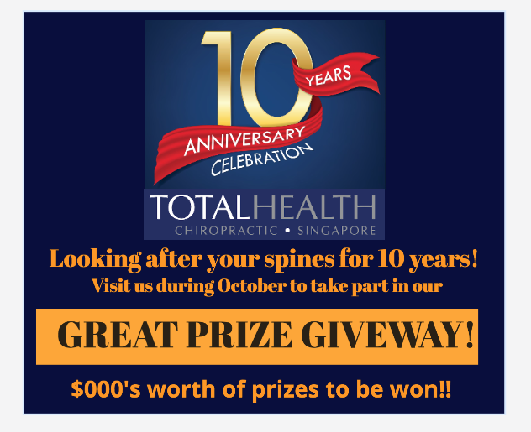

I need an A3 poster to display in our clinics to promote this anniversary.

The big message is:

BUY A NEW PACKAGE, OR UPGRADE YOUR CURRENT ONE, DURING OCTOBER TO ENJOY A 10% DISCOUNT!!!

PLUS
Everyone takes part in our GRAND PRIZE GIVEAWAY

Your opportunity to win one of our $000’s prizes including

ONE GRAND PRIZE OF ONE YEAR CHIROPRACTIC WELLNESS CARE!!!!

The other prizes are a mixture of items … I am attaching some images so you can hopefully make one image of all the prizes. We also have

1 x 1 hour bed massage from PepperMinted that needs to be included on the prize image – please include the logo ..



____________-

Also, somewhere on the poster, please let them know that we are donating back to the community using the B1G1 logo and the words below. Can use the picture if there is room.



As a thank you to Singapore, we know we would never have made it this far without the loyalty of our clients. Therefore, we will be giving back to the community and with every package purchased in October, we will buy 10 meals for the hungry people in Singapore via B1G1 and the Food Bank Singapore.

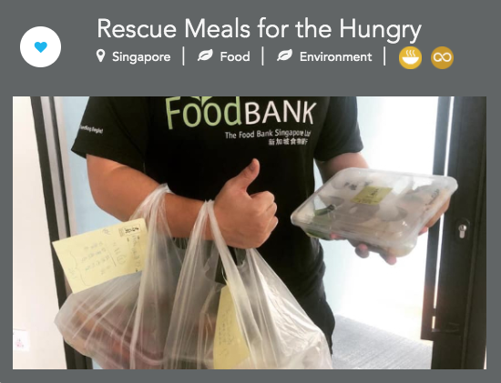

T&C’s
- THC Anniversary Prize Giveway and 10% discounts valid from 1st October to 31st October 2020 only.
- Receive one lucky prize draw entry for every adjustment during October (max 4 during the month).
- Receive an additional lucky prize draw entry for each year you have been a client with Total Health Chiropractic
- All prizes must be collected from the clinic.
- THC decision is final

I am attaching our logos in different formats.

