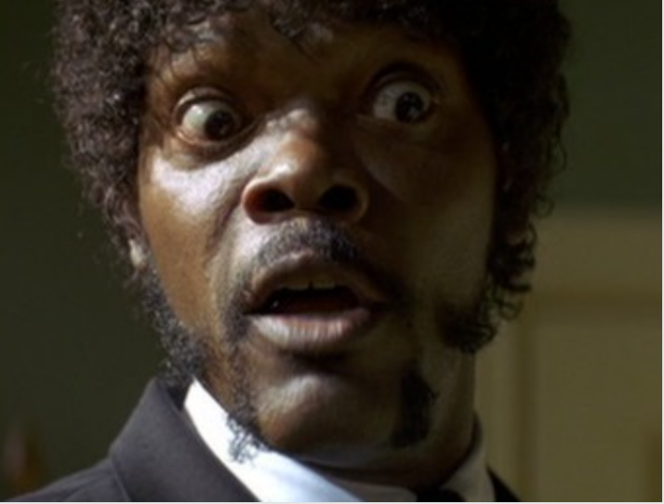
Do They Speak English in What?!!

Stella should be giggling. Like we’re not taking you serious dude

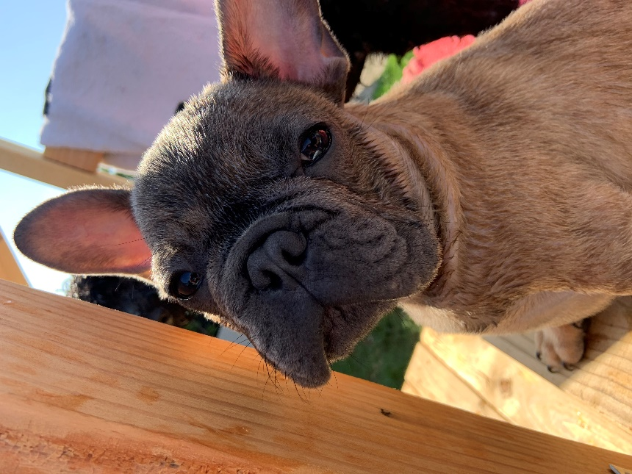
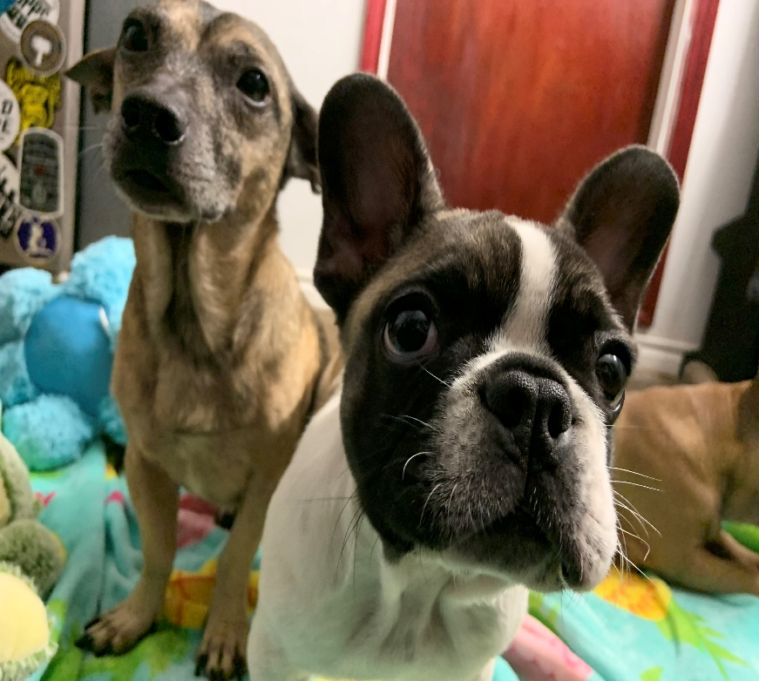

w. W. Wut? (puzzled look) Bo

