Accushield Brochure Redesign Notes

Accushield is looking for a complete redesign of our corporate brochure. The current version is attached for reference. Also attached are images & logos that may be used if desired.

The copy in the current version should be used (or improved), but look/feel, layout/design are all up for grabs (although the corporate colors blue (#384275) & green (#3FA863) should remain predominant). In addition to the existing copy, the following copy should be included:

The Accushield sign in, health-screening, and forehead scanning kiosk can help prevent and/or stop the spread of COVID-19 by giving facilities a streamlined way to validate that every staff member, visitor, third-party caregiver, and vendor has completed the required daily screening protocol before entering. Because the Accushield system tracks which resident the visitor, third-party caregiver, and vendor sees during the visit, this can assist in reducing the spread of the virus should one of these visitors and/or residents contract COVID-19.

Daily screening checks include:
- Touchless forehead temperature scan
- COVID-19 screening questionnaire
- Required PPE acknowledgment form

Facility infection control improvements:
- Helps keep out individuals that show symptoms of COVID-19.
- Helps mitigate the spread of COVID-19 by tracking visitor and resident visit interaction.
- Helps with mass visitor, staff, third-party caregiver, and vendor communication should there be a COVID-19 outbreak.
- Helps with COVID-19 messaging (example: the person must agree to wash hands and wear a mask before completing the sign-in process and entering the facility).

Additions to the Features & Benefits section (rename Features & Benefits to All-in-One Solution):

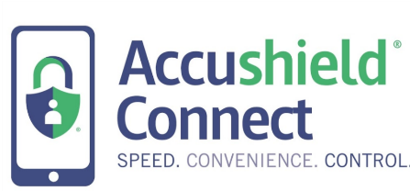
Touchless sign in with AccushieldConnect mobile app
With health safety in mind, Accushield has prioritized the development of an all-in-one touchless sign-in and health-screening solution designed to capture temperature, ask COVID-19 questions and even validate a negative COVID-19 test result for staff members, visitors, and third-party caregivers who enter senior living communities and nursing homes.

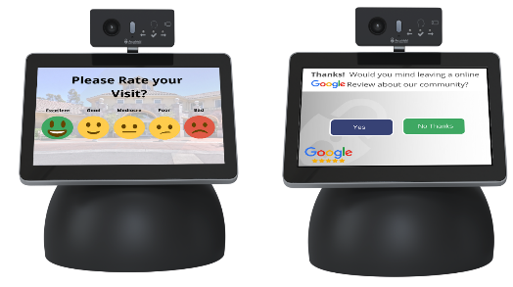
Visitor Experience Surveys
Receive valuable visitor experience feedback immediately upon sign out. Simple visit surveys can help improve visitor satisfaction and identify visitor issues that need resolution in real-time by onsite staff. Improve community online rankings by automatically requesting social reviews as visitors sign out of the community.

--------------------------------------------------------

Please direct any questions to John Leavitt at john.leavitt@accushield.com.

Thank you!
John Leavitt

