Website: Affinity Relief International – ARI

Logo Inspiration:
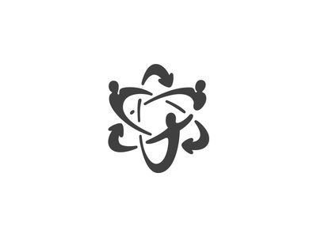 | 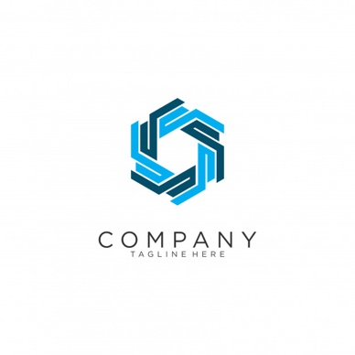 | 

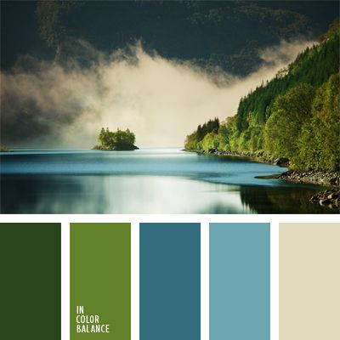
- Minimalist style
- Unity
- Circles / Links
- Colours
  - Blue
  - Green
  - White
  - Yellow (?)

Site Map:

Home
- About us
- Become a Client
- Contact us
- Testimonials
- Careers
- Why chose ARI
- Fundraising
  - Door to Door
  - B2B
  - Donate now

Website Inspiration:
- https://up-fundraising.com/
- https://www.globalfacesdirect.com/
- https://givebridge.com/

Design elements:
- Stats/numbers
- Graphics
- Photos
- Companies worked with

