
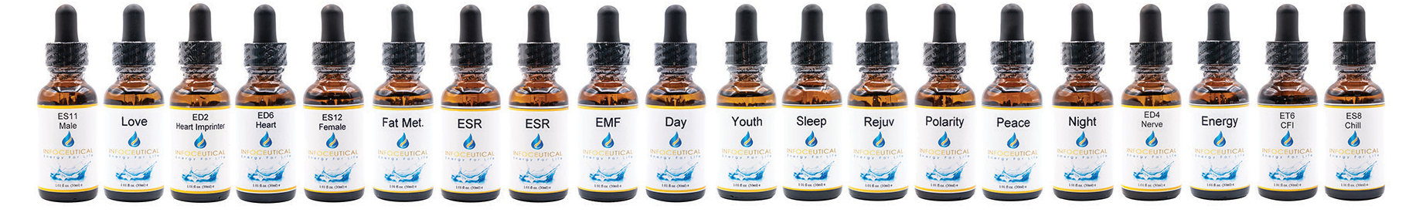
*
**
Name is the name on the bottle
Scan – when this result shows on the scan, this infoceutical will resonate well with your body.
**** More information on the type of complaint that this infoceutical helps with. See portal.neshealth.com for more information
This is a quick reference type of symptom that is often assisted with this infoceutical
***
#
Name*
Scan**
Symptom***
Description****
1

PL

PL

Jet Lag, Geopathic
Stress, EMFs

Contains the information for charge and light, helping your body to re-establish Polarity to
its natural, optimal state. Helps with air travel, exposure to electromagnetic fields, geopathic stress and long-term stress and health issues.
2

Day

Day

Fatigue

Aids body to catch light particles, helps the cells to produce, store and use energy from sunlight. It matches to the sympathetic nervous system, giving energy and drive during the day.
3

Night

Night

Sleep

Helps body produce energy and burn fat at night. It matches to the parasympathetic nervous system, which governs rest and repair. Helps to protect against EMF. Syncs with natural circadian rhythms and produce melatonin and DHEA at night. Use after sunset
4

Fat Met

Liver

Liver, Overeating

Fat Metabolism helps to correct and normalize liver function, hormonal activity, and metabolism of fat. Supports the nervous system and may encourage appetite regulation.
5

Youth

Day

Ageing, Sleep, Excess Sun / X-Ray Radiation
Addresses ageing of the brain as age increases. May have an effect on melatonin production, helps correct the effects of radiation, eases electro-sensitivity, senility, mental confusion in older people, poor sleep due to melatonin deficiency, and X- ray exposure.
6

EMF

EMFs, BFA

EMF Protection

Helps correct energetic imbalances from radiation exposure. May help improve your ability to deflect electromagnetic fields. May be used topically on the hands, back of neck, or other exposed areas.
7

Rejuv

Muscle

After Sports, Muscles Soreness, Tissue Rejuv
Helps rejuvenate the body after sports, strenuous physical activity, physical injury, impact or shock. Aids in tissue regeneration, muscle recovery, muscle tone. May ease muscle strains, swelling, and trauma. May be applied topically in injured areas.
8

Sleep

Night

Balancing of whole circadian

Promotes balanced sleep cycles and regulation of your body’s natural rhythms. May have a harmonizing affect on the body’s entire energetic system. Use 3-4 times throughout the day, with the last dose before bedtime to reset your sleep cycle.
9

ED 1

Source

Energy Pick Up

Enhances source energy available for physical activity. May be useful when energetically depleted due to chronic illness, mental exhaustion, stress, toxic exposure, malnutrition, or poor breathing. Use before and during physical activity.
10

ED 2

Heart Imprinter

Heart Brain Coherence

Energetically enhances the heart’s ability to imprint nervous system information onto the bloodstream. Helps re-establish the head-heart connection, promoting mental clarity and a positive emotional outlook.

11

ED 4

Nerve Driver

Stress, Toxicity, Sleep

Nerve Driver supports nervous system to help your body deal with stress. Helps to shed toxins, calm the system, and aid in your ability to get a restful sleep.
12

ED 6

Heart Driver

Decisions, Clarity, Self Esteem

Heart Driver helps with decision-making processes, mental clarity and integration, identity and self esteem. Helps regulate emotions. May have a beneficial affect on skin tone and appearance.

13

ET 6

CFI

Flu & Colds

Cold Flu Immunity (ET 6) aid’s in the body’s natural ability to recover from cold & flu symptoms. May provide relief from fatigue, promote drainage, and re-tune cellular function.

14

ES 8

Chill

Long Term Stress

Chill encourages a calm mental state, and the releasing of emotional and sensory data. May be helpful when suffering from constant, long-term stress.
15

ES 11

Male Energy

Charisma, Maleness

Male helps support the correct male endocrine function to enhance social abilities, attractiveness, sexual function, and charisma. Helps promotes confidence, willpower, social warmth, and wellbeing.
16

ES 12

Female Energy
Confidence, Feminine
Female supports female endocrine function to enhance social abilities, attractiveness, sexual function, and charisma. Helps promote confidence, willpower, social warmth, and wellbeing.
17

MB 5

Emotional Stress Release
Emotional Stress, Digestion

Emotional Stress Release / Mind-Body 5 supports the release of emotional stress, soothes the digestive tract, and may assist in the absorption of nutrients. May be applied topically to areas of physical trauma.
18

MB 7

Peace

Calm, Clarity, Honesty with Self

Promotes a calm mental state, mental clarity, and honesty with oneself. Enhances the
head-heart connection to resolve conflicts between emotions and logical thought, as well as memories that have caused disharmony.
19

MB 8

Love

Unconditional Love

Love / Mind-Body 8 promotes feelings of unity and unconditional love for oneself and others. Supports personal transformation, and helps to clear the crown chakra.



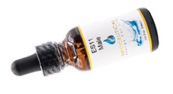
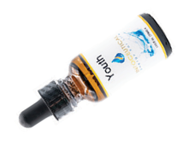
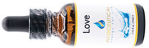
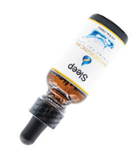
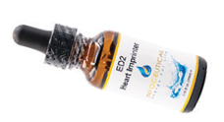
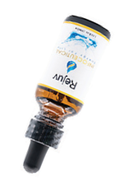
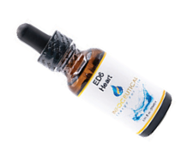
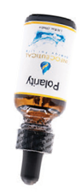
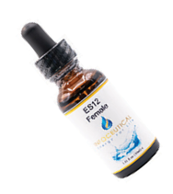
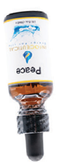
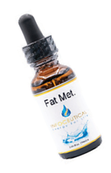
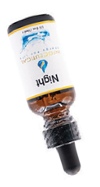
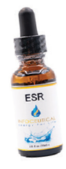
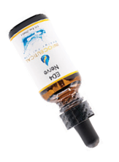
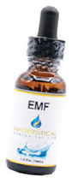
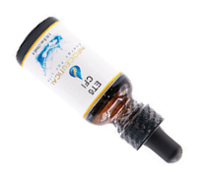
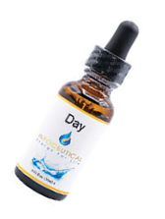
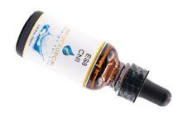
What are Feel Good Infoceuticals?
Designed to make you feel good, these 19 Non-Prescription proprietary liquid remedies are encoded with bio-information help correct imbalances of our Body-Field - the energetic blueprint of our physical body. Uniquely, you may purchase them based on your assessment of your scan, without involvement of a practitioner or prescription.

The Benefits
- may correct Body-Field distortions to support and maintain optimal wellness.
- may induce an immediate sense of wellbeing and vitality.
- may experience more dreams and a greater sense of personal insight.
- may stimulate positive shifts in specific physical and emotional issues
Get your Free Unlimited Lifetime Scans Account & Buy a scanner
Scan Yourself (instructions will be sent)
Look for Orange Dots (4), and or Purple Dots (5) on your scan
Study the reasons in the software & compare with Feel Goods overleaf
Did the Feel Goods come up?
Order from the shop
Get help by contacting The Energy Clinic for a bespoke protocol
Your Next Steps Steps
7)
5)
6)
3)
4)
1)
2)
Ken R Macleod FDP-P CHPC PHC scans@theenergy.clinic
02 9016 2889
theenergy.clinic
Contact: Email:
Tel:
Web:
How to Use the Feel Goods
There is little risk of the feel goods making you feel bad, nevertheless, the standard directions are to take 15 drops as needed in a small glass of water, or under the tongue.
How to Choose the Feel Goods
Use the table overleaf to understand the purpose for each of the Feel Goods. If one resonates with you try that one. Otherwise, if your scan shows any one of the Infoceuticals as purple or orange, then the suggestion is that you could benefit from those Infoceuticals. They are designed to make you feel good, potentially as a first aid even without scan as support.
Why the Feel Goods?
You are able to read your own scan, and select one or more of the Feel Goods without a practitioner’s prescription. They are available for purchase in your account. If you are enjoying the Lifetime Unlimited Scans account without engaging a practitioner (formally) then you are able to self-direct using the software, and any one or more of the Feel Good infoceuticals.
Infoceuticals:
The “Feel Good” Range

