Hello, this is for the herbal tea and petal jars.
I am trying to make them generic so I can just tick and write on the label when each batch is processed. This is just a feel for what I would like so happy for any suggestions and changes to font layout etc etc.

Front Label 9 x 5 cm and 6 x 5 cm
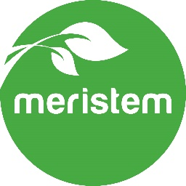


LEaF
& PeTAL

Grown, harvested and dried
Chemical free on our farm in east Gippsland

Back label 5 x5 cm

Single Origin
Herbal Tea etc.
Leaf Base: | Lemon Verbena  Mint  Agastache
Petals:
Batch:
Simpsons Creek
Victoria Australia

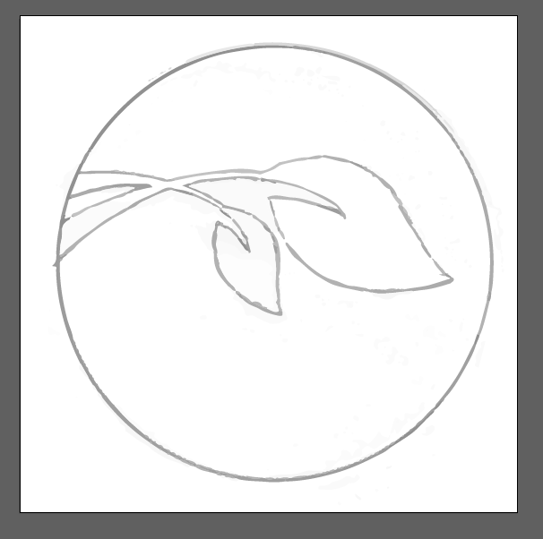
modified logo to go on front label, same as original with the green fill blank leaf (Not square, that was just clip tool)
Labels: paper, removable, eco and textured. I like the White Ever/Kaschmir.
Maybe with the modified logo in foil?

