Cooking Instructions:

* Do Not Boil *
* Not compatible with Induction Stove*

Pan fry:
1. Heat Non-Stick Pan at Medium/ High
2. Add 1 tablespoon Oil
3. Add frozen dumplings
4. Brown bottom of dumplings
5. Add 1/2 cup cold water
6. Cover for 4- 6 minutes
7. Turn dumplings, fry to desired crispiness and serve

Ingredients:

Filling: Chicken, Cabbage, Braised Shiitake (Shiitake, Ginger, Garlic, Mirin (Water, corn syrup, alcohol, rice, salt), Tamari (Water, Soy Beans, Salt, Sugar), Sesame oil), Eggs, Shallots, Oyster Sauce (Water, Sugar, Salt, Oyster Extractives (oyster, Water, Salt), Corn Starch, Caramel Color), Tamari, Garlic, Mirin, Mushroom Stock, Sesame Oil, Corn Starch, Salt, Pepper
Wrapper: Rice Flour, Tapioca Flour, Xantham Gum
Dumpling Sauce: Tamari, Rice Vinegar, Sesame Oil, Sugar, Water
Contains: Egg, Soy, Corn

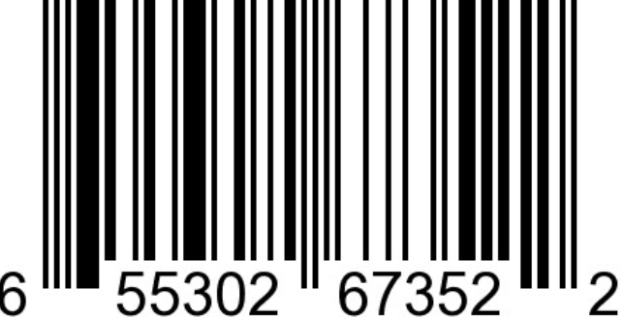

House of Yee Fine Foods

Port Coquitlam, British Columbia
Email: christine@houseofyee.ca

Instagram: @houseofyeefinefoods
Facebook: @houseofyeefinefoods

Manufactured in a Gluten Free dedicated facility.

