Cooking Instructions:

* Do Not Boil *
* Not compatible with Induction Stove*

Pan fry:
1. Heat Non-Stick Pan at Medium/ High
2. Add 1 tablespoon Oil
3. Add frozen dumplings
4. Brown bottom of dumplings
5. Add 1/2 cup cold water
6. Cover for 4- 6 minutes
7. Turn dumplings, fry to desired crispiness and serve

Ingredients:

Filling: Pork, Cabbage, Braised Shiitake (Shiitake, Ginger, Garlic, Mirin (Water, corn syrup, alcohol, rice, salt, Tamari (wWater, Soy Beans, Salt, Sugar), Sesame oil) , Cabbage, Eggs, Shallots, Oyster Sauce (Water, Sugar, Salt, Oyster Extractives (oyster, Water, Salt), Corn Starch, Caramel Color), Tamari, Garlic, Mirin, Mushroom Stock, Sesame Oil, Corn Starch, Salt, Pepper
Wrapper: Rice Flour, Tapioca Flour, Glutinous Rice Flour, Xantham Gum
Dumpling Sauce: Tamari, Rice Vinegar, Sesame Oil, Sugar, Water
Contains: Soy, Corn, Egg

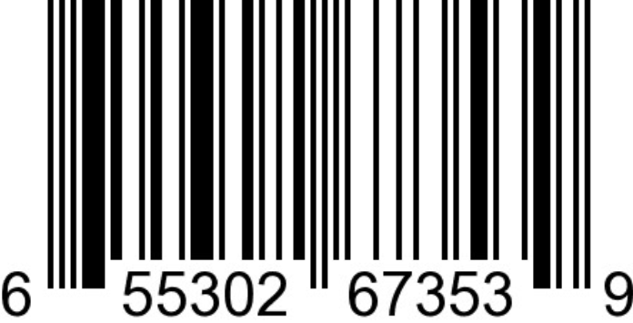

House of Yee Fine Foods

Port Coquitlam, British Columbia
Email: christine@houseofyee.ca

Instagram: @houseofyeefinefoods
Facebook: @houseofyeefinefoods

Manufactured in a Gluten Free dedicated facility.

