Piha Footbridge Video – Brief
8 Sep 2020

We are a team of Bridge designers and we are seeking creative video editing services.

We need a video showcasing our footbridge. We have provided videos and images of the bridge for use in the creation. Please edit/crop out all people and/or red construction fencing. Music would be a benefit (nothing too crazy). The video will be used on our Linkedin and website platforms. Please make it 60 seconds long.

We will have future projects coming up. If we like what you do, our aim is to commission future projects directly with the winning designer.

Can we have the DC logo shown in the top left corner of all videos as a watermark:



Here are examples of a videos we like:
- https://www.linkedin.com/posts/world-economic-forum_environment-activity-6706589850407075840-coAn
- https://www.linkedin.com/posts/matthew-rayner-01ba4a49_snowabrplow-remoteabrcontrolled-technology-activity-6706125433085272064--MQe
- https://www.linkedin.com/posts/the-b1m-ltd_construction-architecture-building-activity-6706501044123287552-jRQk
- https://www.linkedin.com/posts/vectorworks-inc_bim-bimwithvectorworks-activity-6703693191738085376-szAu
- https://www.linkedin.com/posts/arup_digitalfirst-nextnormal-digitaldesign-activity-6708652611383369728-mPLS

We are looking for a sophisticated but modern video.

Part 1 – completed bridge videos and images

Please arrange the videos in a stylish/sophisticated way. Use the following text to overlay over the video (in this order):

Piha Footbridge – Auckland, NZ

15m spanning steel truss

Specifically designed for difficult to access site

All components lightweight and bolted on site

Low cost but architectural solution

Clad in Scandinavian Accoya pickled pine

15m span, 1.2m wide, 2KPa loading, to NZS1170

Part 2 – Computer modelling

Transition from this image:
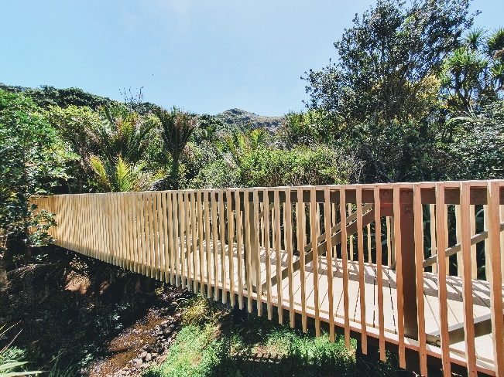
To the modelling video:
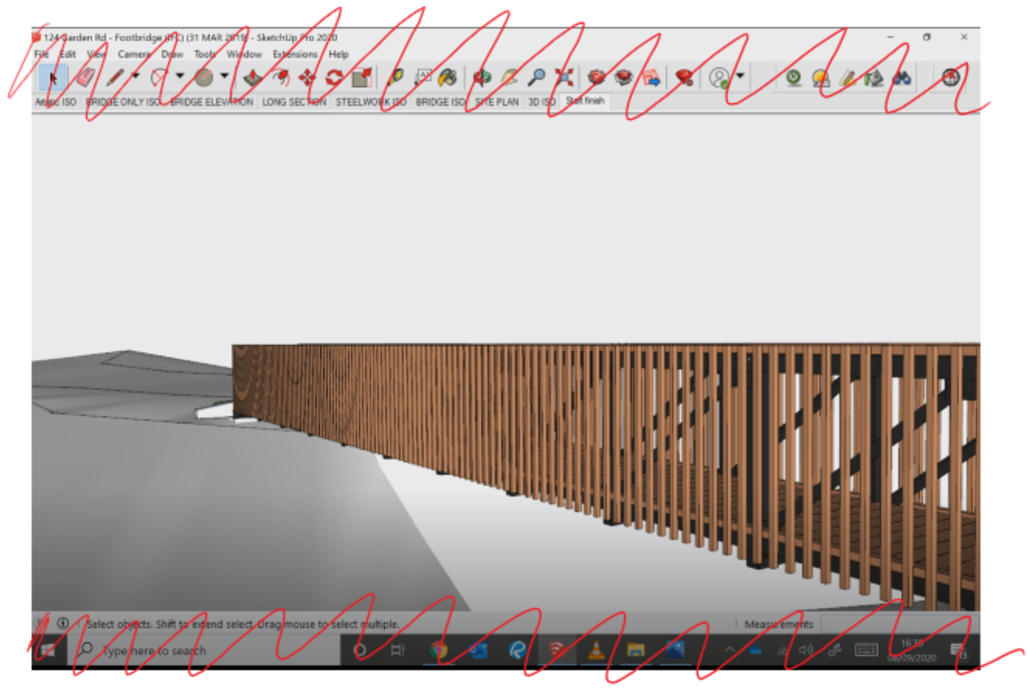
And back to the original image:

Please make it look smooth. And add the following text over the top:

Modelled in full 3D environment

Enabled a perfect fit on site

Allowed for clear understanding of flood envelopes

All steelwork details were carefully considered and crafted

3D modelling prevented unwanted clashes

3D model then used for creating 2D construction drawings

Outstanding results for our client

Part 3 – End Sequence:

Finish with a last sequence including the design firm logo. Make it look sophisticated and professional. Maybe add some dynamic lens flare (or similar).

Architecture and Engineering by:



In associated with



Let us know if you have any questions.

We look forward to seeing what you can do!

Dan and the DC Structures Studio Team.

