Eflute box – 15.5 inch x 13.5 inch x 13.5 inch
Customer box – couture dress company for children – must be sophistcated – not child like
Logo – color back ground – whisper white 11-0701
Font color – pale gold 15-0927 - use these colors and grades to match – suitable colors
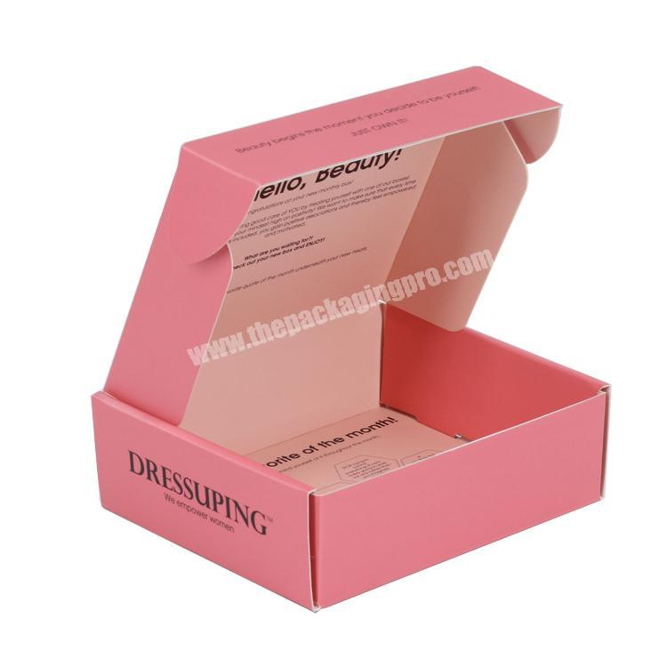

Printing required on all sides of the box – inside and outside of the box -



Inside the box – text
When customer opens the box – they will see this:
– same idea – but different fonts and words and shades of colors to match box and logo (must be feminine font)
Two prominent words = Be (you) tiful , Smart , Princess
Smaller words=
Sparkles, Luxury, Tiara, Magical, Special, Elegant, Delicate
Sweet, Surprise, Royal, Stunning, Confident, Adorable, Brave, Talented, Extraordinary,
Girl Power, Happy, Super Star , Smile , Lucky , Treasure , Adore , Love , Hope ,
Wish, Dreams, Imagine ,

This should also – be on the box :

w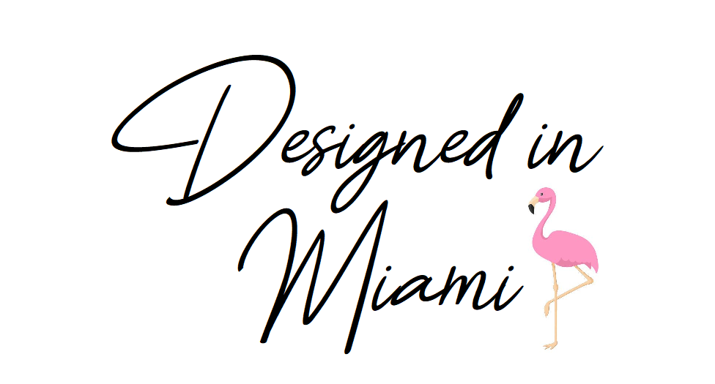

also – on the box:
www.calgaryandballerini
calgaryandballerini ( Instagram )

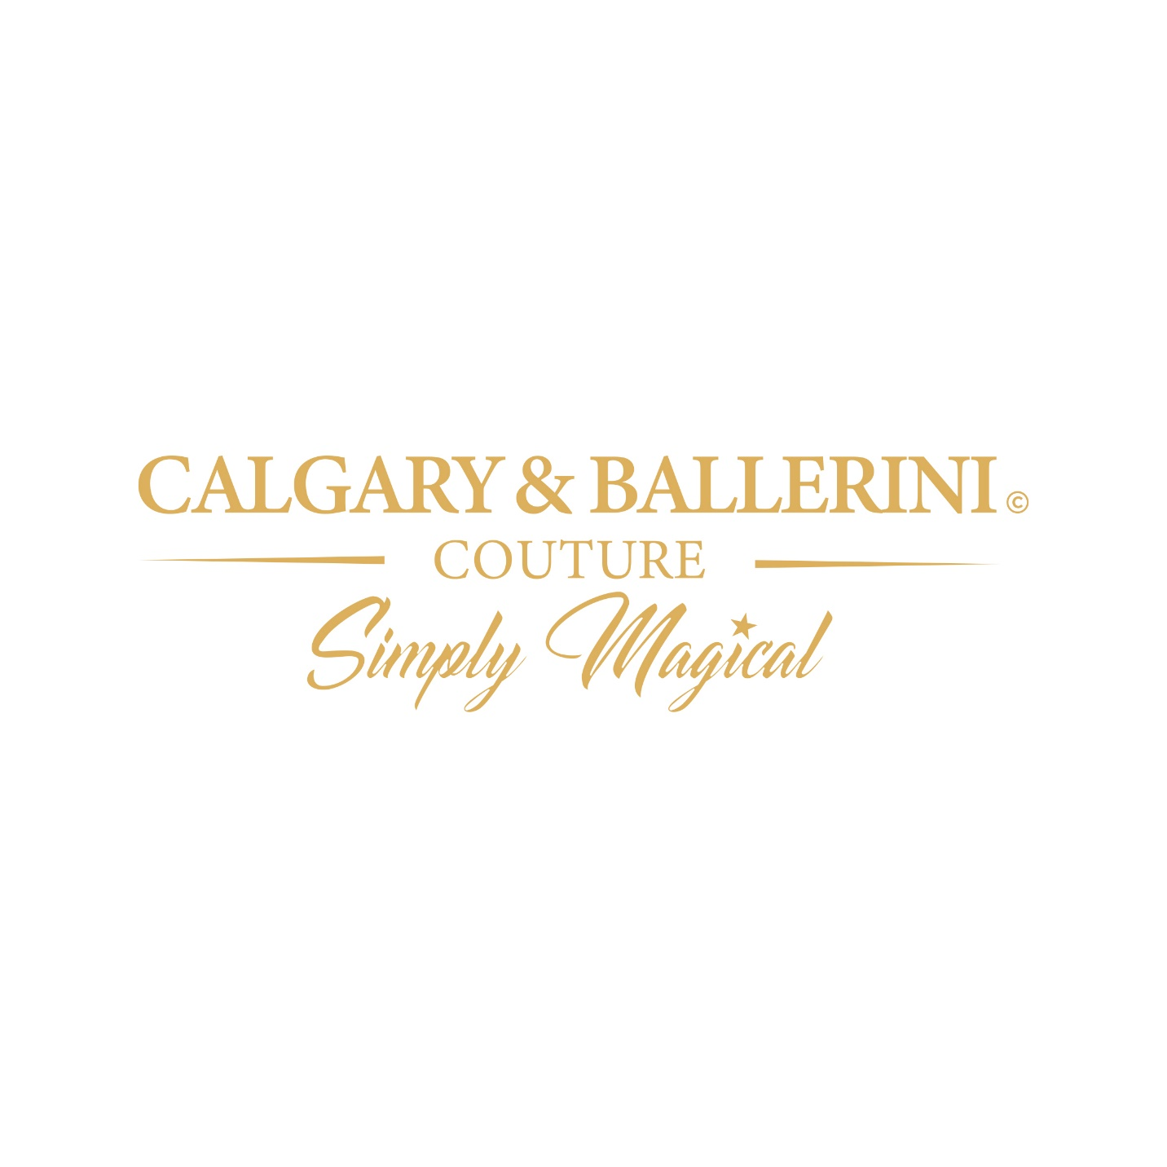
This is the logo and will be on the front of the box

