UpConnectMe

9128 Strada Place, Suite # 10115
Naples, FL 34108

1855-4-UpConnect ( 1855-487-2666 )

Branding guidelines
September 2020

OVERVIEW
This document is a work in progress and aims at providing comprehensive guidelines for the brand identity of UpConnectMe.

SCOPE
These guidelines apply to all forms of communication from UpConnectMe including website, emails, newsletters, press releases, marketing brochures, print and business cards.

Color palette

Color Psychology
The following is a correlation of strong emotions to colors, as generally perceived.

- Blue : Trust, Reliability and Security
- Orange : Confidence
- Yellow : Happiness
- White : Purity
- Black : Exclusiveness

Branding Color Guidelines

Given the above color psychology primer, we established the following color relevant branding guidelines for UpConnectMe and they need to be adhered to in all forms of communication so that the integrity of the brand identity is maintained and projected in a consistent manner :

Blue : The monochromatic blue color palette shown below in this document shall be used whenever the communication is supposed to project a sense of security, privacy and protection offered by UpConnectMe : no data mining and third party access free nature.

Orange : This is the complementary ( contrasting color ) to be used as an accenting color for communication in which blue ( from our color palette ) is primarily used . This enables the users to experience a visual break in a harmonious and balanced manner because Orange is on the opposite end of the color spectrum from blue.

Yellow : This color is to be used when the communication is expected to emphasize the happy, vibrant and relaxed connections enabled and empowered by UpConnectMe’s ad free and data mining free nature.

Black : This color is to be used when the communication is expected to emphasize the exclusive / upscale and PAID nature of the UpConnectMe platform, appealing to the savvy and discerning.

White : Pure white ( for lettering, background or whitespace) is to be used when the communication is expected to project a sense of pristine / clean space offered by the ad free nature of the UpConnectMe app.

Branding Color Palettes :

Blue Color Palette :
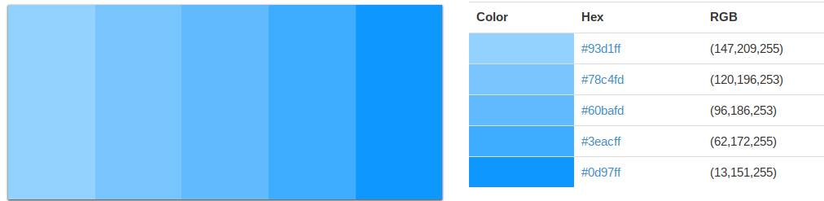
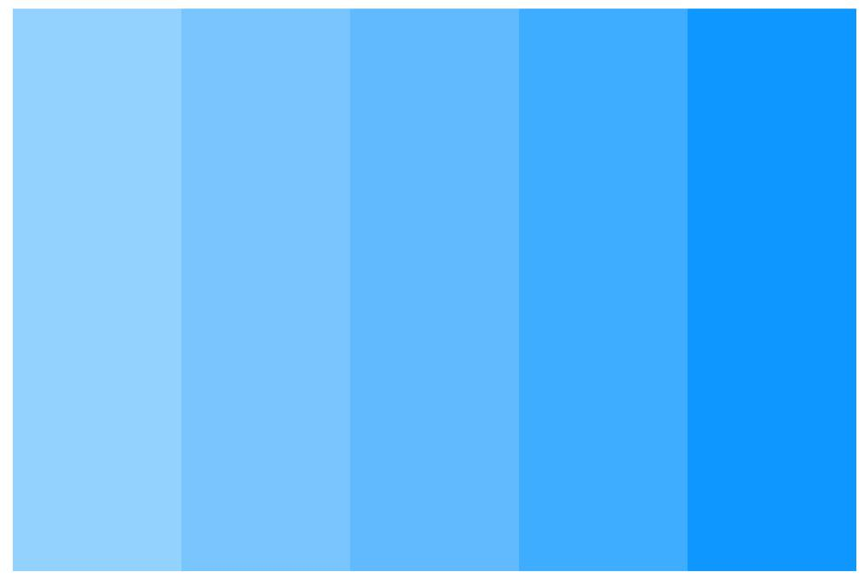

Orange : # fe8900

Yellow : # ffcc33

Black : # oooooo

White : # ffffff

