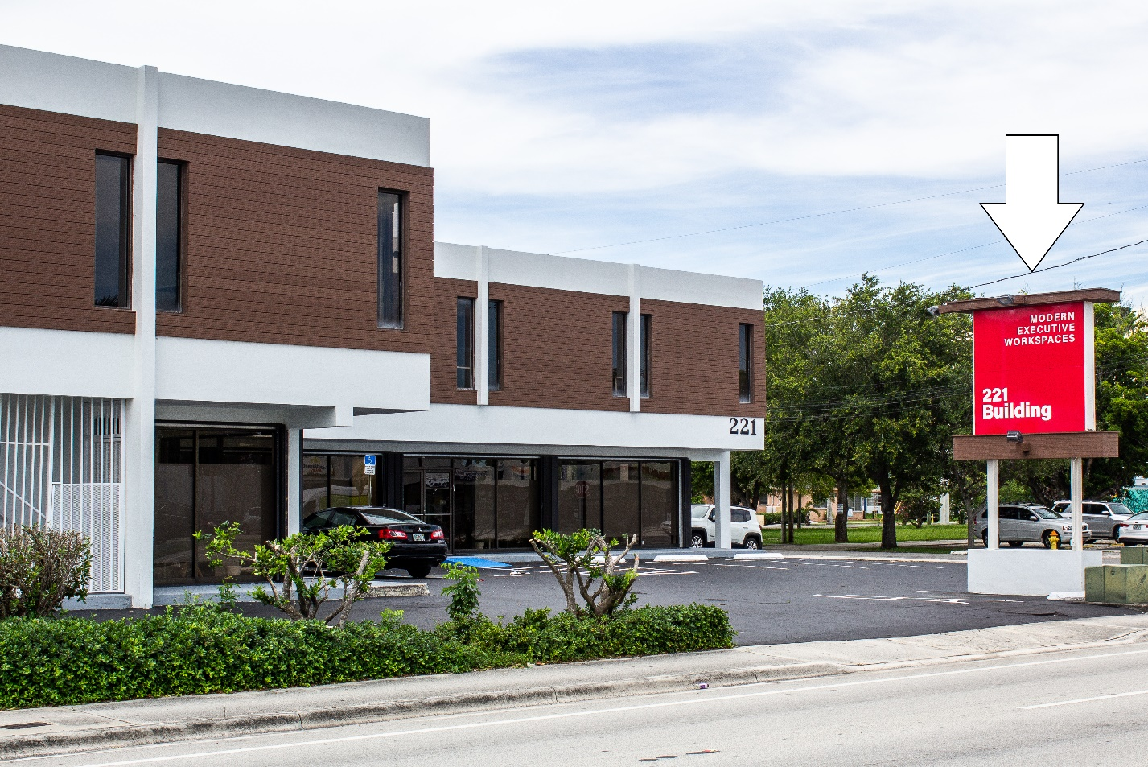
Please put your logo design over our old logo so we can see what it will look like

