US:
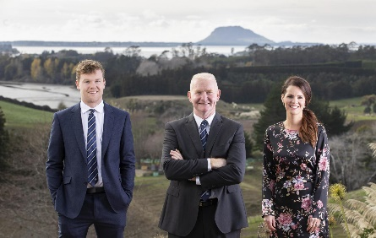

What Are we and where do we want to sit in the market:

We work for a company called “Bayleys’
They are the premium top real estate brand in the area and tend to sell properties at the higher end of the market. $ 1 Million upwards.
We are a three person team working in rural property sales
We sell:
- Lifestyle blocks – small rural properties where you can have a few cows and sheep
- Large farm blocks
- Orchards of various types
- Kiwifruit, Avocados, Berries
- Waterfront sections
- Multimillion dollar lodges and house

Our Current Logo (As it appears in one of our Ads):
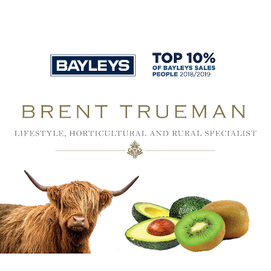
Ad Examples With Current Logo Incorporated
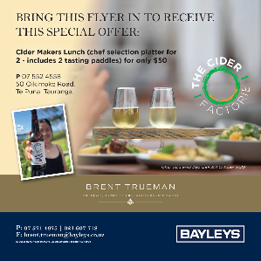
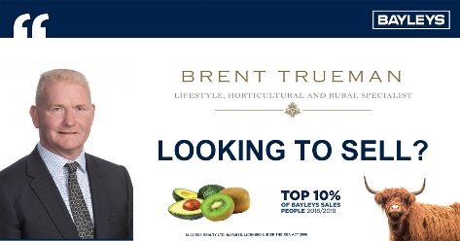

Problems with the Current design.
- Doesn’t stand our when small like when on a facebook or Instagram advertisement
- Needs to be Team Trueman Instead Of Brent Trueman
- Gold makes it look old and not modern.
- Overall the logo looks dated and doesn’t work will overlaid

What we want from our logo

We need a logo that stands out when large (On Billboards) and when small (Facebook advertisements & Instagram).
- Needs to be bold
- Needs to stand out when overplayed on background other than just blue whit and bleck. Needs to stand out when on a property with sky or orchards.
- Bold colours
- Work will with graphical elements such as farm animals or orchards (vines, Grapes, Cows etc)

The Company We Work Under “Bayley’s New Zealand”
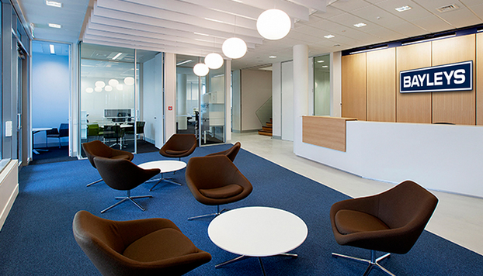
Bayley’s are the premium property sales company in our location we do over 40% of the country property sales and wee focus on the upper end properties in the area
Typical property sale: 1.4 Million – 6 Million

Typical Property images
