 |  | Your property's value will be optimized to reach its potential through our revenue maximization services.
 | Airbnb Search Engine Optimization |  |  | Proprietary Pricing Tool |  |  |  | Strategic Calendar Management
 | Airbnb ranks all listings using an algorithm (much like Google) and our optimization techniques allow your listing to appear higher in search results and receive more bookings. |  |  | We have developed a proprietary pricing tool that allows us to determine future nightly rates based on demand. This tool has led us to managing the #1 & #5 Highest Revenue 2-Bedroom Listings in Calgary. |  |  |  | Our strategy focuses on future bookings being as long as possible. This, along with other techniques, has resulted iin our properties averaging an ~85% occupancy rate which is ~20% above market average.
 | Guest Experience
 | End-to-end management of the guest experience
 | Local Calgary Experts (events, guidebook, advice)
 | Rapid response time to guest messages
 | 24/7 Guest Support
 | On-Site Services (check-in, maintenance, etc.)
 | Professional Photography
 | Tablet for Guest Use
 | Home Care
 | Professional cleaning with unique cleaning guide
 | Staging guide created for consistent appearance
 | Inventory and replenishment of essentials
 | Property inspection between reservations
 | Linen service including towels
 | Coordination of maintenance
 | Safety & Security
 | Smart Lock (Condo Compliant)
 | Sensory Security Devices (non-invasive, real-time data)
 | Insurance for damage provided by Airbnb*
 | Enhanced Guest Screening
 | Ongoing Guest Risk Assessment
 | Performance Optimization
 | Proprietary Pricing Tool used Only by Your Key
 | Strategic Calendar Management
 | #1 & #5 Highest Revenue 2-Bedroom Listings in Calgary
 | Enhanced Analytics (above what Airbnb provides)
 | Monthly Property Performance Review
 | * we recommend all homeowners purchase additional insurance as desired
 | Safety & Security
 | We pro-actively monitor the property through non-invasive sensory technology. This provides us with real-time data that we can use to intervene on any potential risk situations before they become incidents. We also provide enhanced screening and risk mitigation/ management techniques for every reservation.
 | How is the management fee calculated
 | We strive to keep our fee as simple as possible with 80% of revenue going to you, 20% to Your Key for the management and the cleaning fee is paid for by the guest.
 | For more information on our service options, please see our pricing area.
 | What is a Short-Term Rental (STR)? |  |  |  |  |  |  | Overview of YKRM
 | A Short-Term Rental (STR) is a property that is typically rented for duration of less than 30-days. Although the property is rented for shorter durations (on average between 3-7 days), we would manage the property year-round. By renting on a shorter term, you are able to take advantage of peak demand periods throughout the year (Stampede, etc.) which results in a much higher revenue potential. With a significant amount of long-term rental inventory in Calgary, short-term rentals provide a solution to home owners and investor. |  |  |  |  |  |  | At Your Key Rental Management, we manage the entire hosting process, so you don't have to.  We do much more than provide a hassle-free experience, we specialize in maximizing the revenue from your property.  As a Short-Term Rental (STR), your property is able to take advantage of peak rental demand periods which results in significantly greater revenue than a traditional rental property.

How is the management fee calculated
We strive to keep our fee as simple as possible with 80% of revenue going to you, 20% to Your Key for the management and the cleaning fee is paid for by the guest.
For more information on our service options, please see our pricing area.
 | For example; |  | Nightly Rate |  | Number of Nights |  | Rental Revenue
 |  | Nightly Revenue | $100 | x | 5 | = | $500
 |  | 20% Your Key fee |  |  |  |  | $100
 |  | Owner Net Earnings |  |  |  |  | $400

Pricing
Your Key's share of the nightly revenue
20%
All money goes to your bank account, we invoice you one-time per month.
There are no additional fees and best of all, no surprises!
Our pricing structure is simple and easy to understand, that is by design!
The nightly revenue is split between the Owner and Your Key, 80% & 20% respectively.
The cleaning fee is paid for by the guest which covers all cleaning between guests. We do not take a fee from cleaning.
Click here to see an example

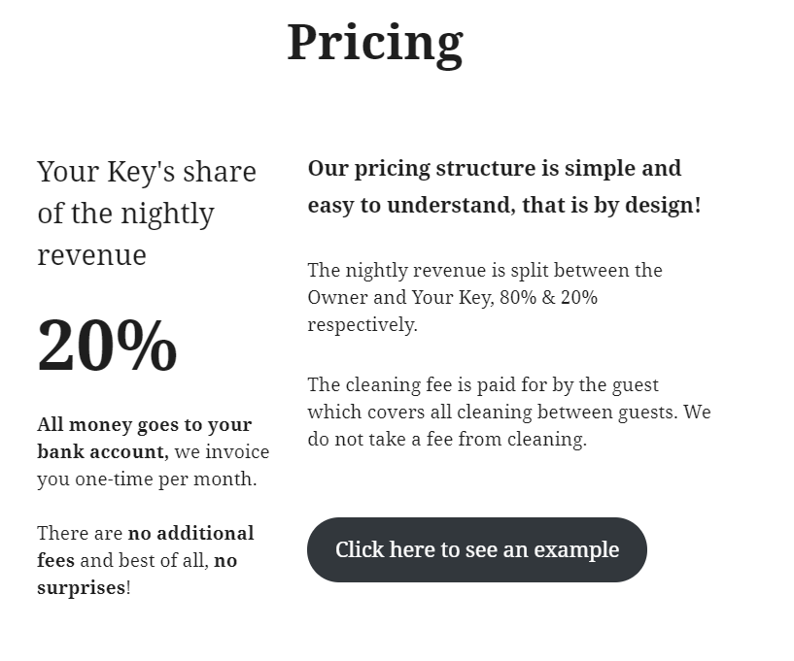

 |  | Full Service
Marketing | Listing Setup
Marketing | Professional Photography
Marketing | Staging & Design Recommendations
Guest Experience & Property Management | Guest Communications
Guest Experience & Property Management | Calendar Management
Guest Experience & Property Management | Pricing Updates
Guest Experience & Property Management | Airbnb Ranking Optimization/ SEO
Guest Experience & Property Management | Monthly Performance Updates
Guest Experience & Property Management | Guest Referrals (from other properties) | Priority
Guest Experience & Property Management | Claims Management
Guest Experience & Property Management | Client Hosting Support
Changeover Services | Cleaning (including Supplies)
Changeover Services | Property Inspection (between Guests)
Changeover Services | Inventory of Essentials
Changeover Services | Replenishment of Essentials
Changeover Services | Linen Replacement (including Towels)
Smart Home | Tablet
Smart Home | Smart Lock
Smart Home | Sensory Security
On-Site Services | In-Person Check-In
On-Site Services | On Demand Guest Requests
On-Site Services | Maintenance Coordination & Supervision
 | Management Fee | 20%
The above is a full list of services that can be incorporated as needed based on the design of the website. We would like to keep the “Pricing” section of the webpage to be clean but we also need people to know our full suite of services.

Example of how to lay out the services but the list would need to be collapsible:
