
  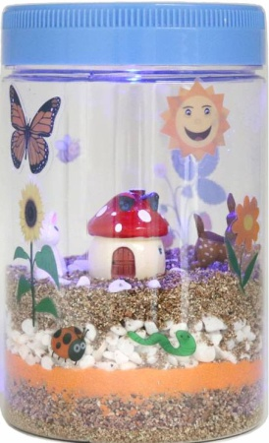
  LED Lighted
  Terrarium Kit
  GROWING GUIDE

What is a terrarium?  A terrarium is a miniature, tabletop garden in a container that mimics the natural world outside. It’s a piece of nature that is small enough to hold in your hands.  Terrariums can be in any glass containers, like a fish bowl or even an old, empty light bulb. EZ Learning Kits Light-up Terrarium is the ideal size for you to observe a mini ecosystem up close right on your desk.  As soon as you plant your terrarium, you’ll find out not just what is takes for plants to grow, but also how fun and exciting gardening can be!  Are you ready to dive in, put together your terrarium today, and start weeks of fascinating, scientific fun? |  |  | We would love to see your creations! For any questions, please e-mail us at support@ezbioresearch.com
 |  |  | 5

HELPFUL HINTS  - Place the terrarium in a sunny and warm spot.  - If the seeds are not sprouting, check the dampness of your soil; it might need more water, so spray as needed.  - If the terrarium gets too wet or humid, you might notice some fuzzy growth appear on the soil. This growth is called mold and is not harmful to your health. Allow enough air into the jar by removing the lid and letting the soil dry up a bit. |  |  | What’s in your kit?
  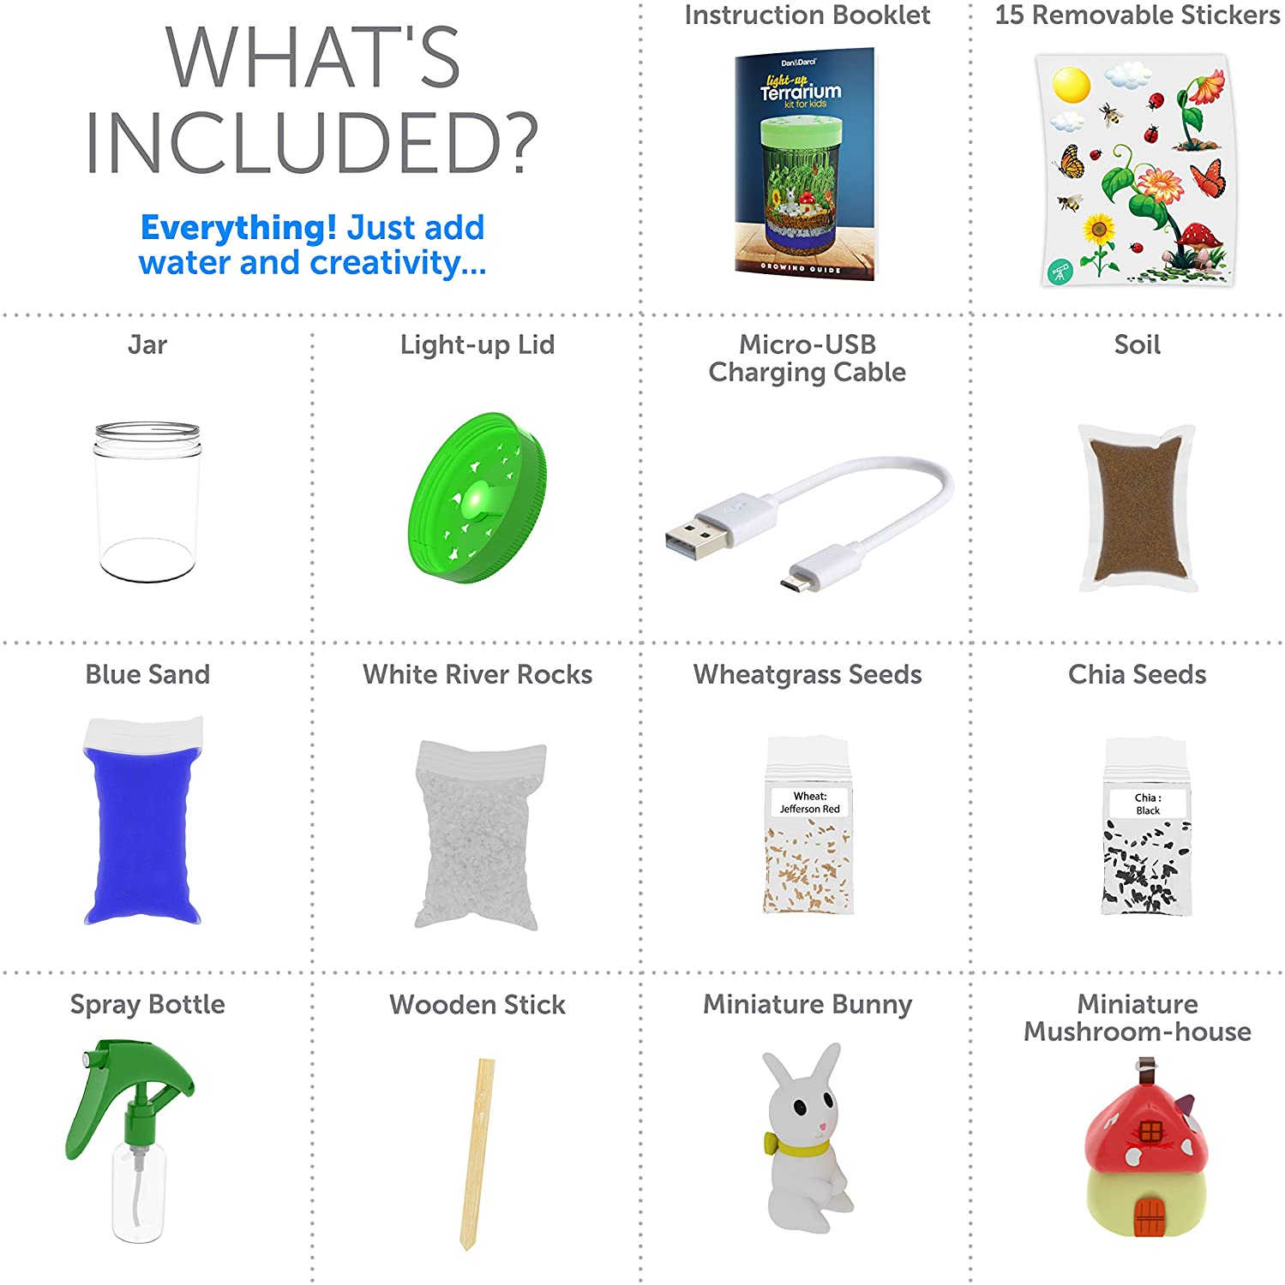 | JAR | 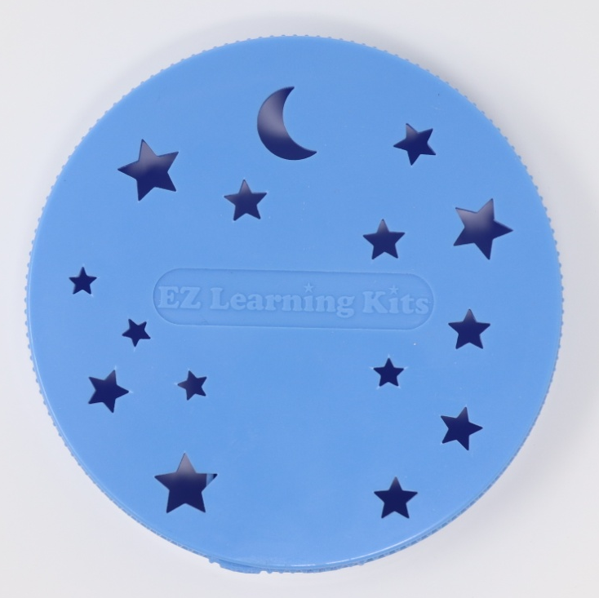 | LIGHT-UP JAR LID
  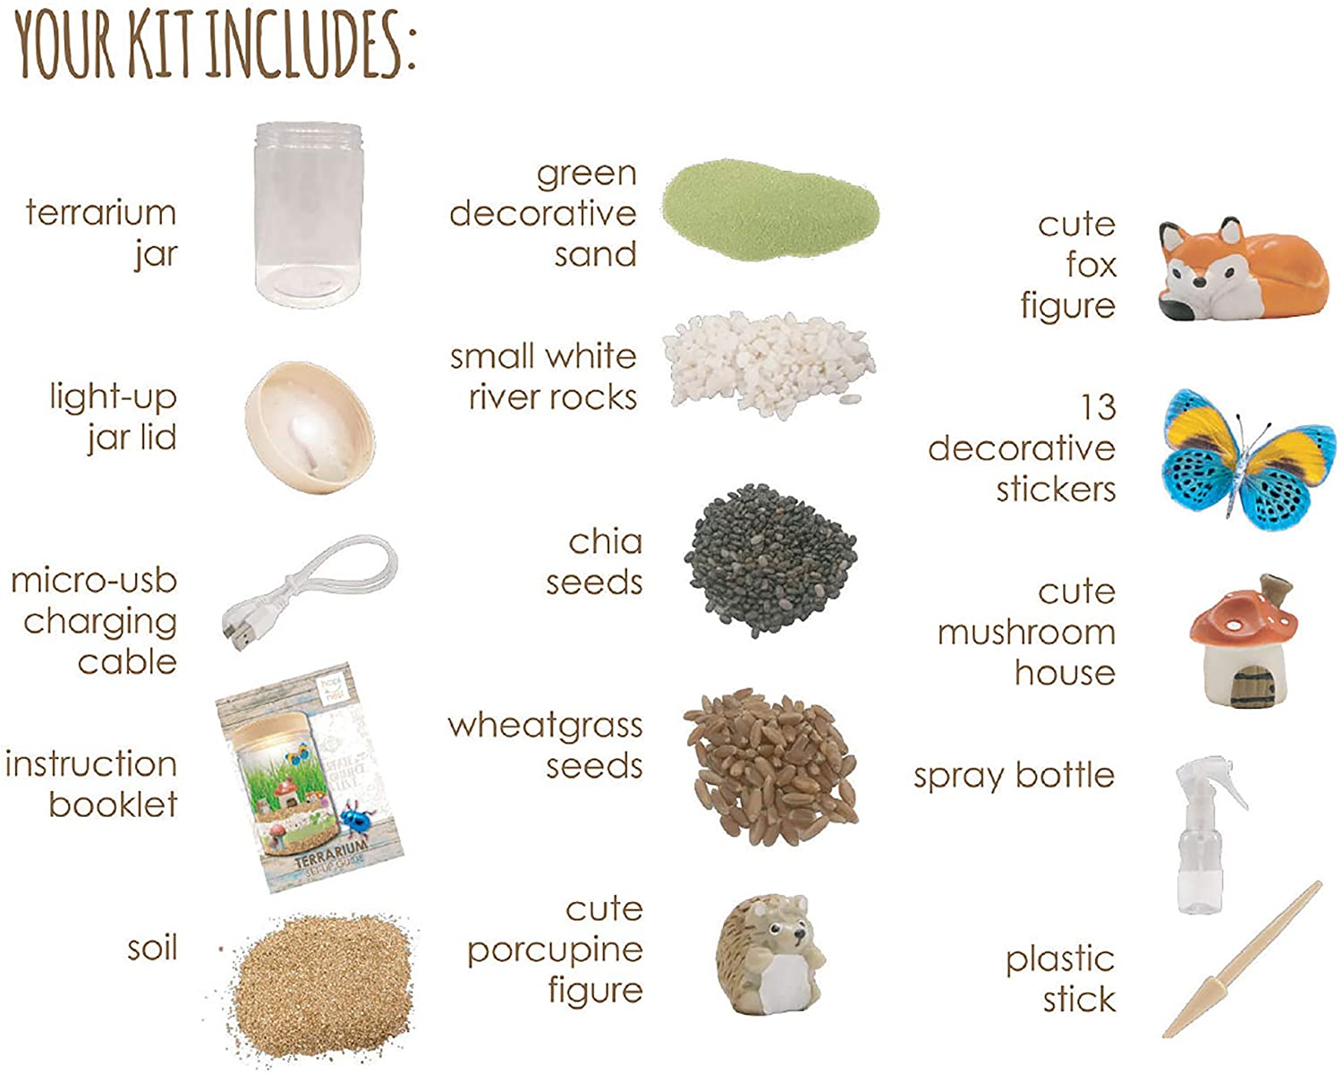 | MICRO-USB CHARGING CABLE | 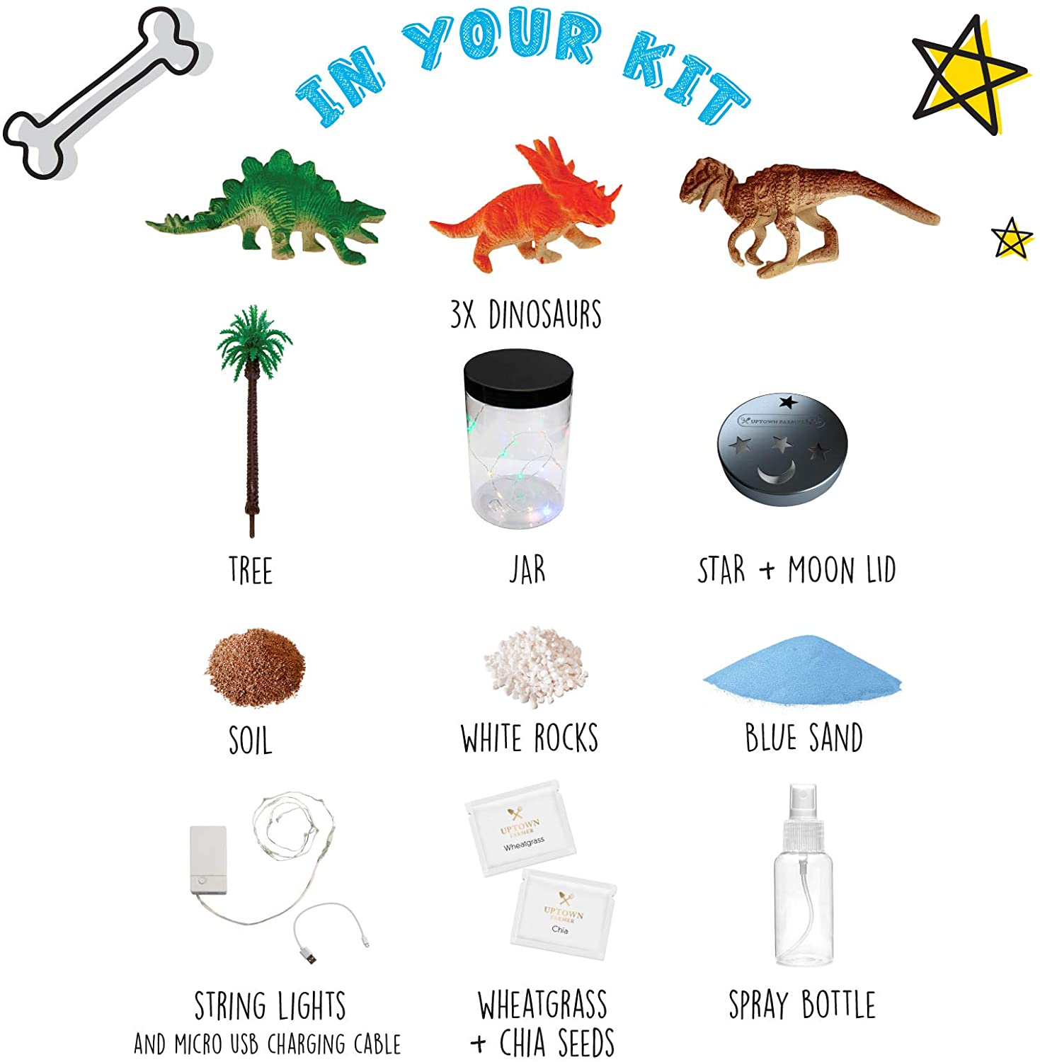 | SOIL
   | ORANGE SAND |  | WHITE RIVER ROCKS
   | CHIA SEEDS |  | WHEATGRASS SEEDS
  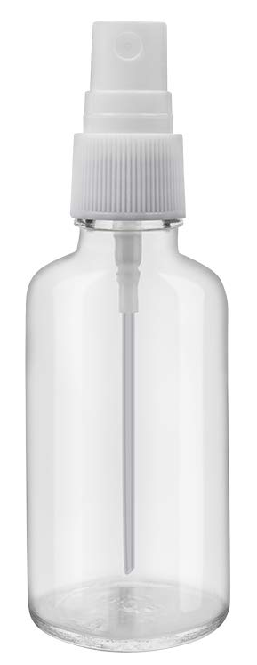 | SPRAY BOTTLE | 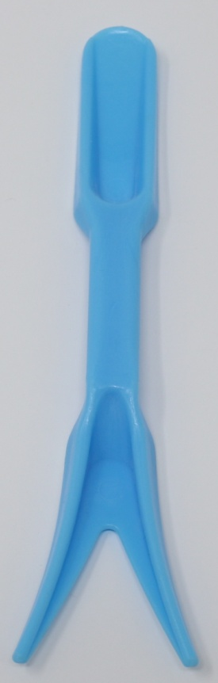 | SMALL STICK
  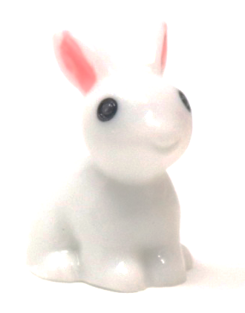 | MINIATURE BUNNY | 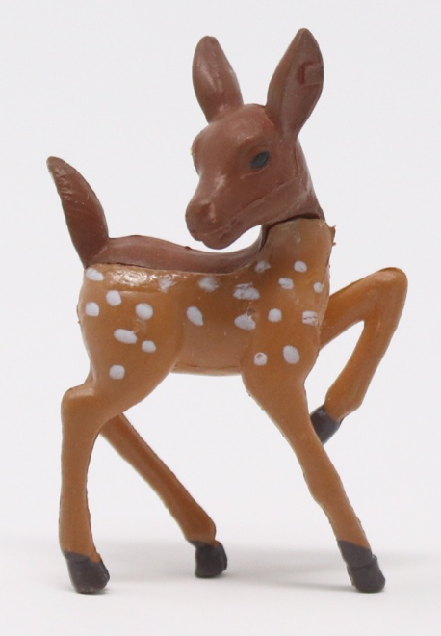 | MINIATURE DEER
   | DÉCORATIVE STICKERS | 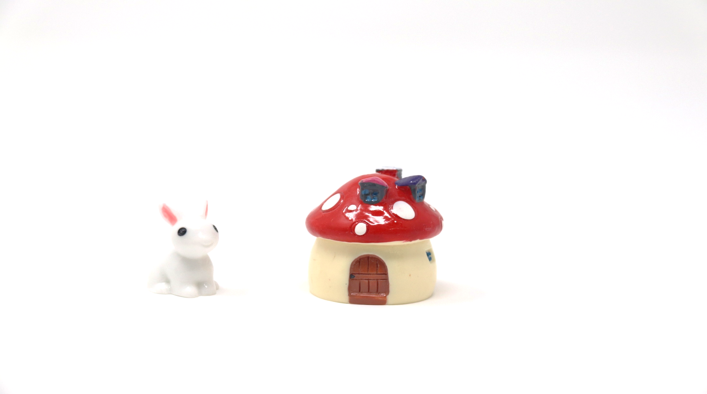 | MINIATURE MUSHROOM-HOUSE
4 |  |  | 1

How to make your terrarium glow!  The light-up lid has star cutouts for air circulation and a small light underneath it so that it will make your terrarium glow at night.  Use the included Micro-USB cord to recharge the light. The charging port can be found by lifting the silicone piece with the USB icon on it. You will need a USB adaptor (not included) to connect the other side to power. It will take 2-3 hours to fully recharge the light.  Once the light is fully charged, just flip the On/Off switch next to the charging port, and the light should shine for approx. 4 hours. Enjoy the truly magical glow in your mini garden!  Tip: To enhance the lifetime of the battery, it is recommended not to charge the battery more than needed.  Warning: Do not tamper with the battery or attempt to open the casing. It may cause injury. |  |  | Your terrarium is all done!  Place it in a sunny spot, and don’t forget to water it with the spray bottle every day. Your plants need a light and water to grow.  Don’t forget to recharge the lid before nighttime.  Once the light is charged, you’ll be ready to turn it on - wait until sunset for a truly magical glow!  In most cases, the seeds take about 3-4 days to start growing.
  Decorate the jar with the stickers. Don’t worry about mistakes or changing your mind, since all the stickers are easily removable. (Be careful not to tip the jar while applying the stickers, or the layers will shift and mix together).
2 |  |  | 3

16
 |  |  | Putting together  your terrarium!  Once you’ve gathered all the materials that come with your kit, you’re ready to get started!  Ta your terrarium!  Once you’ve gathered all the materials that come with your kit, you’re ready to get started!
  12 | Carefully open the seeds mixture packet and sprinkle a generous amount of both types of seeds onto the soil (behind the miniatures). Don’t worry about being too precise, the more seeds you put into your terrarium, the more likely they are to sprout and grow, but too many seeds may overcrowd the jar. | 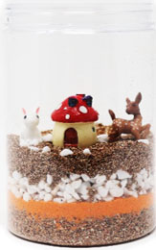
  13 | Gently press the seeds into the soil with the included blue stick.
  14 | Spray the soil again generously after the seeds have been planted. Your plants need lots of water to sprout and grow!
  15 | Screw the lid onto the jar. | 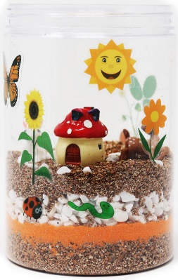
  1 | Rest the jar (without the lid) on a flat and stable surface. Slowly pour some soil into the jar until there is a layer of about 1 inch thick. Make sure the soil layer is even. Using the spray bottle gently spray all over the soil to make it moist, and then press down firmly with your hands to help keep the soil in place. | 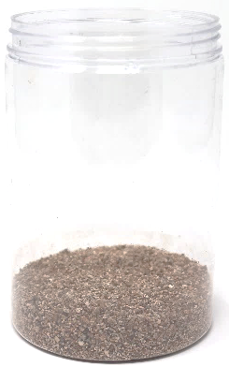
  2 | Slowly pour the orange sand on top of soil. Make sure the sand layer is even. Using the spray bottle, gently spray all over the sand to make it moist and firm, but do not press down with your hands. | 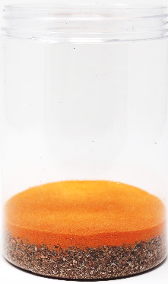
  3
2 |  |  | 3

  4
  5
  6 |  | 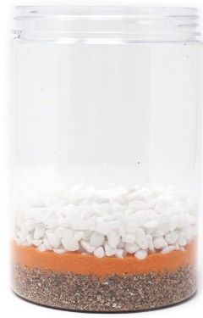
  7 | For the final layer, slowly pour some more soil on top of the rocks until you have an even layer about ¾ inch thick. | 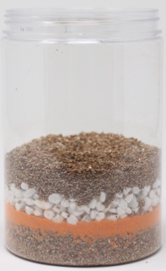
  8 | Using the spray bottle, generously spray all over the soil until it is very damp to the touch but not too watery.
  9 | Gently wipe off the inside walls of the jar from any dirt.
  10 | Place the miniature figures on top of the soil layer wherever you’d like. We recommend that you place them near the edge, facing outward so you can still see them when the plants start growing.
  11 | For added decoration, place some rocks around the miniatures.
2 |  |  | 3

