Outdoor Inns

Logo design brief

Background
Outdoor Inns is a startup intending to rollout ‘pub pods’ next to country pubs across UK.
Each ‘pub pod’ will accommodate up to six people in basic, clean and comfortable, standard structures. They will be off grid and environmentally efficient. The pods are designed to offer great value (£180 per night, ie £30 per person per night). There will be three twin sleeping areas and a shower room/loo.
Pubs will be chosen carefully to provide for a great few days away for activity groups, up to six people going on a country outings (eg cycling, hill walking, fishing, etc).
Brand
The Outdood Inns brand should appeal to all ages and specifically to those who like outdoor pursuits as well as the ‘craic’ and banter that comes with a day’s physical activity followed by real ale and a great meal in a the pub, as well as good clean accommodation.

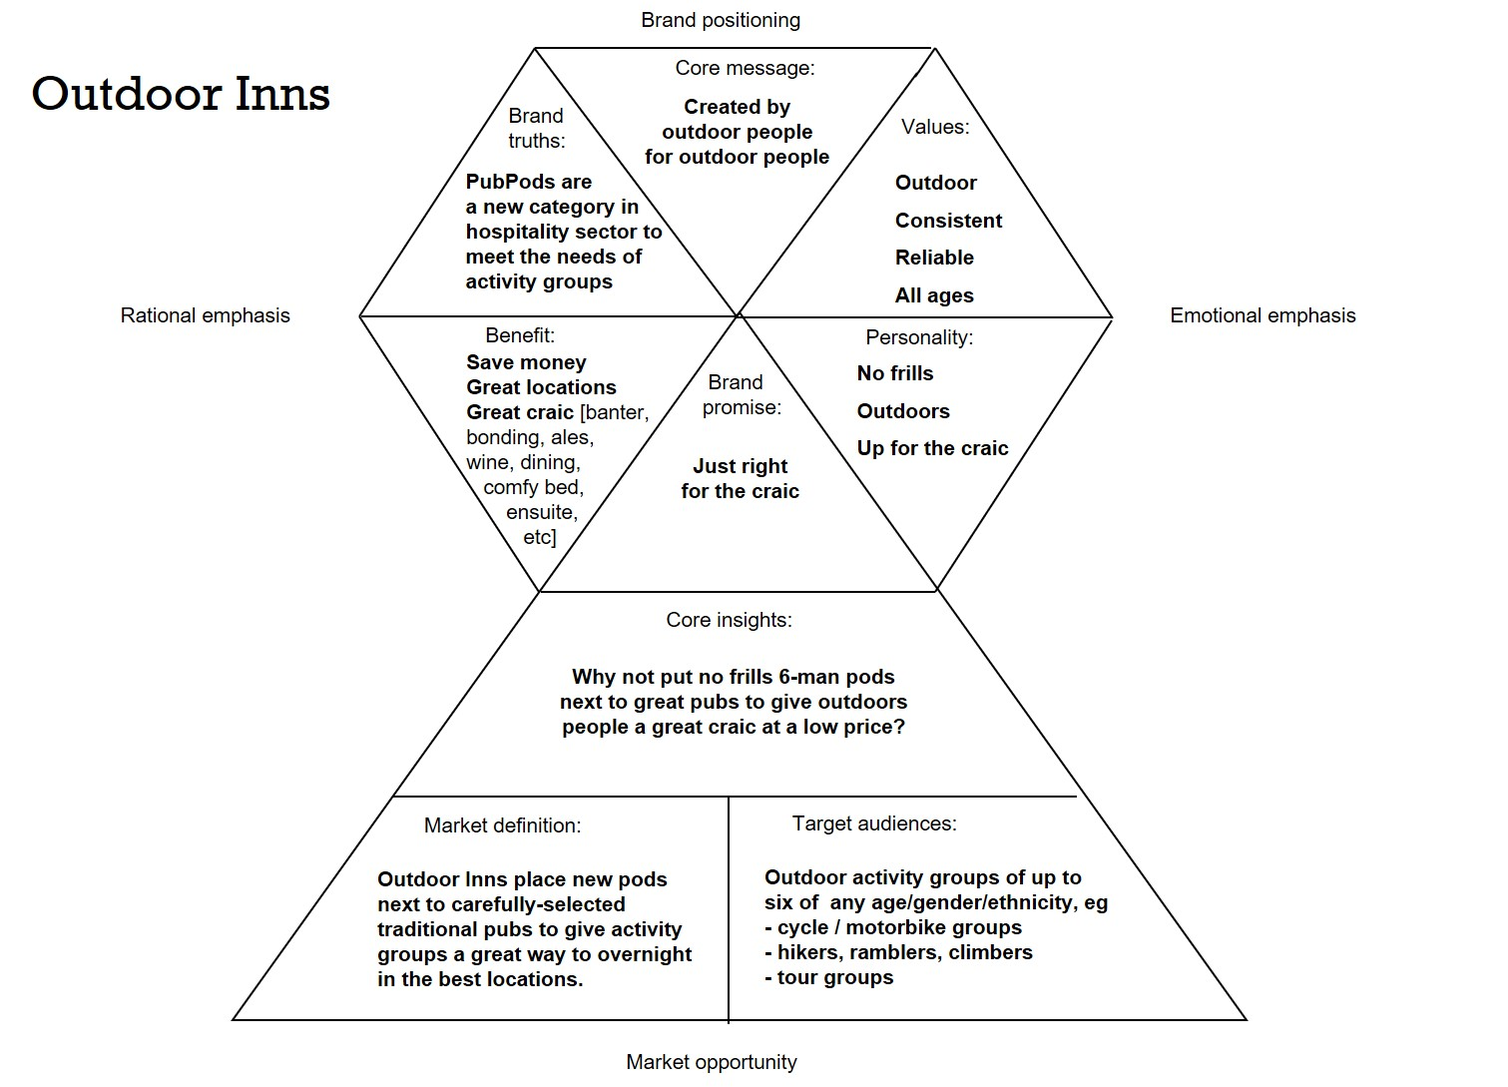

The proposition… the ‘craic’
This is central to the offer… it’s all around the fun, banter and pure enjoyment of being with friends on a bike ride or round a pub table, cracking jokes and maybe singing a few songs.
The proposition is that Outdoor Inns is ‘Just right for the best craic’.

Call to action
Whatever you’re into, get into Outdoor Inns

Corporate/consumer brand
Outdoor Inns will be a corporate brand (eg addressing investors and b2b targets, eg pub trade, local authorities for planning permission, etc) and a consumer brand appealing to activity group leaders and members.

PubPods
‘Pubpods’ will be a sub-brand… one of the ways that Outdoor Inns delivers great customer experience. This could have a logotype that is consistent/compatible with the Outdoor Inns identity.

Logo
A logo is required for Outdoor Inns. This can be a logotype or a type-plus-symbol.
The logo should communicate:
- being of our time/the spirit of our COVID/post-COVID age
- natural, rural values
The logo should appeal to:
- Activity groups (cycling, hill walking, fishing, offroad motorbiking, etc)
- 20 to 80 year olds
- Any gender/ethnicity
- Nearly all UK based
Applications
- all digital media
- possibly traditional media
- clothing (caps, T-shirts) and other branded merchandise
Timing
- logo needs to be finalised by mid Sept
Budget
- to be agreed

