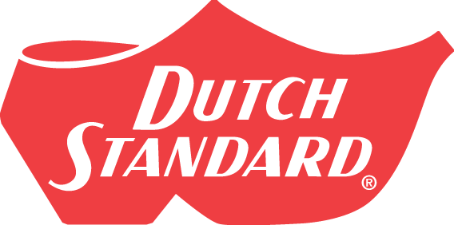
DANGER 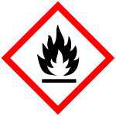 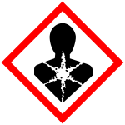
Contains: Ethanol
Drug Facts
Active Ingredients: Purpose
Alcohol 80% v/v…………… Antiseptic
Uses:
Hand Sanitizer to help reduce bacteria that can potentially cause disease.
For use when soap and water are not available.

WARNINGS:
For external use only, flammable liquid and vapor.
Keep away from heat/sparks/open flames/hot surfaces.
Harmful if inhaled.
Do not use:
In Children less than 2 months of age
On open skin wounds
When using this product keep out of eyes, ears, and mouth. In case of contact with eyes, rinse eyes thoroughly with water.
Stop use and ask a doctor if irritation or rash occurs. These may be signs of a serious condition.
Keep out of reach of children. If swallowed, get medical help or contact a Poison Control Center right away.
DIRECTIONS:
Place enough product on hands to cover all surfaces. Rub hands together until dry.
Supervise children under 6 years of age when using this product to avoid swallowing.
Other information:
Store between 15-30C (59-86F) •
Avoid freezing and excessive heat above 40C (104F)
Inactive ingredients
glycerin, hydrogen peroxide, purified water USP
STORAGE:
Keep cool. Store in a well-ventilated place. Keep tightly closed. Store locked up.
DISPOSAL:
Dispose of contents/container in accordance with local/regional/ national/international regulations.


DANGER!
FLAMMABLE LIQUID AND VAPOR
VAPOR HARMFUL
HARMFUL IF INHALED
1 U.S. GALLON
(3.78 Liters)
Ethyl Alcohol Antiseptic
80% Topical Solution

Hand Sanitizer
Non-Sterile Liquid Solution
196-4989

1329 HARRISON AVE SW, CANTON, OHIO 44706 USA 330-455-5125 FAX 330-454-1750

