Beyond advisory
  - Consulting Pty Ltd.
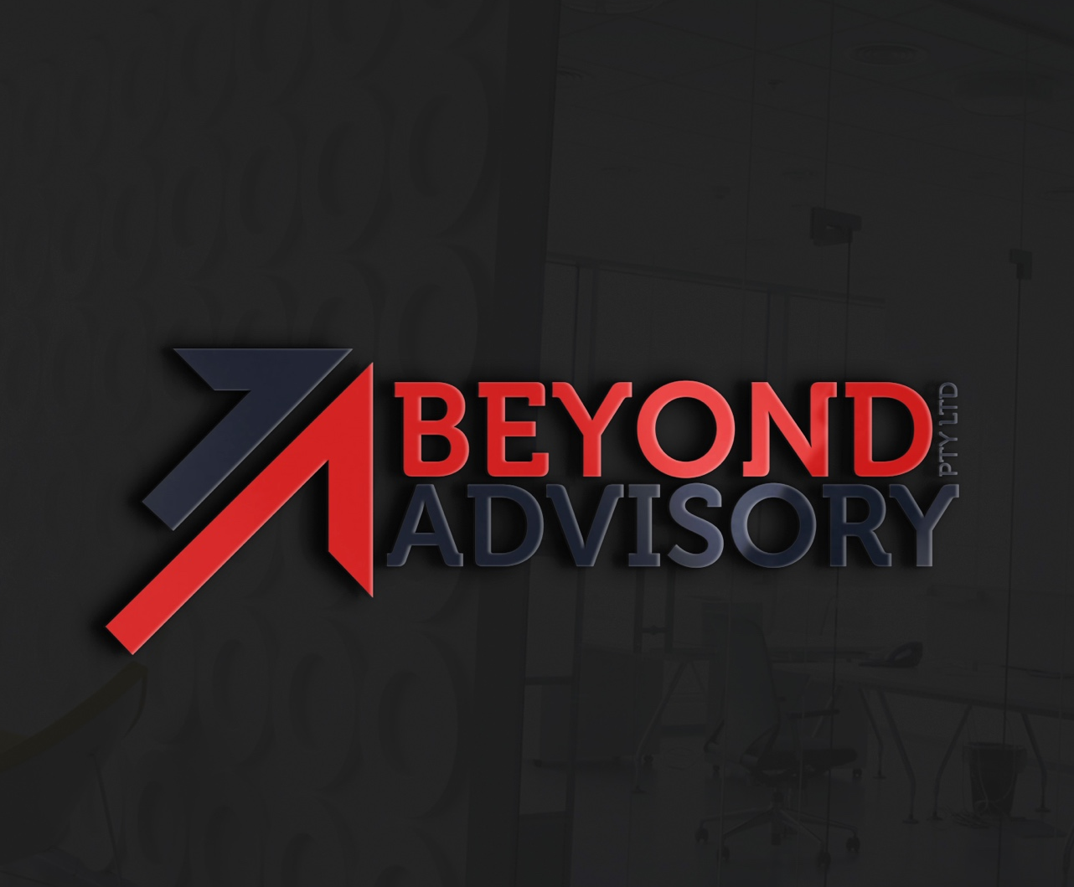
ABN

Table of
Contents
beyond advisory 1
ABOUT US 1
PROCESS IMPROVEMENT WITHIN GOVERNMENT 1
TECHNOLOGY ANALYSIS WITHIN HEALTHCARE 1

beyond advisory
CONSULTING FIRM
To get started straight away, simply tap any placeholder text (such as this) and start typing.

ABOUT US
We are a specialist operational excellence firm, delivering consulting and advisory services in six core capabilities, across all industries and all business lines to improve performance, efficiency, profitability, automation and scalability, for clients across Australia.
We’re known for our pragmatism, in depth analysis, strategic insight and nurturing long-term client self-sufficiency. We approach business consulting differently, with a Genuine Client Partnership model that builds client capability and rightsized solutions for the client.

WHY WE EXIST
Our aim at Brainhouse Capital is to be a leading strategy and financial advisory firm across the continent solving complex management problems for small and medium sized enterprises across a wide range of industries.
We help you scale your business operations to become highly profitable.
We offer your organization cutting-edge expertise leveraging on first-class, strategic and financial insights that help you simplify and structure your processes to become a lean efficient enterprise.

PROCESS IMPROVEMENT WITHIN GOVERNMENT
Across the three levels of Government – Federal, State/Territory and Local – leaders continually face complex decisions around how to allocate limited resources to best service their citizens. In the past, Governments have faced criticism for an over reliance on bureaucracy and an inability to adapt or even prepare for the future. However, the trend among global leaders now is one of innovation both in how they run the business of Government and in the services they apply their resources to. Programs of innovation and transformation are actively sponsored to promote a more competitive and viable society. A focus on reducing waste is leading to more efficient, cost effective government bodies underpinned by the adoption of technology and process improvement techniques. And of course the safety and security (physical and data) of its citizens remains a primary goal in a world facing an unparalleled level of technological advance.
We work closely with public sector bodies to drive cost and efficiency gains through best practise process excellence programs and identify & implement opportunities to improve the customer experience. We understand the traditional challenges of the public sector and that each level of Government faces its own unique challenges. To this we bring deep expertise in process excellence and a pragmatic approach to the application of these techniques to drive improvement.

TECHNOLOGY ANALYSIS WITHIN HEALTHCARE
Australia’s health care system is a complex web of public and private providers, settings, participants and supporting mechanisms. Health providers include medical practitioners, nurses, allied and other health professionals, hospitals, clinics and government agencies and private providers. These providers deliver a complete range of services across many levels, from public health and preventive services in the community, to primary health care, emergency health services, hospital-based treatment, and rehabilitation and palliative care.
We work closely with both the Public sector health services through the 3 levels of government and the Private sector health service providers to drive efficiency across their diverse range of services. Through best practise business process re-engineering, the pragmatic use of toolsets such as Lean Six Sigma and a deep understanding of Business & Technology Change, we drive significant cost and efficiency gains across all types of healthcare from hospital to aged care facilities and everything in between.

