The project requirement is to design a product label for a new brand of Collagen Powder.
- The target customer is women aged between 25 and 60. We would like to cross over between both audiences, without ruling one out.
  - The upper end (in terms of age) of the customer base are financially better off and care about their appearance and reducing the signs of aging
  - The lower end of the customer base are more concerned with recovery and would use the collagen blends after or before a workout
- The benefit the product will bring to customers is:
  - A reduction in lines and wrinkles and smoother skin, making them look younger.
  - Improved joint, nail, muscle and bone health
  - Improved gut health
- There are 3 different product we will sell. The label should be interchangeable across all 3 products, where only the colours change.
- The text we have provided on the 3 sample JPG’s is all we would like to have on the front of the label. The idea is to be more minimalist and not have too much text confusing the customer with facts. This will go on the back of the label instead.
The product is an internet only product and won’t be sold in stores. As such the text needs to be striking enough to be seen in online ads.
The label needs to have the following characteristics:
- It must be eye catching, i.e. people need to stop scrolling when they see it.
- It must have contemporary colours that are popular with women, i.e. pinks, apricots, dark greens, mustards, etc
- The image needs to be very feminine, just like the target audience
- The label must evoke some emotion, yet still be a little bit fun without being too serious. There are already 2 or 3 brands that are in the higher end price range that look like an expensive perfume. We don’t want to look like these companies. Here are the 2 big players as an example
  - Dose & Co
  - Kissed Earth
- We also don’t want it to look like “just another” nutritional brand selling Bulk Nutrients.

- We want to be somewhere in the middle, as in, the right price point accessible for most people, but still with a bit of class, fun and femininity.
The label must use this image below as the main foundation. I have included the EPS file with this email.

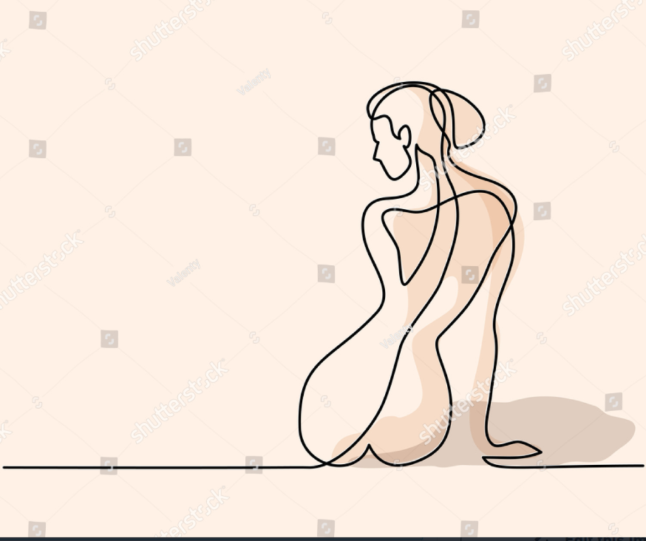

Here are some examples of products that are working very well at the moment.
We would like to base the new label around the same idea KOi have below. As in, the 2 dimensional colours that cross over each other to create a unique pattern. However we would like it to include the feminine silhouette as the focus in the main image. I have attached 3 examples that I put together in PowerPoint as a general guideline.
Finally, the designs need to be consistent with the clean theme we have on the website. Take a look here at www.ketobody.com.au where we will use the Montserrat font throughout.
