Crystallize Analytics





- Cost Recovery
- Operations and Profit Improvement
- Data Quality
- Cash Management

78DF12


Hex: #78DF12
RGB: 120, 223, 18
CMYK: 46.2, 0, 91.9, 12.5
HSV: 90, 92, 87

235FAE

Hex: #235FAE
RGB: 35, 95, 174
CMYK: 79.9, 45.4, 0, 31.8
HSV: 214, 80, 68

4DC5D6

Hex: #4DC5D6
RGB: 77, 197, 214
CMYK: 64, 7.9, 0, 16.1
HSV: 187, 64, 84

23AE2C

Hex: #23AE2C
RGB: 35, 174, 44
CMYK: 79.9, 0, 74.7, 31.8
HSV: 124, 80, 68

B3B3B3

Hex: #B3B3B3
RGB: 179, 179, 179
CMYK: 0, 0, 0, 29.8
HSV: 0, 0, 70

E6E6E6

Hex: #E6E6E6
RGB: 230, 230, 230
CMYK: 0, 0, 0, 9.8
HSV: 0, 0, 90

390066

Hex: #390066
RBG: 57, 0, 102
CMYK: 44.1, 100, 0, 60
HSV: 274, 100, 40

9C80B3

Hex: #9C80B3
RBG: 156, 128, 179
CMYK: 12.8, 28.5, 0, 29.8
HSV: 273, 28, 70

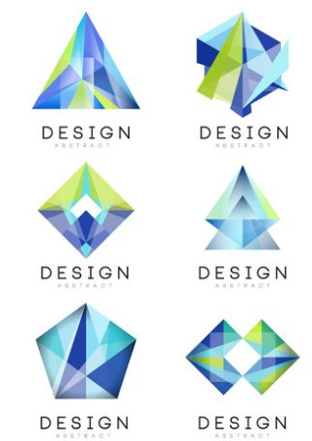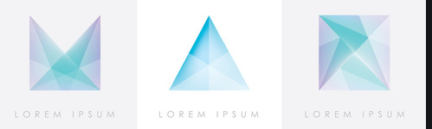
https://www.vectorstock.com/royalty-free-vector/abstract-logo-design-set-crystal-gem-geometric-vector-21832701

