Thermal Scanning and Facial Recognition Camera

The temperature of your body is no longer considered private information. That’s the stance that businesses around the world are taking as they install thermal imaging cameras for the safety of staff and visitors, often equipped with facial recognition technology, in their buildings in an attempt to cope with the COVID-19 pandemic. It’s a movement one might call the automation of temperature checks.

The Purpose of Thermal Scanning & Facial Recognition
The purpose is to identify anyone walking into an establishment with a high temperature. This will reduce the likelihood of spreading any potential virus and brings some peace of mind to people in the building.
We can pair your thermal camera/s with facial recognition software. Employees will check in by standing in front of the camera, which identifies them by their face in just a few seconds without contact (with or without a mask on) and simultaneously performs a thermal scan. It will record a photo of the individual, the date, the time and the temperature reading at that time of entering the building. If the camera detects a high temperature reading, it will sound an alarm in real time and send a notification to a nominated administrator/in-house security.

Where and how can it be used?
This Camera can be used with access control gates. It is used in office buildings, schools, hotels, hospitality, in fact, any space where Covid is potentially a threat to staff or visitors.

Our Thermal Scanning & Facial Recognition Camera is used as a safety and security measure.
If someone gets sick and takes legal action, you can demonstrate that you have made your best effort to protect your staff and visitors.

Portable Camera for a Reception Desk
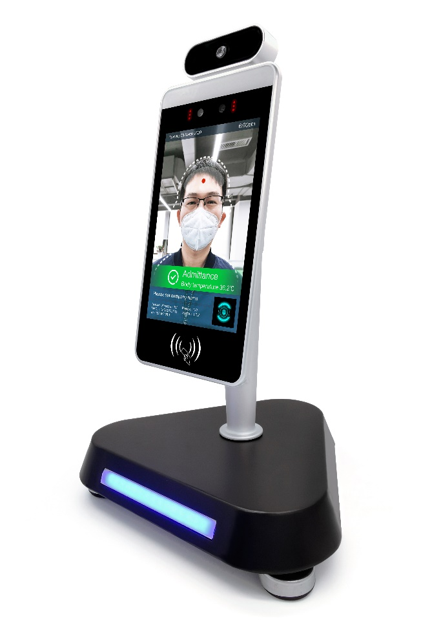

Portable Floor Standing Camera

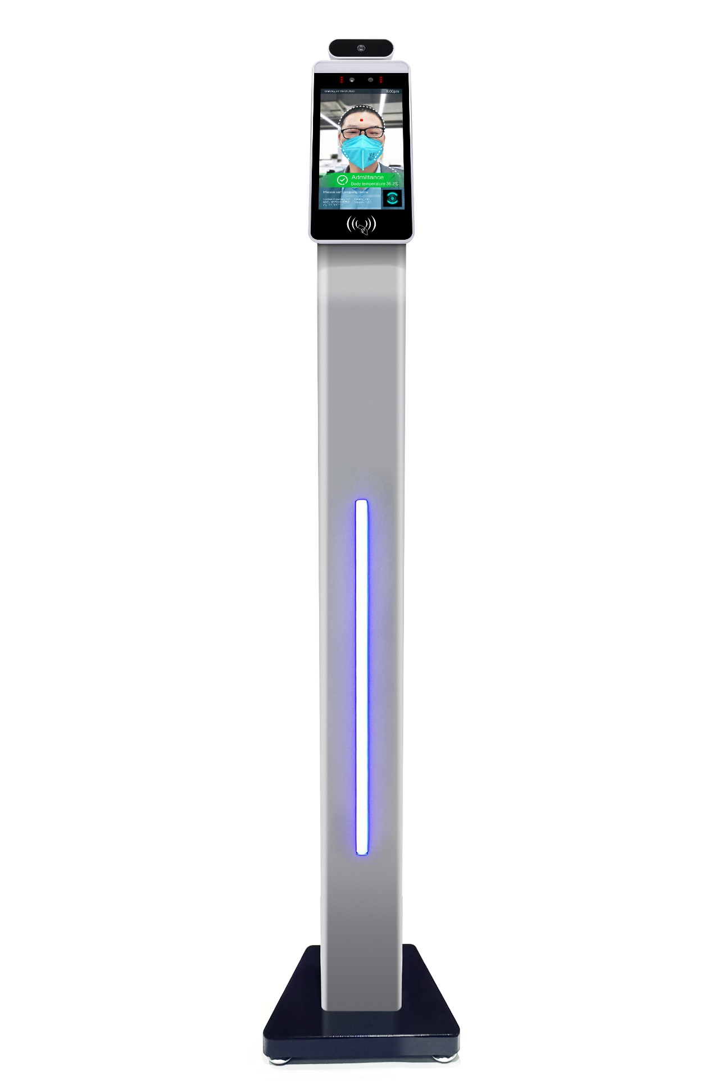

CALL 1300 302 884 for further information and a free quote

Technical Specifications
Model TY-08Camera
Camera
Resolution: 2 million pixels
Type: Binocular wide dynamic camera
Aperture: F2.4
Focusing distance: 50-150cm
White balance: auto
Photo flood light: LED and IR dual photo flood light
Screen
Screen
Size: 8.0 inch IPS LCD screen
Resolution: 800×1280
Touch: Not supported
Processor
Processor
CPU: RK3288 quad-core
Storage: EMMC 8G
Interface
Interface
Network module: Ethernet and wireless (WIFI)
Audio: 2.5W / 4R speakers
USB: 1 USB OTG, 1 USB HOST standard A port
Serial communication: 1 RS232 serial port
Relay output: 1 door open signal output
Wiegand One Wiegand: 26/34 output, one Wiegand 26/34 input
Upgrade button: Support Uboot upgrade button
Wired network: 1 RJ45 Ethernet socket
Function
Function
Face Detection: Supports facial detection
Face library: Up to 30,000
1: N face recognition: Support
1: 1 face comparison: Support
Stranger detection: Support
Identify distance configuration: Support
UI interface configuration: Support
Upgrade remotely: Support
Interface: Interfaces include device management, personnel /
photo management, record query, etc.
Deployment method: Support public cloud deployment, privatized
deployment, LAN use, stand-alone use

Infrared Imaging Thermal Module

Temperature detection: Support
Temperature detection distance: 1 meter (optimal distance 0.5 meter)
Temperature: ≤ ±0.5℃ measurement accuracy
Temperature measurement range: 10℃~42℃
Pixels: 32 X 32 dots (total 1024 pixels)
Visitors' temperature is
normal and released
directly: Support
Abnormal temperature alarm: Support (temperature alarm value can be set)

AV Media Systems
MELBOURNE – SYDNEY – PERTH – BRISBANE
1300 302 884

www.avsystems.com.au

