Present logos
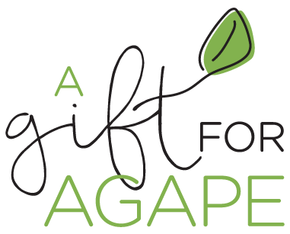
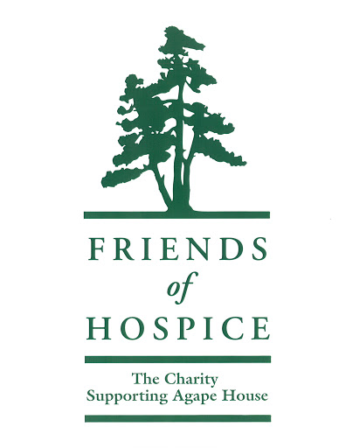
A gift for Agape logo will continue to be used
FoH logo is being redesigned

requirments ***************************************** get from pdf.

First draft of Logos (these are Agape House when they should be FoH)
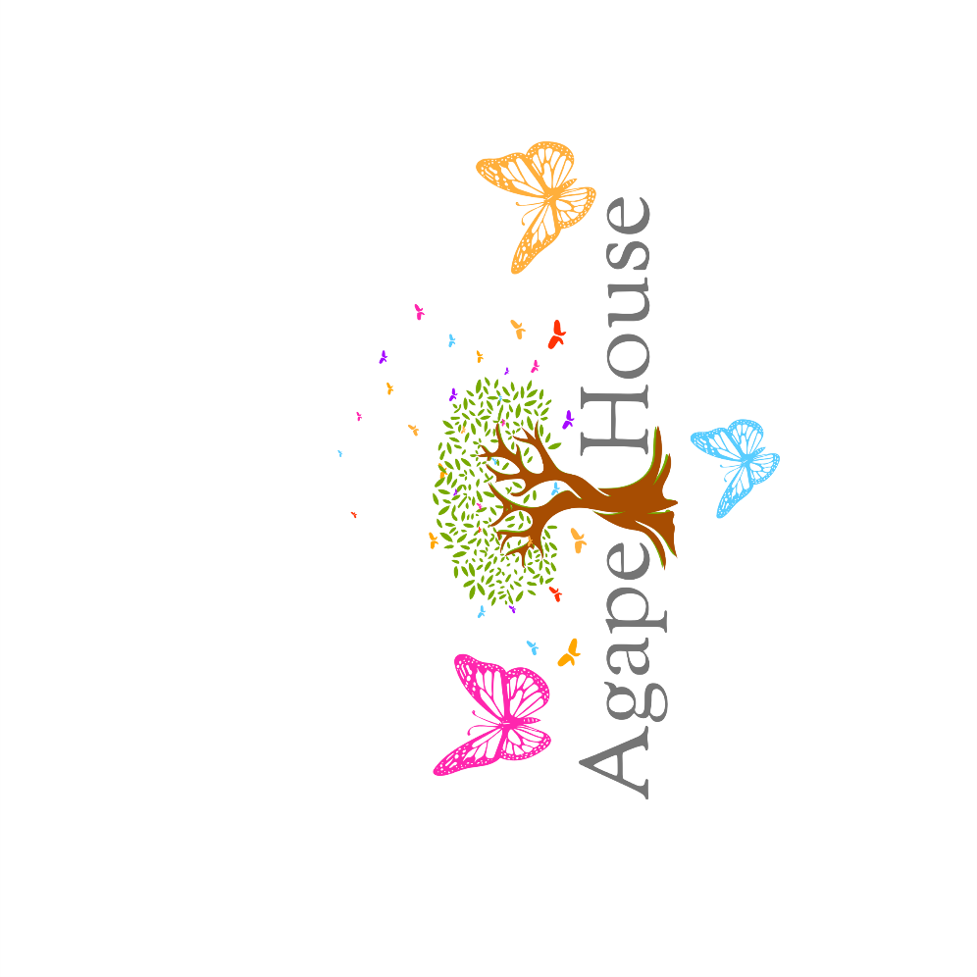
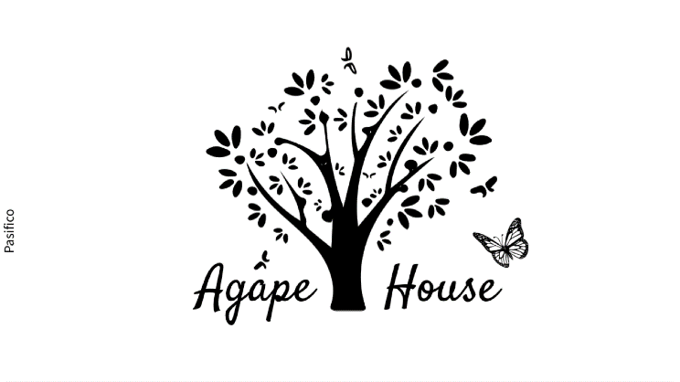
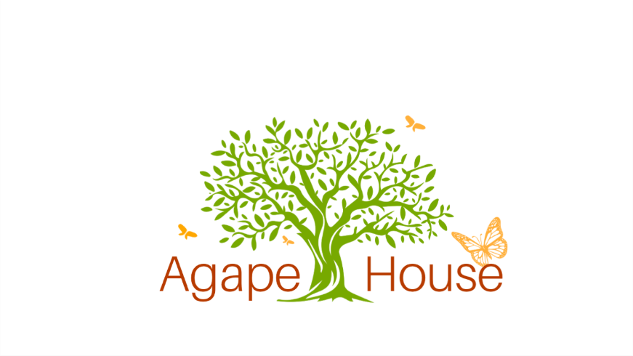
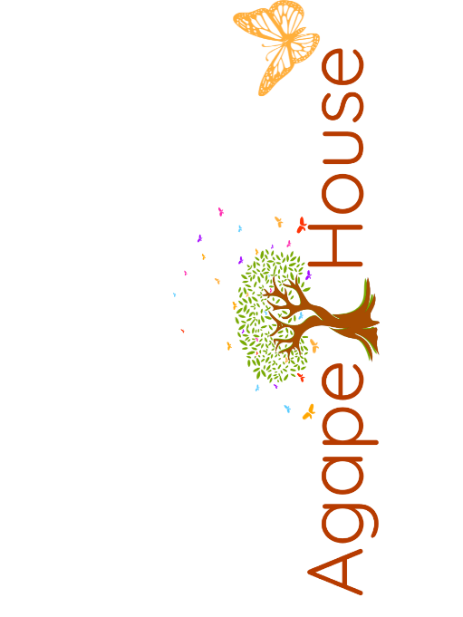
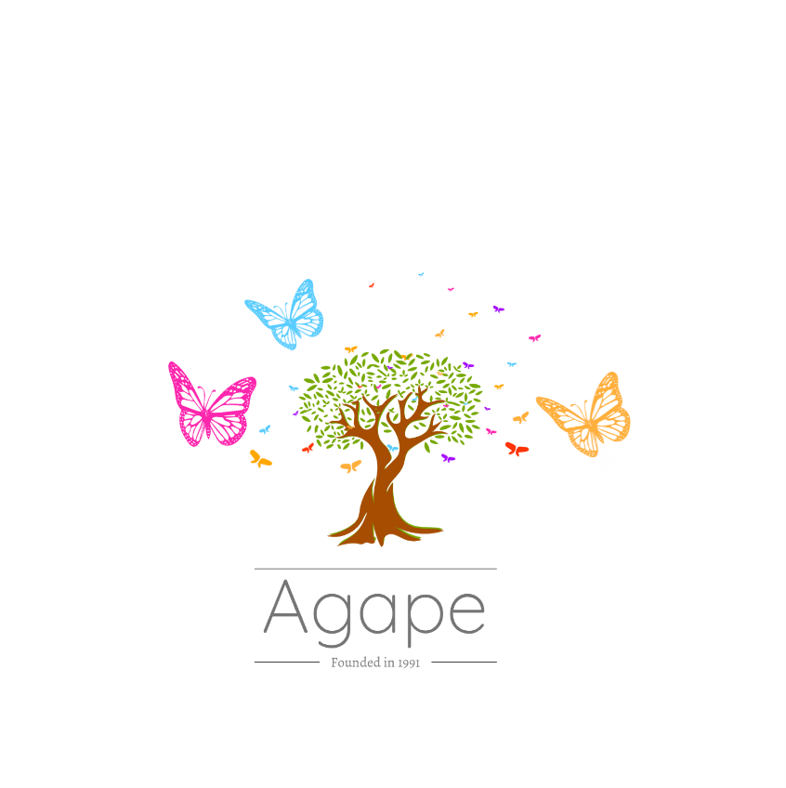
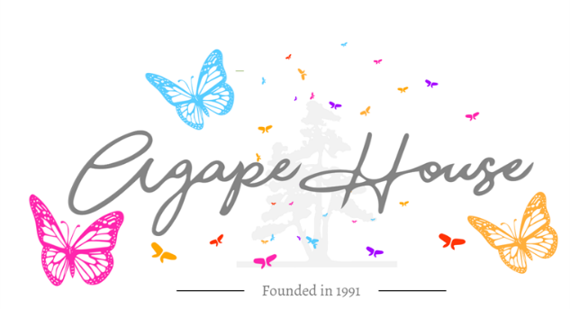

Feedback:

**** Jen had mentined that she was interested in having a gif/movement of the tree (or butterfly) when on the website ****

- 1st Set of Designs:
  - Not focus on the green, as it only remains for a gift for agape. Would be using FoH, not the brand.
  - Needs more color
  - **forget about the green!**
- Likes the faded out back, so the tree is not the focal point. Butterflies to be the focal point as they are very symbolic to hospice care.

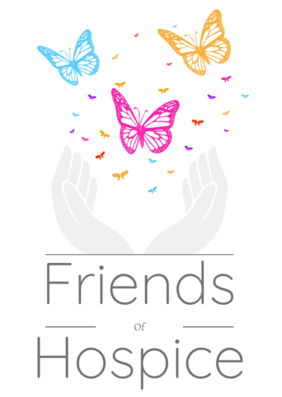
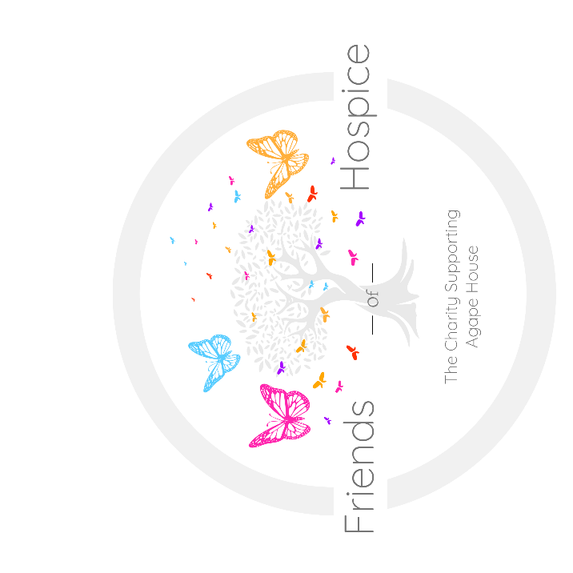
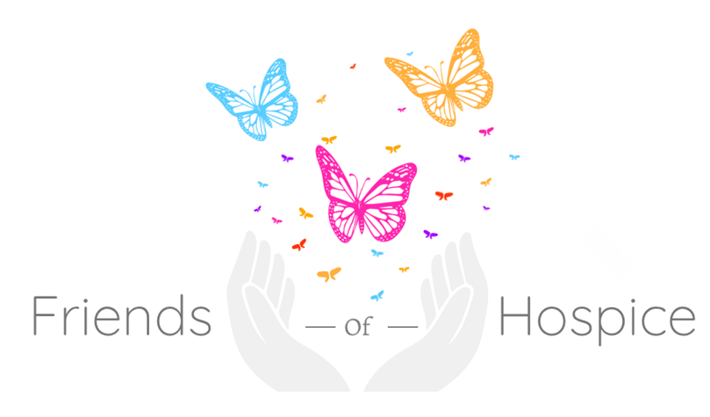
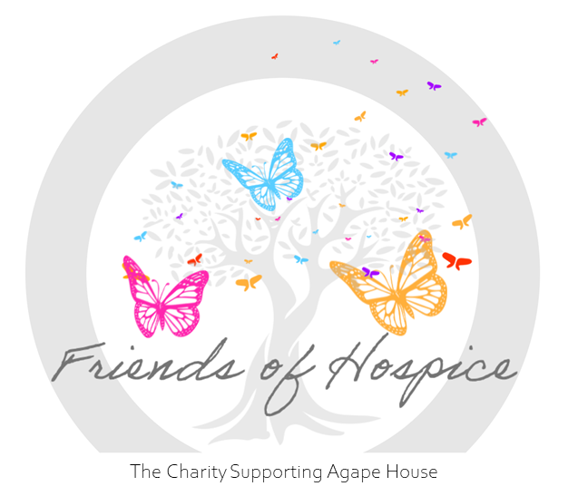
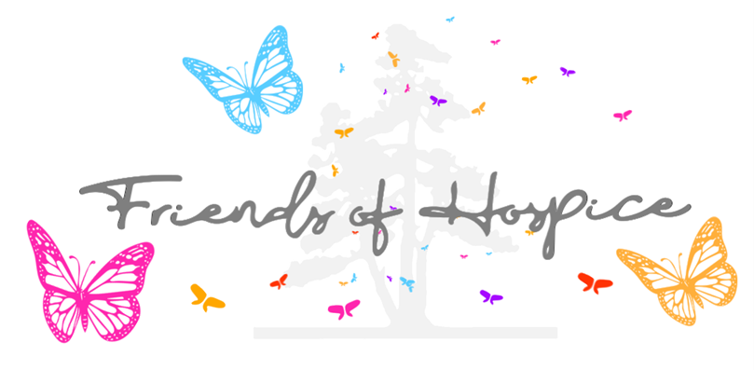
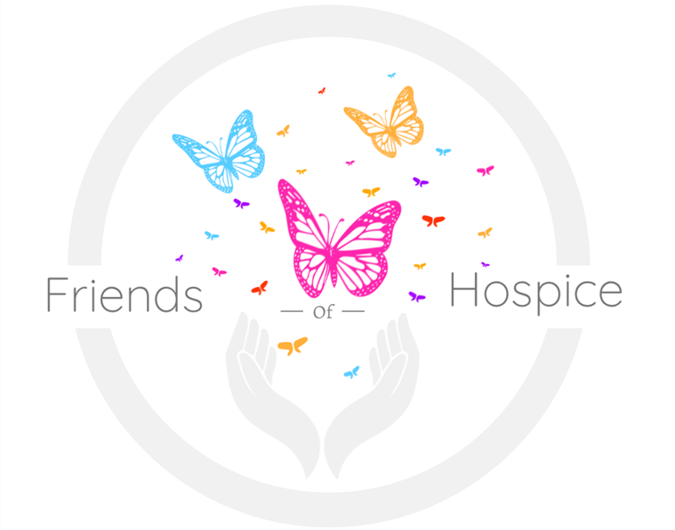
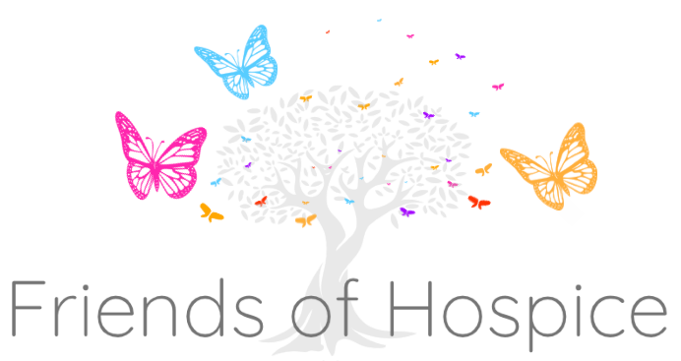
Second draft of Logos
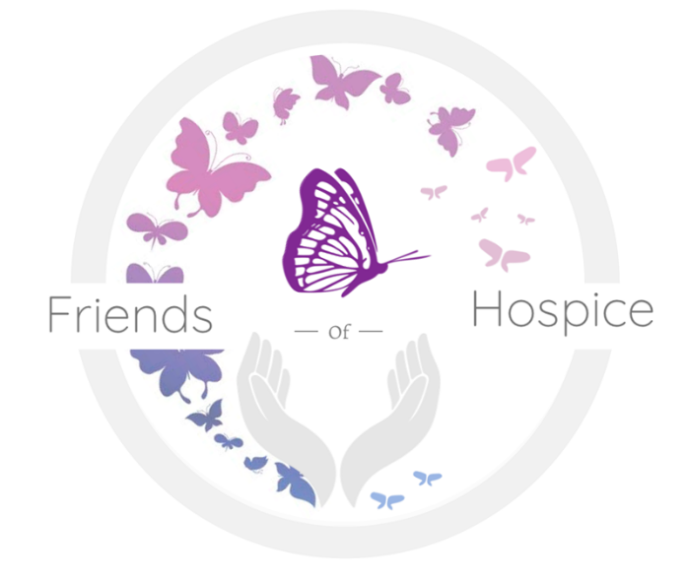

Feedback:
- Liked that explored a circular image
- Image of butterflies… the smaller butterflies will look like tiny dots if printed or made smaller. Consider how the logo will be used (i.e. t-shirts)
- Butterflies are only in a single color, opposed to a butterfly with multiple colors
- Would like to see a butterfly with multiple colors
- The last page with butterflies, like the proper color fade
- Don’t like how the name clips outside of the circle
- Don’t like the hands… already used for another charity in BDA
- Different color palettes
- Place logo in t-shirts, business card etc. for envisioning purposes
- Explore with the trees to be a darker grey (25-30%)

