- Need: Logo for Ignite Your Life in our colors and our branding
  - Our color palette:
Eb2b90
D79e5a
FFFFFF
000000
  - Font: Playfair Displa, Storytelling
- Here is the old logo: (like the woman in the middle of the flower)



- This is our new website: https://datingwithdignity.com/ (you can see our font, colors, etc. here and also our main Dating With Dignity logo)
- Like the “show” feel or maybe even a festival?
- Here are some options we looked at:

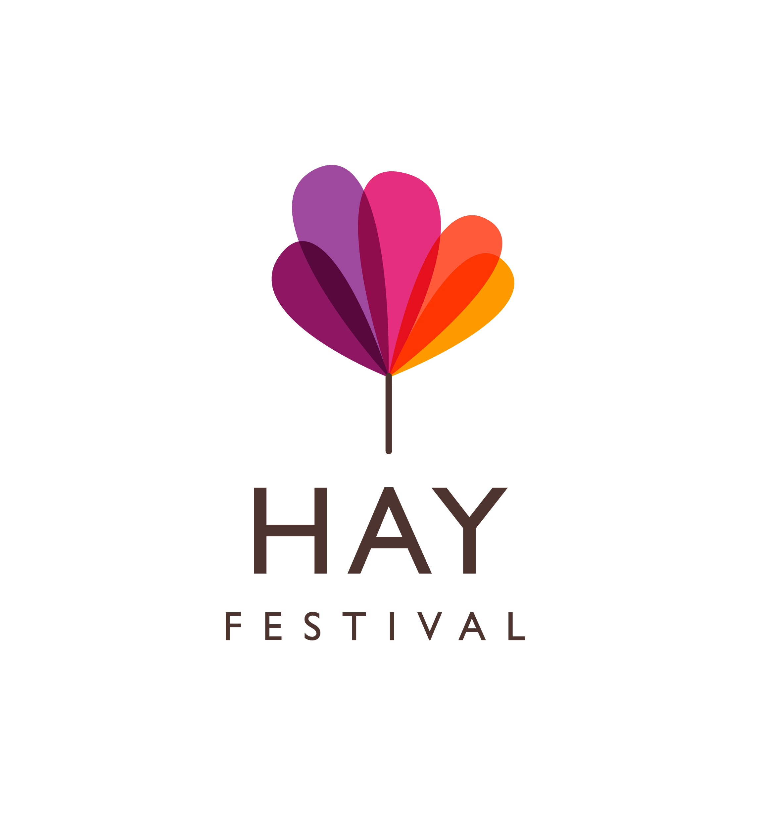
Like this one, but not the guitar - maybe a flame?
