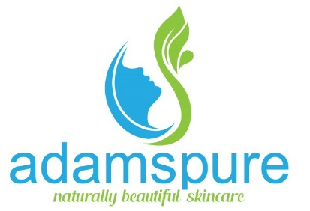
Adams Pure
52 Westminster road Gladesville, NSW 2111
sales@adamspure.com
adamspure.com
Hand made in Sydney Australia

All in one completely natural cleanser, exfoliate & moisturiser. With refreshing & uplifting antimicrobial essential oils and finely milled organic sea salt. Apply a small amount on your hands, scrub and cleanse for 60 seconds or longer. Rinse with water only and towel dry for an amazing immediate result.

Hand Scrub
Dry & damaged hand repair
100% Natural ingredients; Sunflower oil (Helianthus annuus ), Sundried Sea Salt (Sodium chloride), Rosehip oil ( Rosa eglanteria), Avocado oil ( Persea Gratissima ), Macadamia oil (Macadamia integrifolia ), Jojoba oil ( Simmondsia chinensis ), ( Wheatgerm oil (Triticum gestivum ), Thixin ( hydrogenated castor oil), tocopherol ( Vitamin E). Essential oils of; Tea Tree ( Melaleuca alternifolia ), May Chang ( Litsea cubeba ), Lavender ( Lavandular angustifolia )
No Alcohol, water or chemicals only pure natural products. Shake contents occasionally.
Precaution, This product contains sun dried sea salt and stinging may occur on cracked skin. Discontinue use if irritation occurs.

Immediate results
Ultra-moisturising with
Rosehip & essential oil

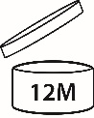
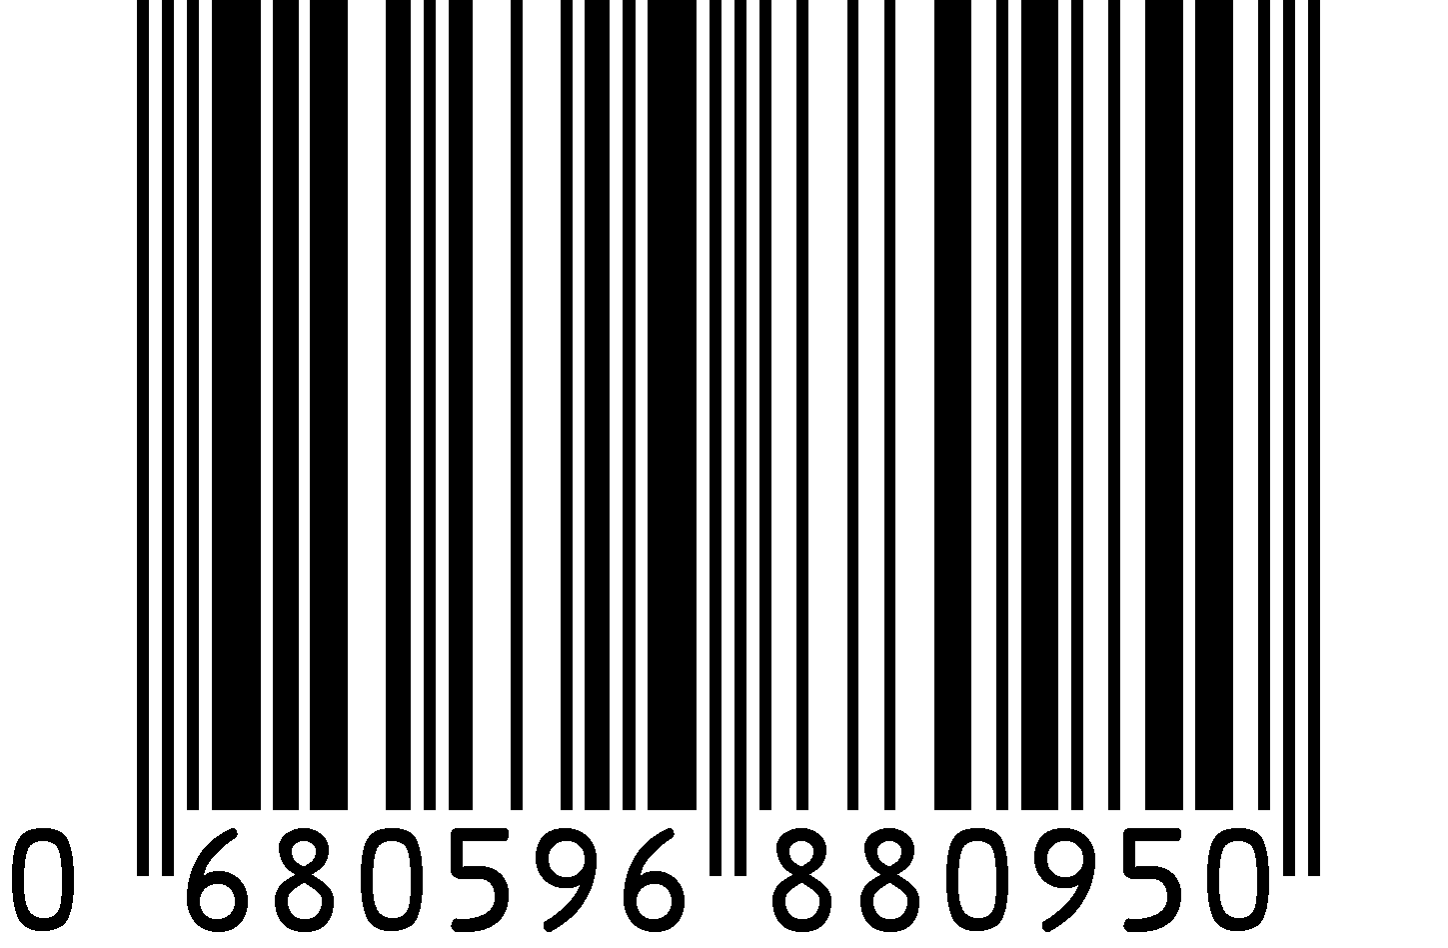

Australian made
250g

