Website Design Currently: www.AndreaLuoma.com 7/24/2020
I’ve tried hiring two different people to create me a website. Unfortunately, all come back with autogenerated templates from Wordpress, none of which I’ve liked that have been shared. My website is currently on SquareSpace and created in Wordpress. It would be ideal to continue to have it in this format.
Pages include:
Home
Meet Dr. Andrea
Speaking
NeuroCoaching
NeuroLeadership & Communication Consulting
Organizational Rejuvination
News & Media
Results
Learn (this page will eventually be virtual and in-person workshops and trainings)
Contact

Home page must have an ‘upcoming activities’ section – I particularly like how this website does this: https://eckharttolle.com/ (I like this website in general as well).
Utilize the current logo and its colors  consider adding a contrast color of royal purple, or kaleidoscope colors (mostly in blues and greens) to emphasize the following point…

Consider utilizing in the design a kaleidoscope concept. (Verbiage this relates to: Dr. Andrea has an astute ability to get clients to think from different perspectives to attain breakthrough moments and develop their own solutions. Like a kaleidoscope, her work brings together multiple disciplines and practices into pictures that are always transforming, just as leaders are always transforming. She bridges the leader’s impact on the organization and the organization’s impact back on the individual.) Types of images might include:
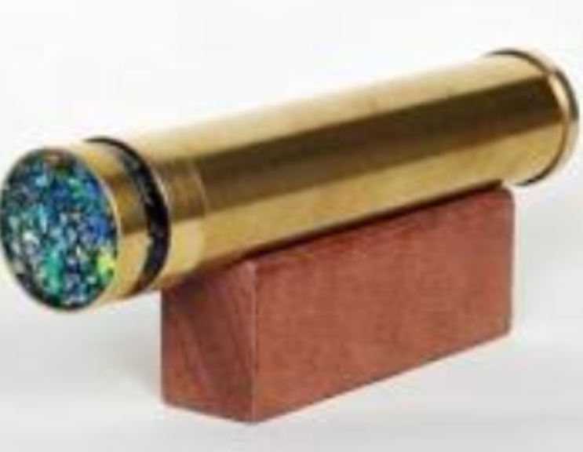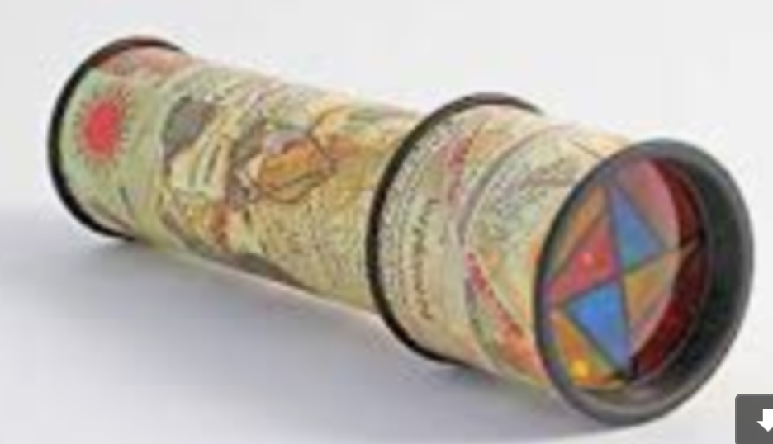
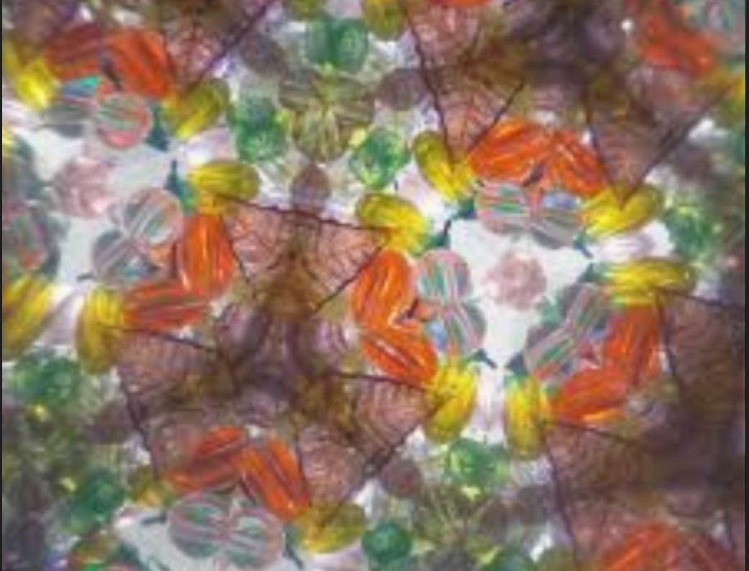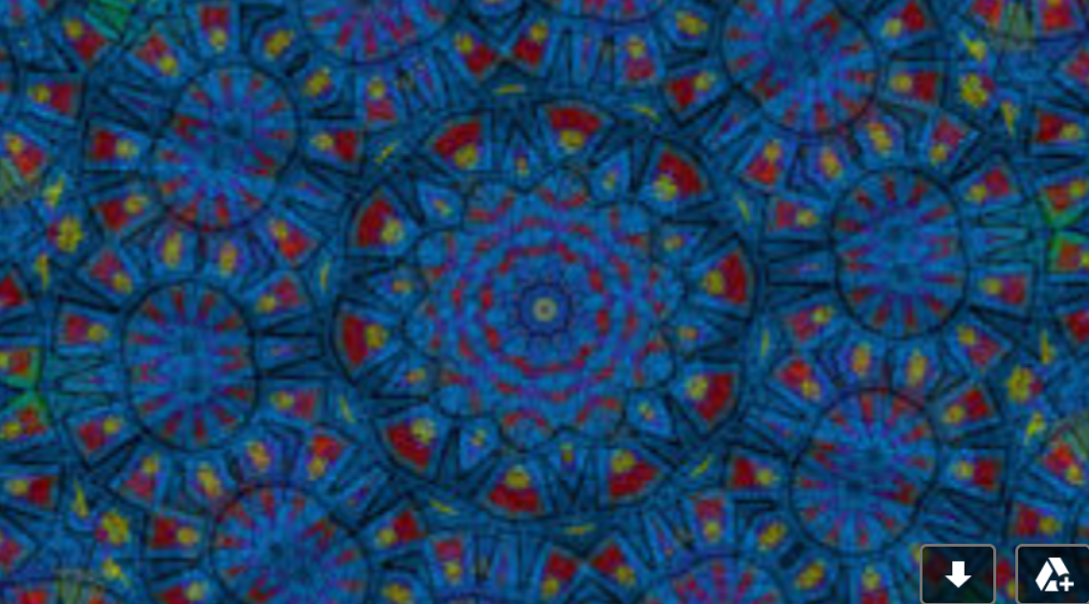

My current www.AndreaLuoma.com was meant to be a tri-column. It's too much verbiage now...
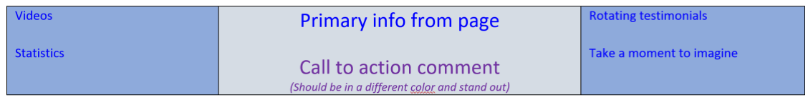
Contemporary websites have changed and become much starker since mine was created. Though there’s way too much verbiage in mine, many of today’s websites are too stark, with too much space, and too much scrolling. The verbiage on my current website will be getting a complete overhaul.
My current website: www.AndreaLuoma.com was built around that of https://www.stevengaffney.com/ his website is quite different now than it was then. I still like of the current one. Particularly his https://www.stevengaffney.com/meeting-planners/ and https://www.stevengaffney.com/speaking/ (I’d like something along this idea for speaking engagements)
Websites I like:
http://www.endeavorco.com (Really like this one! I like how it moves)
https://eckharttolle.com/
https://punkave.com/process
Must be usable (easily loadable) on mobile phones and computer

