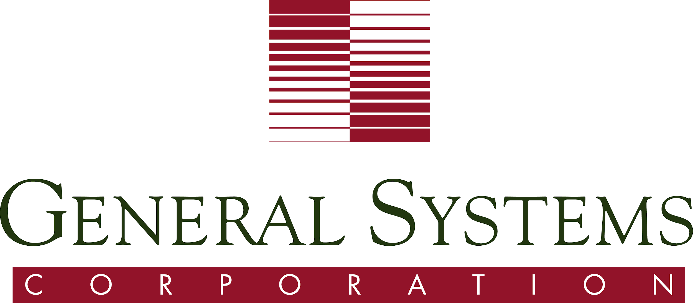50 Years of NonProfit IT Services

An Efficient and Elegant Approach to IT Solution Implementations
General Systems Corporation has been supporting the Information Systems needs of nonprofits for over 50 years. We continually strive to bring the latest technologies and best practices to nonprofits to drive down the cost of IT while implementing systems that drive revenue.

Successes
90% Reduction in Software Development Costs
National Automobile Dealers Association Used Car Guide needed to update its core product they engaged their in-house IT department who estimated the project would take 3 years and cost $3,000,000. NADA decided to work with General Systems Corporation instead, and the product was released to production in only 9 months at one-tenth of the cost, only $300,000

10x Increase in Membership
Rails-to-Trails Conservancy needed to move to online membership registration and contracted with General Systems Corporation to build a significant online presence to engage potential members. Through compelling online tools and mobile applications, Rails-to-Trails has increased membership 10 fold.

20% Reduction in Overhead
The National Organization for Women had antiquated systems in place to manage over 500 chapters across the nation. General Systems Corporation developed online tools to allow communication and management between the local chapters and national headquarters. This eliminated much of the overhead of chapter management, reducing HR costs by 20%.

Solutions
Web Applications
With a focus on non-profit websites and web-based applications, GSC helps nonprofits communicate with their members and donors while maximizing online giving and engagement.

Mobile Applications
General Systems Corporation implements mobile applications for iPhone and Android to provide direct communications with members and donors enabling real-time, two-way interaction.

Systems Integration
IT applications can get scattered and disconnected. General System Corporation has decades of experience integrating these applications into a single cohesive system.

Business Intelligence and Reporting
General Systems Corporation can wrestle all of an organization's data into simple executive dashboards and reports.

Cloud Migration
Reduce IT costs by migrating to the latest cloud solutions.

Member Donor Database
General Systems Corporation’s WinFunds Member / Donor CRM system is fully customized for each client meeting the unique needs of your organization.

Contact General Systems Corporation at Info@GeneralSystems.com or 703-442-8800 x306

