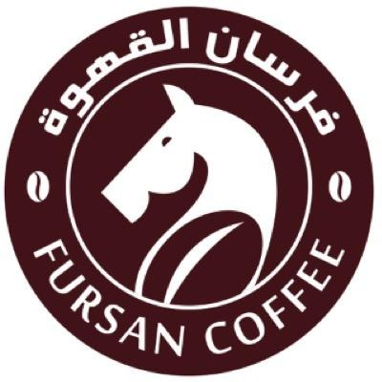

fursan
What was the story behind the love for coffee?
It started all in Kuwait when he was 10 years old , MR. Ayed was going to the desert and at his father is house when there was a gathering he was always the one who is responsible for making the coffee for all the guests .
from 2002 until 2009 he was working at any coffee shop he can work in>
When was the start of the journey?
The start of Fursan coffee began in Dammam at 2010-2012 , the first ever branch of al Fursan coffee opened in al Khobar.
the first contract was with Ramada hotel al Khobar , the second contract was with Aramco .
after 2012 Fursan coffee opened in Jeddah and at 2014 secured a contract with Saudi Airlines .
what is the story behind the logo ?
because it’s The origin of courage and generosity that was what equestrian represent .
Where is the delivery within the Kingdom?
they deliver to everywhere within the kingdom .
Who are we?
Fursan Coffee is one of the most famous coffee roasters in the Kingdom of Saudi Arabia, which is characterized by the quality of its products and its diversity, and its production and preparation is local and with 100% Saudi hands.
We look forward to expansion through a strategic plan to develop the coffee industry and distribution for individuals, institutions and companies in all cities within the Kingdom and neighboring countries to be the first name In the world of coffee
Our mission is to be the first name in the world of coffee and its culture.

