Title: Irish Liquidations Illustration Design Brief
Website: Irish Liquidations
Designer: Davin Mac Ananey
Date: July 20th, 2020

Overview
Irish Liquidations is a local Irish firm that specialises in helping firms liquidate their business. It is a small SME business with 2 staff and have been operating for circa 15 Yrs.
The Requirement
A new and updated website design has been undertaken for both desktop and mobile and to complement the design, there is a requirement to add illustration to the website.

Illustration style and interpretation and is very much up to the illustrator, however it is key that a unified illustration style is chosen, personified in the brands colours and the tone is; warm and friendly bust still needs to be corporate, credible and respectable as the firms subject matter is serious (insolvency)
Website Design has been created in figma and thus sample design can be shared at the following URLS.
Desktop Website
https://www.figma.com/proto/5j3iHfLRkIPBq5UF2bWr6u/IL-New-Website?node-id=3%3A1&scaling=min-zoom
Mobile Website
https://www.figma.com/proto/5j3iHfLRkIPBq5UF2bWr6u/IL-New-Website?node-id=173%3A0&scaling=min-zoom
A total of 5 illustrations & 6 Icons need to be prepared in the brand’s colours in SVG format for both Desktop and the Mobile Website. In addition, there is a requirement for the treatment of 3 logos converted to a mono (brand specific) colour.
See below a summary of the requirement as well as detailed brief of each of the illustrations and icons required.
For the competition - Just provide samples of the recommended Illustration style
together with a treatment of 1 Illustration and 2 icons.

Summary of Requirements
2 Colour Illustrations
- A Georgian Front Door
- Graphic of SME
- “Sorry We Are Closed” Sign
- Final Notice /Past Due Payment Letters
- A Register in Book format
- 2 Coffee Cups filled with coffee

6 line-style Icons (1 to 2 Colours)
- Free Consultation
- Fixed Fee
- Low Cost
- Qualified & Experienced
- Strictly Private & Confidential
- Peace of Mind

Logo Treatment
3 Logos – (2 Colour with Transparent Background)
Technical Specifications
- File Format SVG
- Sizing (Desktop & Mobile Websites)
- Colour Palette
  - #065E81 RGBA (6, 94, 129, 1)
  - #E2B2A1 RGBA (226, 178, 161, 1)
  - #5C6062 RGBA (92, 96, 98, 1)

Illustration Brief
Brief: Each illustration needs to illuminate, each point expressed in the associated copy
Image concepts have already been devised and act as reference as per the website mock-up
Illustration style and interpretation to be devised by the illustrator sporting one to two of the colours from the colour palette
See below Image concept its associated copy.

Image: Georgian Door (Image of actual door will be provided)
Concept Rationale: Front door of the firm, shows the firm has a physical office
Headline: Our Company
Associated Copy: With over 15 Yrs. dedicated & qualified Insolvency experience, we
understand that facing financial difficulties can be stressful and very traumatic. At Irish Liquidations, we take-away your worry by not only agreeing to a one-time, low-cost, fixed fee upfront, but also, we are with you, shoulder to shoulder through the entire liquidation process.
Our promise is to provide you with the smoothest, most pragmatic, and least expensive liquidation process that will deliver maximum return to Creditors, Directors & Shareholders in the shortest time possible while ensuring all your Company & Director’s legal obligations & fiduciary duties have been met.
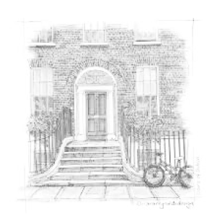
Placeholder Reference Image:

Image: A Graphic of the words “SME” illustrating Small Business
Concept Rationale: Graphic illustrates the SME Sector which the company focuses on
Headline: Our Focus
Associated Copy: Even though we service a broad range of industries
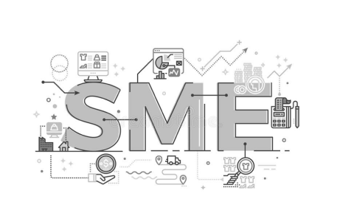
& sectors, At Irish Liquidations, our experience & expertise greatly favours the smaller entity. We primarily work with SMEs, Entrepreneurs, non-trading corporate subsidiaries and assist local legal & accountancy firms.
Placeholder Reference Image:

Image: A Sign that says “Sorry We’re Closed (Just the sign - no background)
Concept Rationale: A friendly image that suggests the business is no longer operating
Headline: Liquidations
Associated Copy: There are 2 voluntary liquidation (winding up) procedures we can assist you with; a Creditors Voluntary Liquidation (CVL) and a Members Voluntary Liquidation (MVL).
CVL: 90% of cases in Ireland are Creditors Voluntary Liquidations. In a CVL, the insolvent company voluntarily decides to go into liquidation. The process is usually initiated by the company's Directors calling a Board Meeting to agree that the company should be placed in liquidation.

MVL: When a solvent company ceases trading, or the Directors decide to retire, an MVL is often the best course of action to effectively liquidate and wind up the company. Appointing a liquidator to undertake an MVL is also the most tax efficient way to withdraw monies held within the company.

Placeholder Reference Image:

Image: A Pile of Letters Demonstrating Payments are Overdue/Final Notice
Concept Rationale: Illustrates that payments have not been made
Headline: Receiverships

Associated Copy: A Receiver is appointed by a debenture holder (Lender) on receipt of a debenture document which grants the lender a charge over the borrower’s assets, by means of collecting the debt if the borrower defaults.
When appointed, Irish Liquidations will take possession of the charged assets, realise those assets, and discharge the debt owing to the Lender.
In some instances, Irish Liquidations will endeavour to keep the business running with a view to maximising the value of the company’s assets, via the sale of the business (or part thereof) as a going concern and therefore improve the prospect of loan recovery

Placeholder Reference Image:

Image: Official Looking, Old Style Hardback Book with the words “Company
Register” Inscribed
Concept Rationale: Visualises the concept of being on a physical register
Headline: Voluntary Strike Off
Associated Copy: Striking off a company is an alternative and voluntary procedure to formally winding up (liquidating) an existing Limited company.
At the request of the Directors, the Registrar of Companies can strike off (remove) the company from the Companies Registration Office (CRO) so long as the company is solvent, no debts remain outstanding and is not carrying out any business or operation.

Irish Liquidations can assist you with the application and Strike Off process and will confirm all debts have been discharged, file the necessary paperwork with the Companies Registration Office (CRO), obtain Revenue clearance and ensure all Shareholder & Director’s legal obligations have been met.

Placeholder Reference Image:

Image: 2 Coffee Cups filled with coffee
Concept Rationale: Visual representation having an informal chat over a cup of coffee
Headline: Director & Creditor Advice
Associated Copy: Our No 1 priority is to have you remain in business. Nevertheless and with over 3,300 Irish Liquidations successfully administered and a regular advisor to local accountancy & legal firms, Flavien is always on-hand to both Directors and Creditors alike to help navigate the myriad of options available, the legal pitfalls to avoid, and the best insolvency strategy and process to follow.

All consultations are strictly private & confidential and there is no-obligation to proceed with Irish Liquidations even in the event a liquidation is the best course of action.

Placeholder Reference Image:

Icon Brief
Brief: Each Icon needs to demonstrate the benefit and thus users can see immediately, what is being
offered to them – simplicity is always better
Icon concept and illustration style to be devised by the illustrator. However, I have provided concept suggestion references which you can add to or stylise as, as per your illustration style.
In terms of style, simple key-line vector illustration sporting one to two of the colours from the brand’s colour palette. The Tone needs to be authoritative, but friendly.
An Icon needs to be created for each benefit – see associated copy below

- Free Consultation
Initial consultation free of charge with a no questions asked, no obligation to proceed with Irish Liquidations.
Image Concept Suggestion:

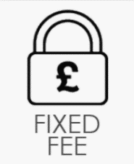

Fixed Fee
No hidden costs, surprises, or additional fees, just one fixed fee agreed upfront prior to engagement.
Image Concept Suggestion:

- Low Cost
We operate with minimal overhead to bring you the best value & most cost-effective insolvency solution.

Image Concept Suggestion:




- Qualified & Experienced
Charted Accountant with over 15 Yrs. qualified experience who has successfully administered over 6,345 liquidations.
Image Concept Suggestion:

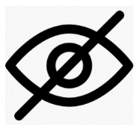


- Strictly Private & Confidential
All consultations, communications & discussions are strictly private and confidential and are also bound by GDPR & Data Protection.
Image Concept Suggestion:

- Peace of Mind
We are with you every step of the way and will ensure all your Directorial Duties & Legal Obligations have been met.


Image Concept Suggestion:

Logo Treatment Brief
Brief: Convert Each Logo to a monotone colour (#E2B2A, RGBA 226, 178, 161, 1) with a transparent background so it can be placed (reversed out) of a duo-tone image
files for each logo will be supplied on commission
Logos:
